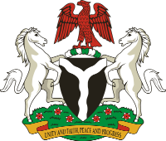

NATIONAL MALARIA STRATEGIC PLAN
2026 – 2030

NATIONAL MALARIA ELIMINATION PROGRAMME
FEDERAL MINISTRY OF HEALTH & SOCIAL WELFARE

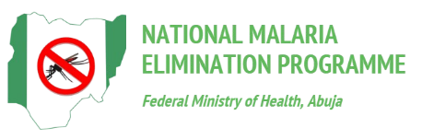

November 2025
Table of Contents
- Introduction 4
1.1 Policy and Programming environments 4
1.2 MSP and the national Planning cycle 6
1.3 The process of Developing the NMSP 2026-2030 6

2. Country Profile 8
2.1 Overview 8
2.2 Sociopolitical system 9
2.3 Ecosystem, environment and climate 9
2.4 Demographic data 9
2.5 Socioeconomic situation 10
2.6 Health system analysis 10
2.6.1 Leadership and Administration 10
2.6.2 NMEP Organizational Structure 11
2.6.3 Policy and Legislative Framework 11
2.6.4 Health Work Force 12
2.6.5 Health Product Management 12
2.6.6 Health Information System 13
2.6.7 Health Care and Malaria Financing 13

3. Situation Analysis 16
3.1 Historical Perspective of Malaria Control and Elimination 16
3.2 Epidemiology 17
3.2.1 Malaria Parasites distribution 17
3.2.2 Malaria vectors distribution 17
3.2.3 Dynamics of malaria transmission 18
3.2.4 Morbidity and mortality 18
3.2.5 Malaria Stratification, mapping and intervention mixes 20
3.2.6 Impact Projections 21
3.3. Review of previous MSP 22
3.3.1 Goal Level Achievement 22
3.3.2 Financing the MSP 23
3.3.3 Objective Level Achievement and Capacity to Implement Planned Activities 23
3.3.4 Key achievements on the Delivery of Malaria Services 25
3.3.5 Lessons Learnt 28
3.3.6 Future Strategic Direction 29

4.0. Strategic Framework 31
4.1. Vision 31
4.2. Mission 31
4.3. Strategic directions and policy priorities 31
4.4. Goals and objectives 32
4.4.1. Goals 32
4.4.2. Objectives 33
4.4.3. Supportive Cross-cutting priority areas 33
4.5. Strategies and Broad Activities. 35
4.5.1 Objective 1 35
4.5.2 Objective 2 37
4.5.3 Objective 3 40
4.5.4 Objective 4 43
4.5.5 Objective 5 45

5.0. Implementation Framework 48
5.1. MSP Work Plan 48
5.2. Implementation Arrangements 63
5.2.1. Programme Planning 65
5.2.2. Partnership Coordination Framework 65
5.2.3. Procurement and supply management (PSM) system 65
5.2.4. Financial Resource Management 67
5.2.5. Risk Management and Mitigation. 68

6.0 Monitoring and Evaluation Framework 70
6.1 Performance Framework 70
6.2 Data Management System 73
6.3 M&E Feedback, Complaint, and Response Mechanism (FCRM) 74
6.4 M&E Coordination Mechanisms 75
References 25

Chapter One

Introduction

Introduction
1.1 Policy and Programming environments
The development of the National Malaria Strategic Plan (NMSP) 2026-2030 is grounded in Nigeria’s evolving health policy landscape. It aligns with national development priorities, sector-wide reforms, and global commitments towards achieving Universal Health Coverage (UHC) and the Sustainable Development Goals (SDGs). The NMSP is informed by key policy and strategic frameworks, including the National Health Sector Strategic Blueprint (HSSB), health sector reforms focusing on a sector wide approach (SWAp), and the WHO Global Technical Strategy for Malaria (2021-2030). The NMSP is being developed in the era of the Roll Back Malaria (RBM) Partnership’s "Big Push", a global call for accelerated action, increased investment, and renewed political commitment to end malaria. This additional context provides a critical opportunity for Nigeria to align national priorities with global momentum, scale up high-impact interventions, strengthen systems, and mobilize the resources needed to achieve malaria elimination targets.
The National Health Sector Strategic Blueprint (HSSB) 2023-2027 succeeded the National Strategic Health Development Plan (NSHDP II) 2018-2022, and it sets out a comprehensive development agenda for Nigeria’s health sector in alignment with the Renewed Hope Agenda. The Blueprint addresses critical system gaps and seeks to improve health outcomes, governance, equity, and quality of care through 13 priority areas and strategic initiatives such as the Sector-Wide Approach (SWAp). In other words, the HSSB serves as the current policy compass for Nigeria’s health sector transformation and focuses on building a resilient, people-centered, and results-driven health system by strengthening Primary Health Care (PHC), expanding universal access to essential services, including malaria prevention, diagnosis, and treatment, and leveraging technology, innovation, and data-driven planning. Within this context, the NMSP 2026-2030 is positioned to serve as a key vehicle for translating the HSSB’s vision into malaria-specific priorities.
The NMSP 2026-2030 equally aims to align with other national health reform efforts, particularly the Health Sector Renewal Investment Initiative (NHSRII), to ensure consistency and coherence with the broader sector priorities, strengthen health system integration, and promote sustainable, country-led malaria response.
Additionally, this plan is designed to align with the WHO Global Technical Strategy (GTS) 2021-2030, to ensure that Nigeria’s malaria response is grounded in evidence-based, globally recognized best practices, which allows the country to adopt proven, high-impact interventions, harmonize country efforts with global goals, and monitor progress using measurable targets and indicators for more effective performance tracking and accountability.
The National Primary Health Care Development Agency (NPHCDA) has articulated a strategic vision through its Strategic Blueprint that seeks to revamp Primary Health Care (PHC) across Nigeria. This blueprint is aligned with the HSSB, NHSRII, and the Basic Health Care Provision Fund (BHCPF). The key components of the NPHCDA blueprint include Governance, institutional strengthening and accountability; expanding and optimizing the functionality of PHCs; developing and retaining healthcare workforce; improving quality, equity, and access essential services; emergency preparedness; and use of digital tools, data and innovation. These provide several alignment opportunities for the NMSP 2021-2030.

The evolution of Community-Based Health Care Services (CBHCS) in the country presents significant opportunities to strengthen malaria prevention, diagnosis, treatment, and surveillance at the community level. The NMSP 2026-2030 will leverage the ongoing re-design and expansion of community healthcare workers platforms to ensure effective delivery of malaria services and to enhance community-level ownership and accountability. The CBHCS represents the broader service delivery platform at the community level, providing a comprehensive package of essential health services delivered at the community level, with the aim of bringing care closer to the people especially in rural, underserved, or hard-to-reach populations. However, the Community-Based Health Workers Programme (CBHWP) is the operational backbone of the CBHCS, providing a structured programme for recruiting, training, deploying, and supporting the workforce that delivers the CBHCS mandate. Specifically, the framework comprises a mix of formally trained, certified and regulated Junior community health Extension Workers (JCHEWs) and informal Assistant community-based health workers recruited from the communities they will work in.
This framework of the re-designed CBHWs will be implemented along 12 dimensions (roles, profiles and responsibilities, governance, financing, supervision, supplies and tools, data collection & use, community involvement, remuneration and incentives, training, accreditation, recruitment and placement, and career advancement) across three domains (Strategic, operational and workforce development)
The scope of work of the Community Based Health Workers includes Community Mapping, Health promotion and demand creation, Integrated Community Case Management, Continuity of care for essential services and community distribution of commodities, Screening for important health conditions, Surveillance and epidemic response
The WHO Global Technical Strategy for Malaria 2016–2030 (GTS), adopted by the World Health Assembly in 2015, provides the overarching framework for malaria control and elimination in endemic countries. It sets ambitious yet achievable goals, including:
1. Reducing malaria case incidence by at least 90%,
2. Reducing malaria mortality rates by at least 90%,
3. Eliminating malaria in at least 35 countries, and
4. Preventing malaria resurgence in all malaria-free countries by 2030.
Nigeria, as one of the 11 High Burden to High Impact (HBHI) countries, was identified by WHO and partners to adopt subnational stratification of malaria interventions. In line with WHO’s HBHI initiative launched in 2018, the concept of subnational tailoring (SNT) was introduced in Nigeria around 2018-2019 to ensure more targeted and context-specific interventions.
The HBHI approach is anchored on four pillars:
● Political will to reduce malaria deaths,
● Strategic information to drive impact,
● Better guidance, policies, and strategies, and
● A coordinated national malaria response.

In response, the National Malaria Elimination Programme (NMEP) and partners initiated formal subnational malaria stratification exercises in 2019, leveraging state-level data such as parasite prevalence, entomological indicators, health system capacity, and intervention coverage. This marked a shift from one-size-fits-all programming to data-driven, stratified responses tailored to the epidemiological and operational realities of each state. This current strategic plan is developed in tandem with the sub-national tailoring. Nigeria’s malaria response is further shaped by commitments to equity, human rights, and gender-responsive programming. Recent policy frameworks, including the National Gender Policy (2021), the Discrimination against Persons with Disabilities Act (2019), and the Global Fund’s Human Rights and Gender Strategy provide the basis for ensuring that malaria interventions reach underserved populations. The 2025 Malaria Programme Review and the 2021 Malaria Matchbox assessment confirmed that Internally Displaced Persons (IDPs), refugees, the poor, and marginalized populations face various barriers resulting in service delivery gaps. Findings of the thematic sub-committees and Equity, Human Rights and Gender Equality (EHRGE) related reviews also underscore the need for EHRGE principles to be systematically embedded into the NMSP 2026-2030.

Nigeria’s current strategy for malaria elimination is based on the NMSP 2026-2030. The Strategic Plan states the Government’s goal to reduce parasite prevalence by 60% and deaths attributed to malaria by 60% compared to the status in 2025; and achieve very low prevalence in low prevalence states, a 60% reduction in moderate prevalence states, and a 30% reduction in high prevalence states from 2025 levels by 2030. The Strategic Plan articulates the country’s priority thrusts for governance, vector control, disease prevention for those at high risk, malaria case management, effective surveillance system, and sustainable financing. The Malaria Programme Review, 2025, highlighted the gaps and weaknesses related to the implementation of the previous NMSP and provided future direction in terms of strategy mixes and the implementation approaches.
1.2 MSP and the national Planning cycle
Nigeria’s Ministry of Finance, and Budget and Planning lead in national planning and the preparation of an annual budget for all sectors of the economy. This process ensures that resource allocation is prioritized in a manner that allows funds to reach where they are most required. Section 81 of the Constitution of the Federal Republic of Nigeria, 1999 allows the President and the Governors to prepare and lay before the National and State Legislatures at any time in each financial year estimates of the revenues and expenditure of the Federation for the following financial year using the Medium-Term Expenditure Framework and Fiscal Strategy Paper (MTEF/FSP). The MTEF/FSP provides estimates and projections that guide annual budget planning and fiscal management over three years.
In Nigeria, crude oil production continues to shape government finances and foreign exchange earnings, even though its role in the wider economy has declined. In the first quarter of 2020, the oil sector accounted for about 9.5% of real GDP, contributed roughly 50% of federal government revenues, and generated nearly 90% of foreign exchange earnings. By contrast, in 2024, oil’s share of GDP fell to an annual average of 5.5%, and further to 4.6% in the fourth quarter, as non-oil sectors such as services and agriculture drove most of the growth. Despite this reduced contribution to output, oil revenues remained critical, providing around two-thirds of federal government income and sustaining about 90% of foreign currency inflows into the country in 2024 and early 2025. This underscores Nigeria’s continued heavy dependence on oil exports for fiscal and external stability, even as its economy diversifies toward non-oil sectors.
The annual planning and financing for health in Nigeria are anchored on the Health Sector Strategic Blueprint (HSSB) 2023–2027, which serves as the overarching framework for coordinated action in the sector. Malaria control is one of the focus areas of this blueprint, featuring prominently under Strategic Objective 6, Priority Initiative 10 of Strategic Pillar Two. Both the HSSB and the National Malaria Strategic Plan (NMSP) 2026-2030 are operationalized through the respective annual operational plans, ensuring alignment of priorities and resources.
The Malaria Programme Review 2025 highlighted that planning cycles can overlook the specific needs of displaced populations, PWDs, and marginalized groups. The NMSP 2026-2030 will therefore ensure that equity and rights are systematically integrated into planning, financing, and annual operational plans. Mechanisms such as the BHCPF and NHIA already track and prioritize vulnerable populations, ensuring that financial protection reaches those most at risk. The BHCPF and NHIA are the primary equity-financing mechanisms, mandated to extend financial protection to underserved groups.
The HSSB 2023-2027 provides the foundation for the development of NMSP 2026–2030. It defines clear objectives, interventions, and performance targets for addressing endemic diseases, including malaria, while strengthening accountability for results within the health sector.
1.3 The process of Developing the NMSP 2026-2030
The National Malaria Elimination Programme and partners commissioned a Malaria Programme Review (MPR) in February 2025. The findings and recommendations of the MPR set the tone for the development of the National Malaria Strategic Plan, 2026-2030. Following the approval of the Hon. Coordinating Minister of Health and Social Welfare, the process of development started with the setting up of the Secretariat Advisory Committee. The Technical Working Group (TWG) Malaria, and its sub committees supported the development of a detailed work plan/protocol for the planning process and supported the recruitment of the consultants for the MPR thematic desk review and NMSP development.
The recent changes in the global funding landscape interrupted the initial planning process for the Malaria Programme Review (MPR) and the development of the National Malaria Strategic Plan (NMSP). The resultant funding gap necessitated adjustments to the original implementation approach, including a reduction in the number of Technical Assistants, and planned residential meetings were converted to non-residential and virtual sessions in order to minimize costs.
While these adaptations enabled the achievement of the set targets, the processes were protracted. Stakeholders faced competing priorities and limited availability, which slowed down the pace of activities. Consequently, although the objectives of the MPR and NMSP development were met, the process required more time and effort than initially anticipated.
The MSP development process was categorized into seven (7) phases:
- Organizing and preparing the planning process
- Situation analysis – Programme review and validation
- Developing a Strategic Framework
- Developing an Implementation Framework
- Developing an M&E framework
- Finalizing and adopting the strategic plan
- Strategic plan dissemination and resource mobilization
As part of the MPR and NMSP development process, the stakeholders have agreed that the 2026–2030 malaria strategy will mainstream the Equity, Human Rights, and Gender Equality (EHRGE) as a cross-cutting theme. Through consultations with NMEP, TWG subcommittees, CSOs, and partners, specific attention was given to vulnerable groups such as IDPs, refugees, PWDs, prisoners, and miners. These perspectives have been woven into the strategic framework, financing considerations, and monitoring indicators, ensuring inclusivity in both design, data systems, and implementation.

Chapter Two

Country Profile
2. Country Profile
2.1 Overview
Nigeria, the most populated country in Africa lies between latitudes 4o and 14oN and longitudes 2º and 15ºE on the West coast of the continent with a total surface area of 923,708 sq. km. It borders Cameroon in the East, Benin to the West, Chad to the North- East, Niger to the North and on the south by the Atlantic Ocean (see figure 1 below).
The topography of its landmass is diverse with its terrain consisting of lowlands in the South, plateaus and hills towards the Centre, mountains in the South-East and plains in the North. The highest point is Chappal Waddi at 2,419m in Taraba State in the North-Eastern Region of the Country. The Rivers Niger and Benue run from the North-Western and North-Eastern parts of the Country respectively with their confluence in Lokoja from which it runs to the Delta region in the South where it communicates with the Atlantic Ocean.
While Nigeria’s geography creates ecological diversity in malaria transmission, its demographic profile adds further equity considerations. With an estimated population exceeding 237 million in 2025, the country is predominantly young, with nearly 46% under 15 years. Nigeria also hosts over 126,000 refugees and asylum seekers, mainly in Cross River, Benue, and Taraba, further compounding the equity challenge for malaria control.
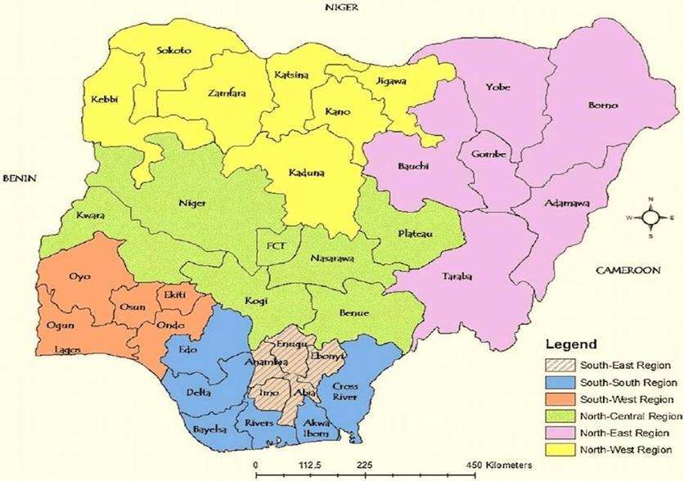
Fig 1: Map of Nigeria showing the States, Regions and the borders

2.2. Socio Political system
Administratively, Nigeria operates a three-tiered federal system of governance comprising Federal, the 36 States and the FCT, and 774 Local Government Areas (LGAs). The LGAs are further divided into 9,565 political wards, which are the focus of PHC revitalization to achieve Universal Health Coverage. For political and administrative purposes, the country is divided into 6 geopolitical zones (North-East, North-West, North Central, South-East, South-West and South-South). These geopolitical zones comprise states with a similar culture, ethnic groups, and common history.

2.3. Ecosystem, environment and climate: the ecological drivers or risk factors of malaria transmission in the country
Nigeria has various ecological zones with vegetation changing from Sahel savannah in the far north followed by Sudan savannah merging into Guinea savannah in the middle belt, then Rain Forest in the south and Mangrove Forest in the coastal areas.
In the northern part of the country, the transmission is highly intense during the short-wet season as compared with the low transmission during the long dry season. In the central and southern parts of the country, the transmission is intense, stable, and uniform throughout the year. The climate varies from arid in the North, with annual rains of 600-1,000 mm lasting for 3-4 months to predominantly humid weather in the South with an annual average of 1,300-1,800 mm (and in some coastal areas up to 2,500 mm) lasting for 9-12 months.
Rainfall is highest in the Northern parts of the country between June and September and from March to November in the Southern parts, which usually coincides with the peak transmission of malaria. The geographic location of Nigeria makes the climate suitable for malaria transmission throughout the country. It is estimated that up to 97 per cent of the country’s population are at risk of getting the disease. The remaining 3 percent of the population who live in the mountains in southern Jos (the Plateau State) at an altitude ranging from 1,200 to 1,400 meters are at relatively low risk for malaria.
2.4. Demographic data: the important disaggregated population groups at risk of malaria
Nigeria is the largest country in Africa with a population of 216,783,381 (National Bureau of Statistics, Demographic Statistical Bulletin 2022). Nigeria has about 374 ethnic groups that are broadly divided into ethnic “majorities” and ethnic “minorities”. The major ethnic groups are the Hausa-Fulani of the north, the Yoruba of the southwest, and the Igbo of the southeast. These ethnic groups speak over 500 different native languages and are identified with a wide variety of cultures. The dependent age groups constitute 50% of the population (disaggregated into 46% for children aged 0 – 14 years and 4% for adults aged 65 years and above). Also, children aged 0-17 constitute more than half (52%) of the population.
The broad base of the population pyramid shows that Nigeria’s population is typical of countries with a low life expectancy and high fertility rates. The average household size is 4.7 persons (disaggregated into 5.0 persons for rural and 4.3 persons for urban households respectively). The majority (82%) of the households are headed by men3. The segments of the population most affected by malaria are the children under-5 and pregnant women who constitute 20% and 5% of the population respectively. The under-5 mortality rate and maternal mortality ratio are 132 per 1,000 live births and 556 per 100,000 live births respectively. According to the World Malaria Report 2024, Nigeria accounts for approximately 31% of global malaria deaths. The country is also responsible for 27% of total malaria cases worldwide. These numbers highlight the significant burden of malaria in Nigeria, with the disease-causing substantial morbidity and mortality, particularly among children under five years old, who account for nearly 40% of global malaria deaths in this age group.
Building on the 2025 Malaria Program Review and consultations, the NMSP 2026–2030 will broaden its focus to additional priority groups whose malaria risk and service access gaps are now better documented. These include Internally Displaced Persons (≈3.3M), prisoners (≈81,400 inmates) , youths in boarding schools and madrassas (≈11M), artisanal mine workers (≈500,000), and an estimated 25M persons with disabilities. Each of these groups faces unique challenges. IDPs experience recurrent ACT and LLIN stockouts in camps. Prisoners show malaria prevalence rates ranging from 15% to over 80% due to overcrowding and poor vector control. Boarding schools and religious institutions face weak malaria oversight, while mine workers are exposed to stagnant water in open pits with limited occupational health protections. People with disabilities remain excluded from campaigns due to lack of adapted protocols. Addressing these disparities will be central to achieving equitable malaria elimination under the NMSP 2026–2030.
2.5. Socioeconomic situation: socioeconomic drivers or risk factors of malaria transmission
According to the 2022 Multidimensional Poverty Index (MPI) conducted by the National Bureau of Statistics (NBS) in collaboration with UN agencies, 63% of Nigerians (about 133 million people) are multidimensionally poor, indicating persistent deprivation across health, education, and living standards. This is a significant increase from the 40.1% (roughly 82.9 million people) identified as purely monetarily poor in the 2019 National Living Standards Survey, underscoring the deepening structural inequality. Life expectancy at birth, a critical indicator of human development, has steadily improved. In 2016, Nigeria’s life expectancy was approximately 53.0 years which was below global standard. By 2022, average life expectancy had risen to 54.08 years, with males at 55.1 years and females at 57.2 years. Recent reports place overall life expectancy around 54.6 years, compared to a global average of 73.3 years.
Communicable diseases (including malaria, HIV/AIDS, and tuberculosis) continue to exert a heavy toll on Nigeria’s population and life expectancy. Health outcomes vary sharply across regions. For instance, under-five mortality rates (U5MR) ranged dramatically from around 59 per 1,000 live births in the South-West to 153 per 1,000 in the North-West according to the 2023–24 NDHS Similarly, antenatal care uptake by skilled providers ranged from just 42% in Zamfara to 96% in Lagos State. Malaria prevalence also exhibited stark regional differences: 38% among children in the North-West versus 12% in the South-East (MIS 2021).
Additionally, factors such as low maternal education, rural residency, and membership in the lowest wealth quintile significantly increase child malaria risk, while children from wealthier households and urban areas fare much better. Insecurity continues to severely disrupt health systems, especially in the Northeast. Ongoing attacks by groups like Boko Haram and ISWAP have displaced millions, destroyed health infrastructure, and made care delivery challenging. This has introduced a new priority around malaria in humanitarian settings.
Malaria transmission is also shaped by poverty and inequality. According to the 2022 Multidimensional Poverty Index, 63% of Nigerians - about 133 million people - are multidimensionally poor. The MPR 2025 highlighted that displacement, gender norms, and disability intersect with poverty to produce stark inequities in malaria outcomes. Rural poor, displaced populations, and informal sector workers face higher exposure and lower access to prevention and treatment services, emphasizing the need for vulnerability-based planning in the NMSP 2026–2030.
2.6. Health system analysis: description of the health system performance in delivering personal and population-based services to those in need & when required
2.6.1 Leadership and Administration
Nigeria’s health system is organized along the three tiers of government, viz., federal, state, and local, which mirrors the country’s political and administrative structure. At the federal level, the Ministry of Health formulates policies, regulates the system, and oversees tertiary and specialized services through teaching hospitals, federal medical centres, specialist hospitals, and research institutes. It also coordinates national health programmes such as malaria, HIV/AIDS, tuberculosis, immunization, and supply chain management, with support from agencies like NPHCDA and NAFDAC.
State governments provide mainly secondary health care through general hospitals and sometimes tertiary care through state-owned teaching hospitals. They also coordinate primary health care through State Primary Health Care Development Agencies and State Health Management Boards. Local governments are responsible for implementing primary health care, working with ward and village health committees, community structures, private providers, and traditional or alternative practitioners to extend services and mobilize communities.
The private sector is extensive, spanning formal providers (hospitals, clinics, pharmacies) and informal actors (NGOs, CBOs, FBOs, and patent medicine vendors). These operate under licenses and complement public services across all levels of care. Health financing is shared across federal and state levels from the federation account, but households remain the main financiers of care through out-of-pocket spending. Health insurance coverage is still limited, reaching mainly civil servants and some rural communities.
2.6.2 NMEP Organizational Structure
The National Malaria Elimination Programme (NMEP), under the Federal Ministry of Health’s Department of Public Health, leads and coordinates Nigeria’s malaria response. Its Coordination Framework strengthens national, state, and local alignment by clarifying roles, and harmonizing partner activities in line with the “Three Ones” principle (One Plan, One Coordination Mechanism, One M&E system).
NMEP operates through six technical branches: Programme Management, ACSM (Advocacy, Communication, and Social Mobilization), IVM (Integrated Vector Management), SMEOR (Surveillance, Monitoring, Evaluation and Operational Research), Case Management, and Procurement Supply chain Management - each headed by a branch head. These feed into the Malaria Technical Working Group (mTWG), which provides technical support and progress monitoring. Stakeholder coordination extends to donors, implementing partners, civil society, commercial actors, and the private sector.
At subnational levels, State Malaria Elimination Programmes (SMEPs) adapt and implement strategies with NMEP alignment, while LGAs are expected to tailor interventions to local needs and drive community engagement.
Nigeria’s malaria efforts face persistent coordination challenges, weak alignment with government structures, limited private sector engagement, and funding shortfalls worsened by post-COVID economic strain and donor programme closures. Stronger government leadership is vital to drive the National Malaria Strategic Plan forward. To address these persistent challenges, there is an ongoing engagement between the malaria community and the government leadership with respect to restructuring the NMEP to enhance its autonomy and strengthen its technical capabilities.
Despite these reforms, humanitarian actors continue to deliver malaria services in IDP camps, while refugees and migrants rely on UNHCR and NGO services rather than BHCPF or NHIA mechanisms. Prisons, mining communities, and PWDs remain outside routine malaria reporting systems, to a large extent. To close these gaps, the NMSP 2026–2030 will commit to equity-disaggregated monitoring and inclusive programmatic models that link humanitarian, correctional, and occupational health sectors to the national malaria response.

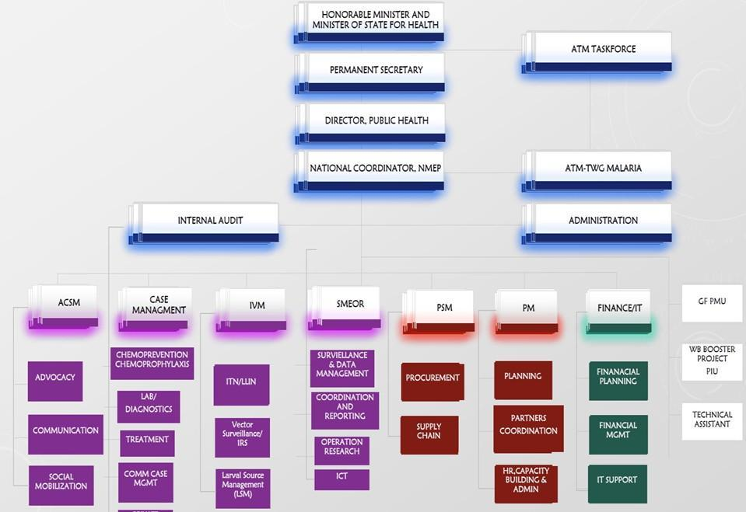
Fig 2: Organogram of NMEP
2.6.3 Policy and Legislative Framework
The National Health Policy 2016 and National Health Act, 2014 prioritize the provision of a comprehensive health care package that is based on Primary Health Care (PHC) to achieve universal health coverage (UHC). The FMOH has launched a ‘Reach Every Ward’ strategy which aims to have at least one functional PHC in each political ward for the delivery of the Basic Minimum Package of Health Services including malaria. The strategy also advocates community participation to facilitate ownership and accountability through the establishment of the Ward Development Committee (WDC) comprising selected community members.

2.6.4 Health Workforce
Skilled health workers, including doctors, nurses, and midwives predominantly provide care across tertiary, secondary, and primary health care (PHC) facilities. At the community level, health services are delivered by Community Health Extension Workers (CHEWs), who are mandated to spend at least 60% of their time within communities, complemented by various cadres of Volunteer Health Workers (VHWs). However, these VHWs are currently engaged through fragmented programmes with inconsistent standards and incentive structures.
To address this fragmentation and strengthen community-level service delivery, the National Primary Health Care Development Agency (NPHCDA) established the Community Health Influencers, Promoters and Services (CHIPS) programme. The CHIPS strategy was introduced to transition all existing community-based workers from phasing-out programmes into a unified national platform, thereby ensuring one curriculum, one training programme, and one standardized cadre of community-based health workers – collectively referred to as CHIPS Personnel. This cadre consists of CHIPS Agents and Community Engagement Focal Persons (CEFPs). However, the CHIPS programme had challenges and gaps which necessitated the transition to a new initiative called the Community Based Health Workers Programme (CBHWP). This model balances the need for skilled service provision with the realities of workforce availability and state-level resource constraints.
For the CBHWP, it is recommended that the minimum number of CBHWs to be deployed per ward should be ten (10). States are at liberty to determine the proportion of JCHEW to Assistant Community-based Health Workers required based on empirical evidence of availability of the JCHEWs and state capacity. However, the two cadres of CBHWs are expected to work in tandem within the wards, with JCHEWs prioritized for deployment to hard-to-reach (HTR) /underserved communities.
CBHWs will be deployed to households to provide health counselling, create demand for essential services, and refer clients to PHC facilities. They also deliver basic preventive services, first aid, and case management for malaria, diarrhoea, and pneumonia in children under five, thereby extending access to care and improving health-seeking behaviour at community and facility levels.
The CBHWP is anchored on the functionality of PHC facilities in each ward, which serves as referral hubs, supervisory bases, and commodity distribution points. Ensuring a minimum of one functional PHC per ward, as prioritized under the NPHCDA Strategic Blueprint (2024–2026), is therefore critical to the programme’s success. Together, these measures aim to professionalize community health delivery, improve competence, expand access, and restore public trust in the PHC system.
2.6.5 Health Product Management
Nigeria has put in place several policies, guidelines, and institutions to ensure the sustainable supply of safe, high-quality, and affordable medicines, vaccines, and other health products. A key institution in this regard is the National Agency for Food and Drug Administration and Control (NAFDAC), which regulates and controls the manufacture, importation, exportation, distribution, advertisement, sale, and use of regulated products including food, medicines, cosmetics, medical devices, packaged water, chemicals, and detergents.
To strengthen supply chain integration across public health programmes, the Government of Nigeria, with support from the Global Fund, established the National Product Supply Chain Management Programme (NPSCMP). The programme coordinates national efforts on the quantification, procurement, warehousing, and distribution of health commodities, under the oversight of the Department of Food and Drug Services (DFDS) of the Federal Ministry of Health and Social Welfare (FMoHSW). At the sub-national level, supply chain activities are coordinated through State Logistics Management Coordination Units (LMCUs), which now operate in all 36 states and the Federal Capital Territory. These units serve as the focal point for planning, monitoring, and coordination of health commodity logistics at state level, ensuring alignment with national systems.
In recent years, Nigeria has advanced further through the Nigeria Supply Chain Integration Project (NSCIP), which introduced end-to-end data visibility systems (such as the National Health Logistics Management Information System, NHLMIS), harmonized standard operating procedures (SOPs), and strengthened governance frameworks to improve efficiency and accountability. A major institutional milestone is the creation of the Supply Chain Operations Unit (SCOU) under the NPSCMP, supported by the Global Fund’s Resilient and Sustainable Systems for Health (RSSH) grant (2024–2026). The SCOU functions as the national lead logistics management unit, providing oversight for warehousing, distribution, and performance monitoring, while also building state-level capacity for sustainable supply chain operations.
Together, these reforms mark a transition from fragmented logistics arrangements to a more integrated, professionalized, and accountable health product supply chain, aimed at ensuring uninterrupted access to essential health products at service delivery points nationwide.
2.6.6 Health Information System
The Revised Health Information System (HIS) Policy (2014) and accompanying HIS Strategic Plan (2014–2018) continue to set the structural framework for how health-related data is collected, collated, analyzed, stored, disseminated, and used across the health sector. At the heart of routine data collection is District Health Information Software 2 (DHIS2), which remains the nationally recommended electronic platform for reporting from both public and private primary and secondary health facilities. Oversight and capacity-building responsibilities for the HIS rest with the Department of Planning, Research, and Statistics (DPRS) within the Federal Ministry of Health and Social Welfare (FMoHSW).
To ensure strategic use of data for decision-making, governance is embedded through the Health Data Governance Council (HDGC), chaired by the Honourable Coordinating Minister of Health, and its operational counterpart, the Health Data Consultative Committee (HDCC). These bodies are replicated at the state and LGA levels to ensure coordinated oversight and responsiveness across all jurisdictional tiers. Since 2019, integration efforts have extended to other program-specific platforms like the National Health Workforce Registry (NHWR), bringing them under the unified governance of HDGC-HDCC. This approach has promoted sustainability and prevented the proliferation of fragmented systems.
In 2020, the National Malaria Elimination Programme (NMEP) officially established the National Malaria Data Repository (NMDR) as a complementary digital system to DHIS2. The NMDR consolidates malaria-specific data - including routine health facility data, surveillance reports, survey findings, and partner data into a centralized repository. This initiative was developed to enhance malaria data harmonization, improve data quality, facilitate real-time analytics, and support evidence-based planning and response in malaria control efforts.
2.6.7 Health Care and Malaria Financing
Approximately 10% of malaria programme funding is sourced from the government, primarily through health sector budgetary allocations across the three tiers of government, viz. federal, state, and local. These allocations are drawn from the country's oil and tax revenues. However, given the broader context of chronic underfunding in the health sector, this contribution remains grossly inadequate to meet the scale of malaria prevention and control needs.
In the last five years, direct allocations to the malaria programme consistently remained below 1% of the total health budget. However, considering that the National budget as well as the health sector component progressively increased during this period, these allocations to the malaria programme surpassed the 25% annual increase targeted in the National Malaria Strategic Plan-NMSP 2021-2025 (Improve funding for malaria control by at least 25% annually through predictable and innovative sources to ensure sustainability at federal and sub-national levels).
In addition to the annual budgetary allocations to the Ministry of Health, malaria service delivery in Nigeria also receives government funding through various special schemes, programmes, and agencies. These funding streams include:
1. The Basic Health Care Provision Fund (BHCPF)
The Basic Health Care Provision Fund (BHCPF) was established under Section 11 of the National Health Act of 2014 as a catalytic funding mechanism to strengthen Nigeria’s primary healthcare system. It is implemented through three main gateways:
- The National Primary Health Care Development Agency (NPHCDA) Gateway
- The National Health Insurance Authority (NHIA) Gateway, and
- The Emergency Medical Treatment Gateway under the National Emergency Medical Services and Ambulance System (NEMSAS).
The Basic Health Care Provision Fund (BHCPF) is financed from the following sources:
a). A statutory annual grant of at least 1% of the Consolidated Revenue Fund (CRF) from the Federal Government
b). Funding support and Grants from international donor partners
c). Contributions from other sources, including the private sector.
Malaria programme delivery is supported through the BHCPF in two primary ways:
• 35% of programmatic funds under the NPHCDA Gateway are allocated to Decentralized Facility Funding, which covers essential drugs, vaccines, and consumables (20%)
• The NHIA Gateway channels funds to State Social Health Insurance Agencies (SSHIA), enabling access to the basic minimum package of services, including malaria-related interventions for vulnerable populations.
The mid-year CRF values for 2021, 2022, and 2023 were ₦134.8 billion, ₦105.33 billion, and ₦252.5 billion respectively. This translates to an average of approximately ₦1.64 billion per month, distributed among the 36 states.
2. The National Health Insurance Authority (NHIA)
Previously known as the National Health Insurance Scheme (NHIS), the National Health Insurance Authority (NHIA) serves as a key health financing mechanism aimed at achieving Universal Health Coverage (UHC) for essential health services, including malaria-related interventions. Malaria case management, comprising diagnosis and treatment, is a core component of the benefit package under both the formal and informal sector schemes administered by NHIA. However, enrolment across the country remains low, currently below 5%, with coverage predominantly concentrated in the formal employment sector. To address this gap, the government has made significant efforts to expand access. Between 2020 and 2024, the number of enrollees increased from approximately 10 million to over 19 million. Additionally, several states have established their own health insurance schemes to broaden coverage, particularly among the informal sector and vulnerable populations.

3. Credit Facility Funding and Projects
In 2020, Nigeria secured a total of USD 300 million in funding for malaria control through the Immunization Plus and Malaria Progress by Accelerating Coverage and Transforming Services (IMPACT) Project. This included USD 200 million from the World Bank and USD 100 million from the Islamic Development Bank (IsDB) via the Lives and Livelihoods Fund. The credit facility, set for an initial period of five years, aims to support malaria service delivery in 11 states that previously lacked significant donor support. The project incorporates counterpart funding mechanisms with the benefiting states and focuses on core malaria prevention and case management interventions. Its primary objective is to enhance child survival and reduce under-five mortality through improved access to life-saving malaria services. Analysis of the funding showed that about 70% of the financing was for procurement and distribution of malaria case management and vector control interventions (ITNs).
The WB/ISDB project effectively took off in 2022 across most of the beneficiary states. However, bureaucratic delays affected the procurement and distribution of commodities such as ITNs for routine use, ACTs and diagnostic test kits to the health facilities.

Trends of Financial Contributions to Malaria from Other Government Ministries and Agencies
Additional government support for malaria includes drug revolving funds (mostly at secondary and tertiary health facilities, although plagued with issues of poor supervision and accountability), and state-level initiatives such as Reproductive, Maternal, Newborn, and Child Health (RMNCH) programmes, free medical outreach services by Federal and State Ministries of Health, and special allocations for malaria response in emergencies and among internally displaced persons (IDPs). However, financial contributions from other government agencies remain difficult to track and assess due to a lack of comprehensive data.
State-level reports indicate substantial extra-budgetary spending on malaria, particularly for interventions like mass distribution of Insecticide Treated Nets (ITNs) and Seasonal Malaria Chemoprevention (SMC). Moreover, several malaria-related activities funded by other Ministries, Departments, and Agencies (MDAs) are not systematically reflected in official annual plans. These gaps, compounded by weak budget tracking mechanisms, make it challenging to accurately determine the actual level of government spending on malaria. As a result, actual expenditures may exceed the figures reported in the national health accounts.

Chapter Three

Malaria Situation Analysis

3. Situation Analysis
3.1 Historical Perspective
Malaria remains a major global health challenge and it is recognized as an impediment to socioeconomic development. It was prioritized under the Millennium Development Goals (MDGs) and it is also embedded in the Sustainable Development Goals (SDGs), with a global commitment to “end the epidemics of AIDS, tuberculosis, malaria and neglected tropical diseases” by 2030. Although significant progress was made during the MDG era, recent gains have stalled. According to the World Malaria Report (WMR) 2024, there were an estimated 263 million cases and 597,000 deaths globally in 2023, with the WHO African Region accounting for about 94-95% of the burden. Progress since 2015 has been modest and falls short of global targets.
Insecticide-treated nets (ITNs) remain central to prevention, with billions of nets distributed, mostly in sub-Saharan Africa, and steady improvements in household coverage has been recorded. However, over 3 billion people remain at risk, and challenges such as resistance, climate change, humanitarian crises, and funding gaps threaten further progress.
Nigeria bears the highest share of the global malaria burden and has implemented successive National Malaria Strategic Plans (2001-2005, 2006-2010, 2009-2013, 2014-2020, and 2021-2025) to scale up interventions and reduce prevalence and mortality. While earlier strategies focused on expanding access, recent plans have emphasized measurable impact. Moving into 2026-2030, Nigeria will align its malaria response with the WHO Global Technical Strategy (GTS) for Malaria 2016-2030, strengthen political and financial commitment, and scale up innovative tools such as next-generation ITNs and malaria vaccines. Building on lessons from previous strategic plans, the country will implement a strengthened, stratified, and data-driven approach tailored to varying transmission patterns across the various states to accelerate progress towards malaria elimination.

3.2 Epidemiology
3.2.1 Malaria Parasites Distribution
Malaria is endemic in Nigeria with all year transmission. Plasmodium falciparum accounts for 97% (94% - 98%) of the parasite species. It is the most virulent of the malaria parasite species and responsible for most reported severe cases. Plasmodium malariae accounts for almost 2% of infections, while Plasmodium ovale is rare, accounting for approximately 0.2% of all infections. Five parasite species of Plasmodium have been documented to cause malaria disease in humans. These include Plasmodium falciparum (P.f), Plasmodium vivax (P.v), Plasmodium ovale (P.o), Plasmodium malariae (P.m), Plasmodium knowlesi (P.k).
National surveys show that parasite prevalence among children under five declined from 42% in 2010 to 22.6% by microscopy (36.2% by RDT) in 2018. Yet inequities persist - prevalence is nearly five times higher among the poorest households (57%) compared to the richest (11%), and rural prevalence remains disproportionately higher than urban. These disparities highlight how poverty and geography intersect with vulnerability to sustain malaria burden in Nigeria.

3.2.2 Malaria Vector Distribution
Historically, 30 Anopheles species have been reported in Nigeria, but recent surveillance across the five ecological zones has confirmed 11 species, with An. coluzzii, An. gambiae, An. arabiensis, and An. funestus being the predominant malaria vectors. Species distribution varies geographically and seasonally, with An. coluzzii becoming more widespread post-2023 insecticide-treated net (ITN) campaigns. Although An. stephensi was confirmed in Gombe in 2022, follow-up surveillance across seven states has not detected its continued presence. Notably, the recent detection of An. stephensi in neighbouring Niger Republic is of significant concern.
There is evidence of species switching between wet and dry seasons, complicating malaria control and elimination efforts. From 2018 to 2019, An. gambiae s.l. remained the most abundant vector. Surveillance data from 2020 to 2024 revealed fluctuating entomological inoculation rates (EIR), with the highest indoor EIR recorded in Kano (580.85 ib/p/y in 2021). Indoor transmission initially dominated but has since declined due to effective ITN campaigns, while outdoor transmission has increased, indicating a shift in mosquito behaviour. In 2024, the national average EIR is 9.38 ib/p/y, which is far from the national target of <1 ib/p/y. This dynamic change necessitates a strategic shift from focusing primarily on indoor interventions to both indoor and outdoor interventions.

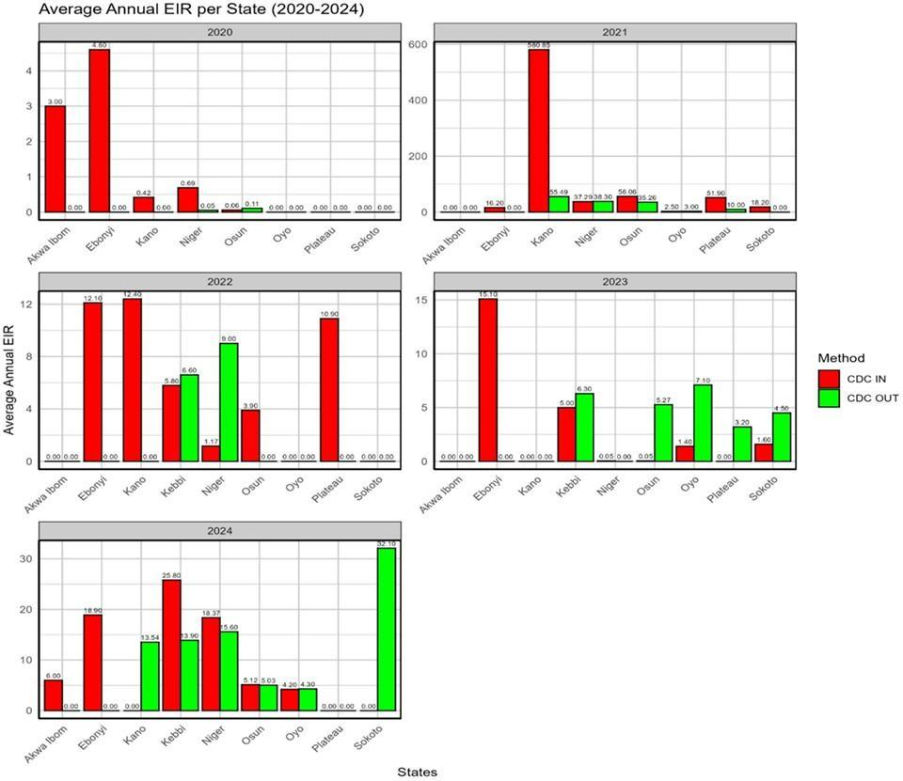
Fig 3: Annual Entomological Inoculation Rate (EIR)

3.2.3 Dynamics of Malaria Transmission
Malaria transmission remains widespread across the country, with particularly higher intensity in rural areas and communities located near major rivers and water bodies, including irrigation dams in the northern regions. Rainfall patterns strongly influence malaria transmission. In the Mangrove and Rainforest zones, rainfall occurs year-round, while the Guinea and Sudan savannahs experience two peaks of rainfall - typically starting in March or April, pausing in August, and resuming until October. In the Sahel savannah, rainfall usually begins in June or July and lasts for about three to four months. In most ecological zones, the timing of malaria transmission closely aligns with these rainfall patterns.
3.2.4 Morbidity and mortality
Over the past fifteen years, Nigeria has recorded a sustained decline in malaria prevalence, reaching 15% in 2025. This demonstrates measurable progress in reducing the national malaria burden and reflects the cumulative impact of scaled-up interventions. During the same period, all-cause under-five mortality declined from 132 per 1,000 live births in 2018 to 110 in 2024 (a 16.6% reduction). However, this improvement likely reflects broader health system and socio-economic gains, not necessarily malaria interventions alone.
Despite national progress, transmission dynamics are increasingly heterogeneous at the subnational level. Remarkably, some previously high-burden states have achieved substantial reductions, and there are currently no states classified as high-burden in the country. However, some states have stagnated, and others have experienced reversals. This divergence highlights persistent disparities across states and a shift from relatively uniform high transmission to more localized and varied patterns. Please see figures 4-6 below.
Overall, national progress towards malaria elimination remains mixed. Therefore, to consolidate gains and accelerate impact, Nigeria must strengthen surveillance, apply targeted and data-driven strategies, and tailor interventions to state-specific transmission profiles while addressing contextual drivers of transmission at the national and subnational levels.
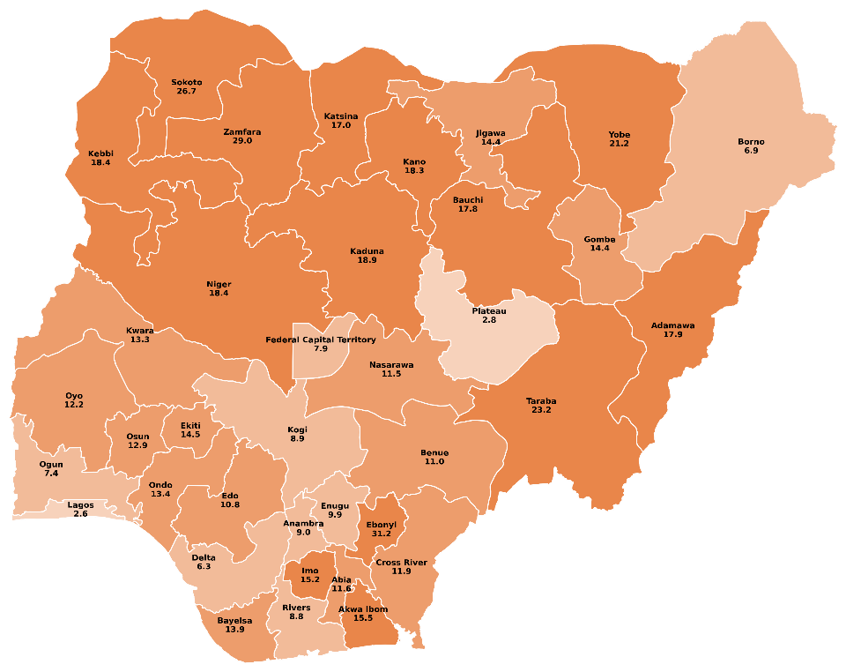
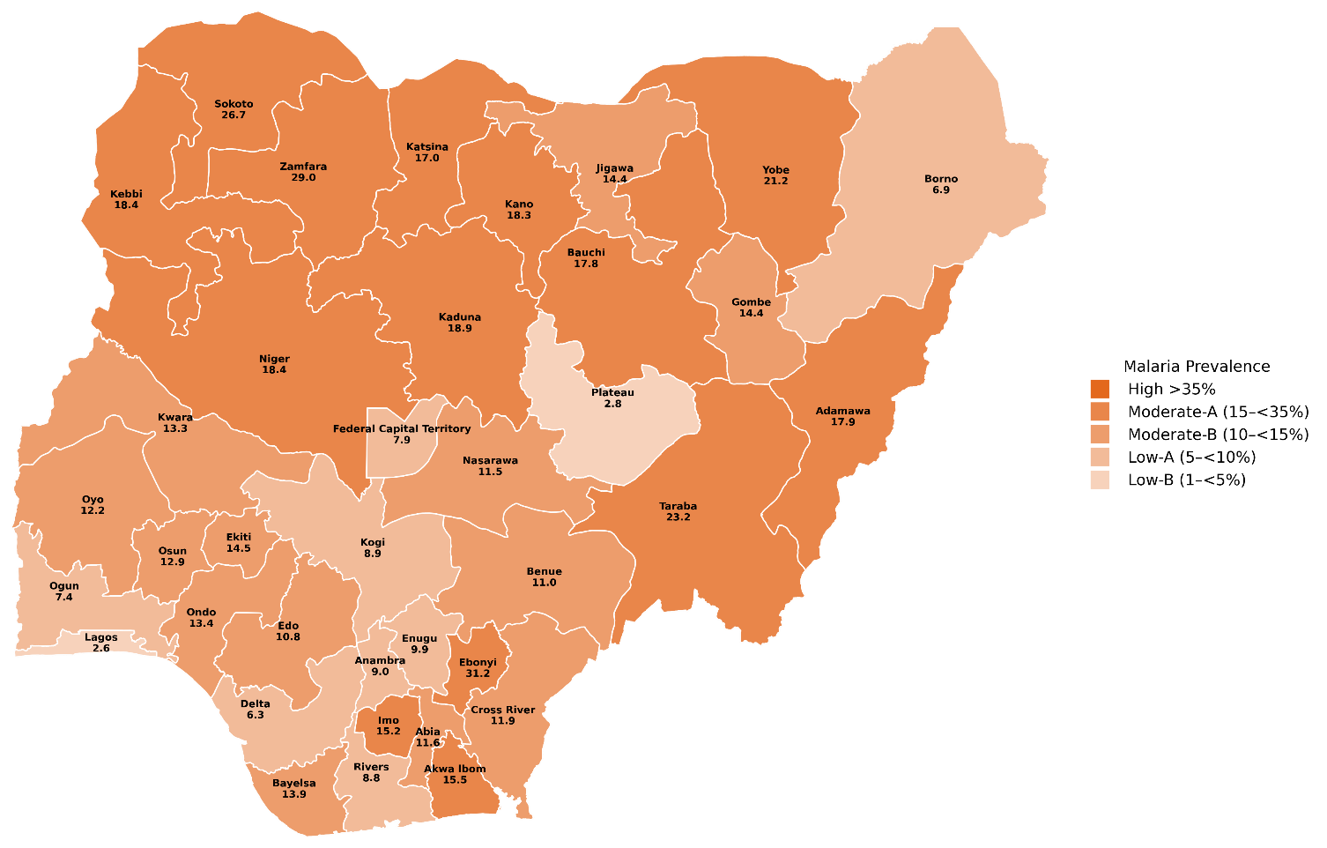

Source: MIS 2025
Country-specific Transmission Intensity Banding

(Courtesy: NMEP/MACEPA)

Fig 4: Malaria Prevalence by States

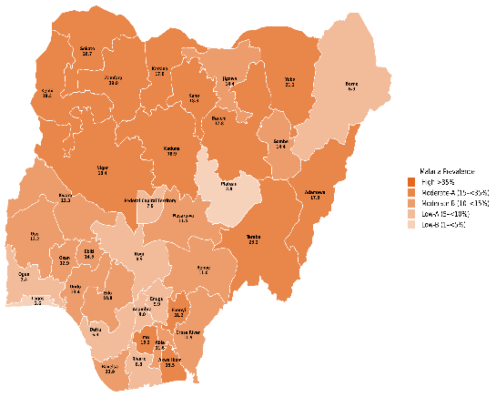
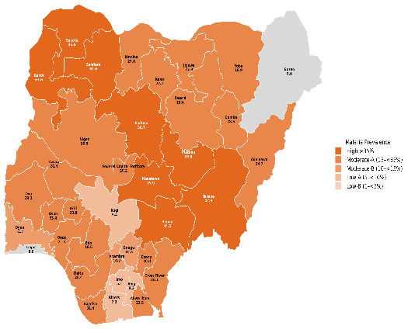
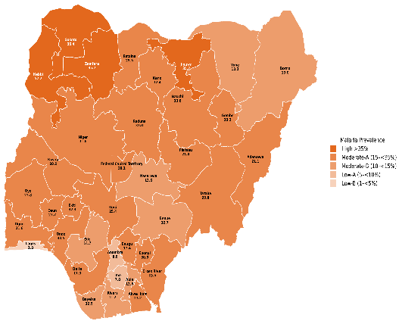
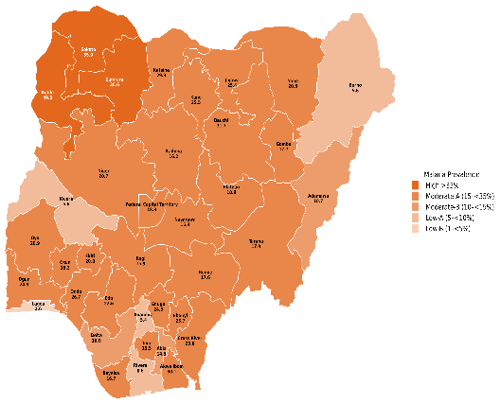
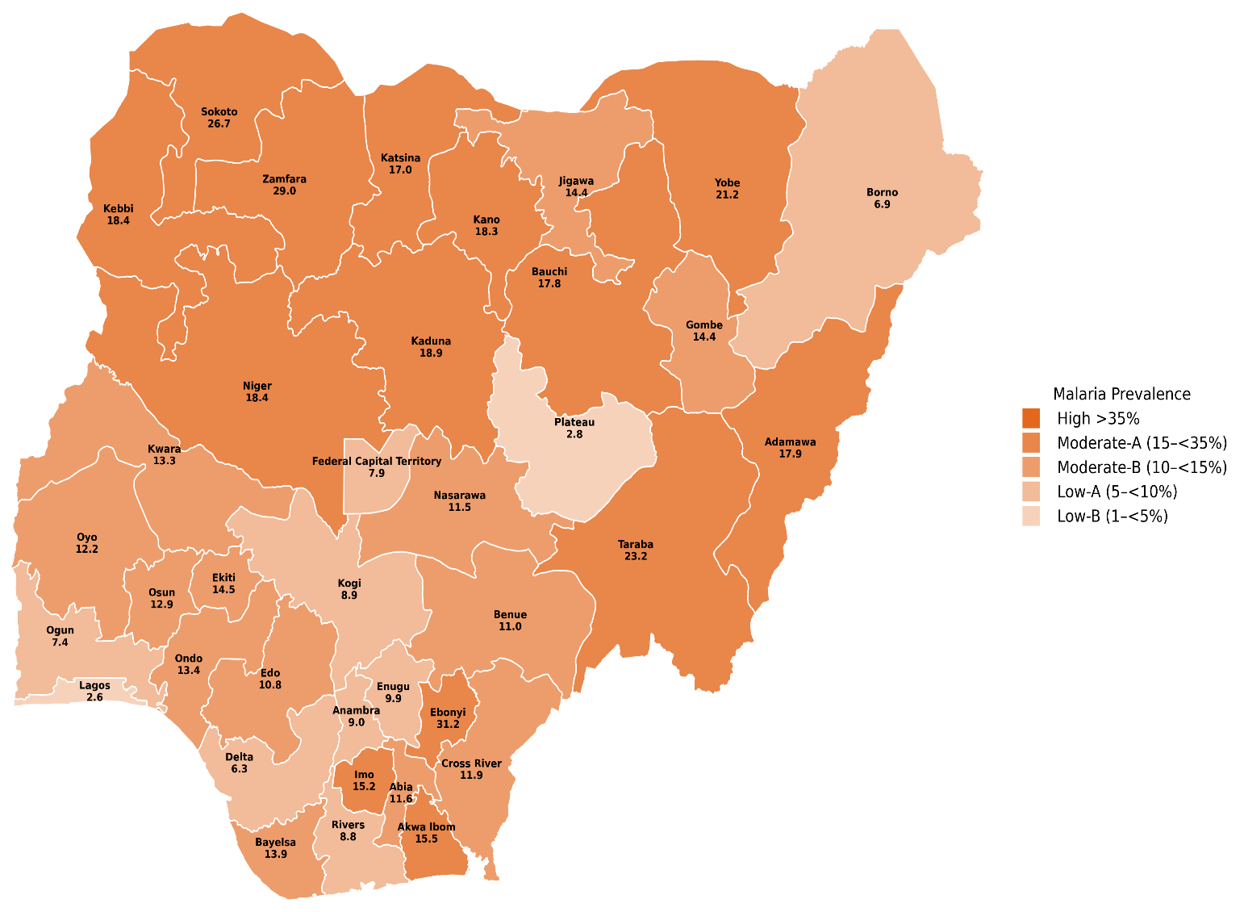

2015
2018
2021
Source: MIS 2015
Source: MIS 2021
Source: NDHS 2018
2025
Source: MIS 2025

(Courtesy: NMEP/MACEPA)
Fig 5: Trends in Malaria Prevalence (2010 - 2025)
Data Souces: National Surveys

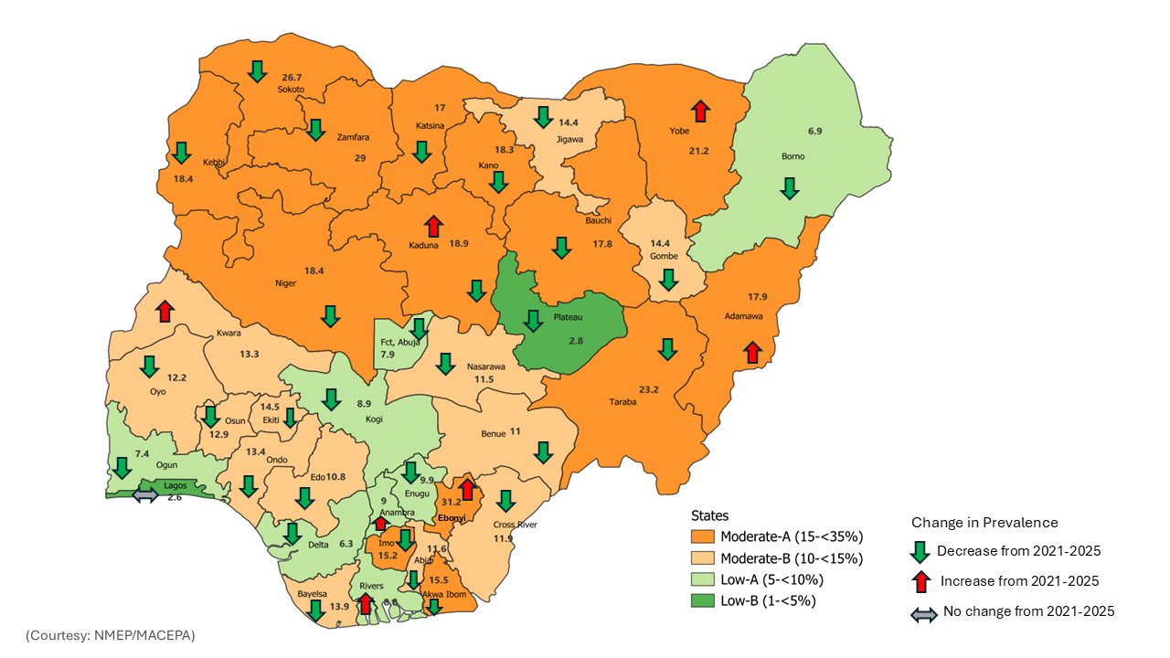

Source: MIS 2025

Fig 6: Dynamic Changes in Malaria Prevalence

3.2.5 Malaria Stratification and Intervention Mixes
In 2019, Nigeria shifted from uniform strategies towards targeting interventions by subnational malaria epidemiology. This stratification process helps the malaria programme to classify different parts of the country in accordance with the heterogeneous transmission intensity, epidemiological patterns, and other contextual influences. Consequently, appropriate intervention mixes are deployed based on these classifications.
Core interventions are deployed across all areas, ensuring that every LGA receives effective diagnosis and treatment tools, IPTp, and distribution of appropriate ITNs. Other interventions such as SMC are implemented in eligible states with highly seasonal transmission patterns, PMC implemented in states with perennial transmission patterns, while the Malaria vaccine has been rolled out, initially targeting Kebbi and Bayelsa states.
Subsequently, urban micro-stratification at the ward level will inform urban-specific interventions, leveraging a mix of epidemiological, entomological, and environmental parameters to map malaria risk at the smallest urban administrative units for the purpose of tailoring interventions accordingly. This approach recognizes that informal settlements, slums, and urban farms face higher localized transmission risk compared to planned neighbourhoods, largely due to the preponderance of mosquito breeding habitats in these settings.
In the last five years, Nigeria implemented the targeted intervention mixes across the states and LGAs, and there has been a clear demonstration of value in using the SNT tool for strategic planning and prioritization. However, there were instances of non-adherence to the SNT recommendations. For instance, 40 LGAs across the country were shown to be implementing SMC even though SMC was not recommended in such LGAs. Conversely, some hard-to-reach LGAs where iCCM was recommended did not implement iCCM during the period under review. A gap that needs to be addressed in subsequent planning cycles, is the need to deliberately align the next NMSP with AOP tools to enable states and all implementers to use the principles of SNT in designing their AOPs. This approach ensures that each state’s AOP (and each partner’s AOP) prioritizes interventions based on the recommended intervention mixes for the states and LGAs. This also helps to allocate resources efficiently and implement these interventions more effectively.
It is expected that the current SNT implementation experience and analysis of additional contextual perspectives from the various states, will be used to further strengthen the SNT process and optimize the SNT tool for future strategic planning cycles. The data-informed SNT approach illustrates the mechanism for decentralizing and appropriately targeting evidence-based interventions.

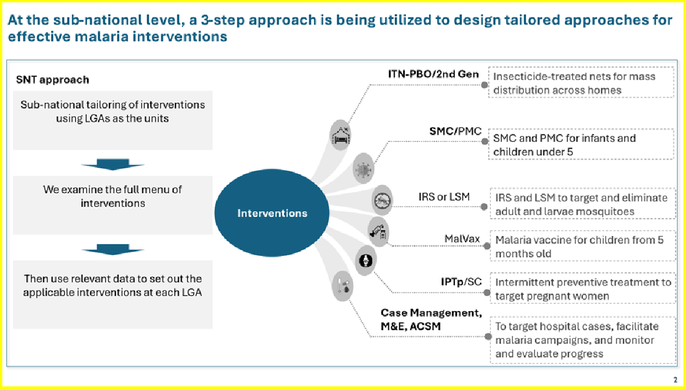

Fig 7: SNT process for delivering sub-nationally targeted malaria interventions.
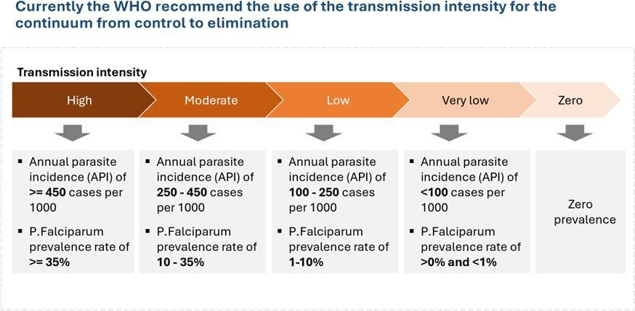

Fig 8: WHO transmission intensity continuum

3.3 Review of previous MSP
NMEP in collaboration with Partners commissioned an MPR with a Stakeholders Consensus meeting in February 2025. The MPR aimed to appraise the country’s malaria situation and programme performance to strengthen the programme for better results and impact. The 2025 Nigeria MPR had five objectives built around the five MPR questions:
- To assess the progress made by the programme towards the epidemiological and entomological impact targets of the NMSP 2021-2025, during the period under review
- To review the level of financing of the national malaria programme during the period under review and make appropriate recommendations towards optimal financing
- To review the capacity of the national malaria control programme to implement planned activities during the period under review and make appropriate recommendations towards optimal capacity for programme implementation
- To review the attainment of programme outcome targets during the period under review and make appropriate recommendations for optimal delivery of malaria service
- To define the programming implications of the lessons learned in the implementation of the MSP.

The key questions answered during the MPR include the following:
- Was the planned impact of the MSP attained? How can the impact on malaria burden be enhanced as we move forward?
- Was the financing of the programme optimal? How can programme financing be optimized?
- Was the capacity of the programme to implement planned activities optimal? How can this capacity be further strengthened?
- Were required malaria services delivered optimally to those who needed them? How can malaria service delivery be further enhanced?
- What lessons have been learned in the implementation of the MSP? What are the future programming implications of the lessons?
Key findings of the MPR, 2025 are presented below:
3.3.1 Goal Level Achievement
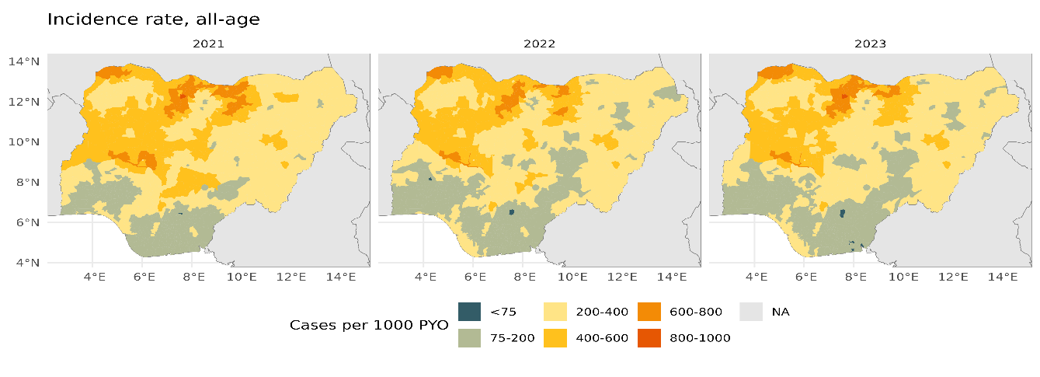
Fig 9: Trends of annual incidence rate, all-ages, per 1000.

The Malaria Programme Review (MPR) revealed mixed progress in malaria control across the country. While malaria prevalence among children under five declined modestly to 15% by 2025, it remains above the national target of less than 10% by 2025. Furthermore, the estimated annual parasite incidence has remained stagnant between 2022 and 2024 (World Malaria Report), reflecting limited recent progress. These findings underscore the urgent need for intensified, state-specific interventions and renewed efforts to accelerate progress, particularly in states where gains have stagnated or reversed.
All-cause under-5 mortality reduced from 132 per 1,000 live births in 2018 to 110 in 2024 (NDHS 2023-2024), which shows a 16.6% drop, but still far from the 2025 target of 56. This decline likely reflects multiple health and socio-economic improvements, and not only malaria response.
Rapid Impact Assessment (RIA 2025) showed a fluctuating malaria incidence trend. There was an estimated 12% decrease in malaria incidence in 2023, followed by a 16.6% rebound increase in 2024, indicating challenges in sustained malaria elimination efforts.

3.3.2 Financing the MSP
Between 2021 and 2025, Nigeria’s national budget grew significantly from ₦13.08 trillion to ₦54.99 trillion, while health sector allocations rose from ₦547.13 billion to ₦2.48 trillion. Despite this increase, the percentage of the national budget allocated to health remained between 4% and 5%, far below the 15% benchmark set by the 2001 Abuja Declaration.
During this period, the government direct allocations to the malaria programme remained below 1% of the health budget. However, there were indirect malaria funding through government initiatives such as the Basic Health Care Provision Fund (BHCPF), National Health Insurance Agency (NHIA), Reproductive, Maternal, Newborn and Child Health (RMNCH) programmes, and the IMPACT project.

3.3.3 Objective Level Achievement and Capacity to Implement Planned Activities
Using an Excel-based ‘NMSP technical and financial performance rating tool’, the assessment of the capacity of NMEP to implement planned activities under each strategy was conducted to determine the overall performance rate by activity based on both quantitative and qualitative dimensions. The five strategic objectives of NMSP 2021-2025 were implemented to varying degrees with an overall implementation rate of 62%.
Table 1: Capacity to Implement Planned Activities
MSP  Objectives | Description | 2021 | 2022 | 2023 |  | 2024 - 202  5 |  | Average Performance | Overall Rating
Objective 1 | Improve access and utilization of vector control interventions to at least 80% of the targeted population by 2025. | 45% | 67% | 63% |  | 82% |  | 64% | Low
Objective 2 | Ensure provision of chemoprevention, diagnosis, and appropriate treatment for 80% of the target populations at risk by 2025. | 60% | 57% | 83% |  | 77% |  | 69% | Low
Objective 3 | Improve generation of evidence for decision making and impact through reporting of quality malaria data and information from at least 80% of health facilities (public and private) and other data sources including surveillance, surveys, and operations research by 2025. | 38% | 71% | 81% |  | 66% |  | 64% | Low
Objective 4 | Strengthen coordination, collaboration, and strategic partnership to promote efficiency and effectiveness of malaria control activities towards achieving at least 75% improvement from baseline using a standardized OCA tool. | 63% | 56% | 50% | 70% |  | 60% |  |  | Low
Objective 5 | Improve funding for malaria control by at least 25% annually through predictable and innovative sources to ensure sustainability at federal and  sub-national levels. | 40% | 69% | 52% | 55% |  | 54% |  |  | Low
Overall Rating |  |  |  |  |  |  |  | 62% |  | Low

From the table above, the overall NMEP capacity to implement its planned objectives was 62% in the period under review (2021 -2025). Performance by objectives reveals that Objective 2 recorded the highest performance at 69%, followed by Objective 3 at 64%. The lowest performance was recorded in Objective 5 at 54%. However, all the 5 objectives scored below 75%, indicating a low performance rating, according to the WHO MPR Guide (High if score is >90%: Moderate if between 75% - 90%; and low if <75%).
Further analysis reveals that the overall capacity of the programme in coordination, collaboration, and financial resource mobilization remains consistently low, posing a critical challenge to the effective delivery of malaria interventions. Objective 4, which aims to strengthen coordination, strategic partnerships, and collaboration to improve programme efficiency, recorded an average performance of 60% over the review period (2021–2025). Despite a slight improvement in 2024/2025 (70%), performance levels remained low all through the period under review, indicating insufficient progress in institutional and inter-sectoral coordination mechanisms.
Similarly, programme performance for objective 5, which focuses on improving malaria funding by at least 25% annually through predictable and innovative sources, averaged 54% for the period under review, with performance peaking in 2022 at 69% but subsequently declining to 55% in 2024/2025. This declining trend underscores the limited availability of sustainable and predictable financing for malaria activities, especially at the subnational level, where reliance on external funding persists and domestic resource mobilization remains weak.
The persistently low ratings for both objectives suggest that while national-level frameworks and tools such as the Domestic Resource Mobilization Framework and the End Malaria Council have been established, their full operationalization and impact have not materialized across states and local government levels. Furthermore, weak capacity for financial tracking, inconsistent advocacy engagement, inadequate partner coordination, and staffing limitations have further constrained progress in achieving the set targets.
In essence, the programme’s capacity to coordinate effectively and mobilize the financial resources necessary for malaria control remains inadequate, limiting the broader system’s ability to accelerate implementation of the National Malaria Strategic Plan (NMSP). However, the current efforts by the Ministry to coordinate malaria funding centrally through the National Health Sector Renewal Investment Initiative (NHSRII), and the Sector-wide approach (SWAp), that aligns federal, state, and local government efforts with support from development partners, provides a strong opportunity to increase funding through more sustainable and predictable sources that should accelerate availability of funds to drive the malaria elimination agenda of government.

3.3.4 Key Achievements on the Delivery of Malaria Service (2021–2025)

Vector Control
- Between 2021-2025, 42% of the targeted number of ITNs were distributed through mass campaigns. There was a considerable rise in household ITN ownership from 8% in 2008 to 59% in 2024. However, coverage remains suboptimal, with only 32% of households owning one ITN for every two people, and a decline in ITN use among pregnant women from 50% to 46%. The ITN use rate is 80% in urban areas and 87% in rural areas, with significant state variations. Widespread insecticide resistance reduces the effectiveness of ITNs
- IRS has not been prioritized in Nigeria; it was conducted in only Borno state in IDP camps
- Larviciding as a component of Larval Source Management was conducted in 3 targeted sites within 3 states. Evidence from the pilot would inform scale up
- The country has expanded malaria surveillance to 30 states and deployed next-generation ITNs with dual active ingredients. These were guided by robust monitoring and evaluation efforts which continue to inform malaria elimination strategies across the country.

Chemoprevention
- Seasonal Malaria Chemoprevention (SMC) was scaled up from 9 to 21 eligible states, and delivered using innovative integrated approaches, reaching about 28 million children aged 3-59 months.
- Intermittent Preventive Treatment in Pregnancy (IPTp) has had low uptake over the years, with only 27% (NDHS 2024) of pregnant women receiving three or more doses of SP. Key challenges include frequent sulfadoxine-pyrimethamine (SP) stock outs, low ANC attendance, and poor adherence to the Directly Observed Therapy (DOT) approach.
- Perennial Malaria Chemoprevention (PMC) and Intermittent Preventive Treatment of school-aged children (IPTsc) have had successful pilots, with scale-up planned based on lessons learned.

Malaria Vaccine
- In 2024, Nigeria commenced the delivery of malaria vaccine R21, integrated into the routine national immunization programme.
- A phased rollout was initiated in Bayelsa and Kebbi States, where over 58,000 children were vaccinated in the first year, achieving 25% of the annual MV1 target. This initial low vaccination coverage rates in the two states highlight the need for strengthened supply chains, improved service delivery, and targeted community engagement to enhance uptake and sustain progress.
- There is weak coordination between NMEP and NPHCDA in the malaria vaccine implementation and monitoring, leading to missed opportunities to leveraging existing malaria community mobilization systems for SMC and ITN.
- There is ongoing coordination between NMEP and NPHCDA in the implementation and monitoring of the malaria vaccine, though the collaboration remains suboptimal
- Existing platforms for malaria community engagement, such as those used for SMC and ITN distribution, can be utilized for promoting malaria vaccine uptake.

Case Management
- Over the last 5 years, Malaria diagnosis and treatment, (as well as chemoprevention) were the highest performing interventions with an implementation rate of 80% and an overall average performance of 69.1%
- Investment in laboratory capacity strengthening and improved RDT availability yielded good results
- Integrated Community Case Management of Malaria (iCCM) has been integrated through the community health programme and is gradually being scaled up, expanding access to lifesaving interventions in hard-to-reach communities
- Therapeutic Efficacy Studies 2021-2023 showed >98% efficacy of all four anti-malarial treatments (AL, ASAQ, DHP and Pyramax) used in Nigeria
- The country commissioned the use of Rectal Artesunate Suppositories (RAS) for the pre-referral treatment of severe malaria in select states. five states. This pilot phase generated critical operational evidence to support a nationwide adoption of RAS
- Slight improvement in malaria diagnostic accuracy, with the Test Positivity Rate (TPR) declining from 76% in 2021 to 73% in 2024. This suggests gradual progress in improving testing practices and reducing overdiagnosis, though further efforts are needed to sustain this.
- Moreover, the 2025 Malaria Programme Review found that case management capacity was still undermined by recurrent ACT stockouts in conflict-affected areas and displacement settings, particularly IDP camps. In some camps, up to 38% of facilities reported ACT stockouts in early 2024. Similarly, diagnostic coverage at the PHC level remains weak in humanitarian and hard-to-reach contexts, limiting access for the most vulnerable.

Programme Management, Policies and Strategies
- National-level coordination platforms are functional but needs to be more focused on coordination and stewardship, than implementation. State-level coordination is inconsistent, with limited role clarity
- Malaria is a benefit package within the BHCPF, aligned to the PHC and NHIS gateways, however, there is inadequate visibility and suboptimal collaboration with NMEP on the BHCPF implementation, monitoring and oversight
- Reduction in donor funding is increasingly acting as a catalyst for domestic resource mobilization (DRM) in the health sector, including malaria programme. This shift is prompting the Government of Nigeria and the malaria programme to rethink the country’s financing strategies and look for alternative and more sustainable sources of funding
- In addition to operational and financing gaps, equity and rights concerns remain prominent. Vulnerable groups such as IDPs, refugees, PWDs, and incarcerated populations were not explicitly prioritized in the 2021–2025 plan, leading to exclusion from the intervention coverage. Surveillance systems such as DHIS2 and NMDR also lacked disaggregation by displacement, disability, or migration status, limiting equity analysis and masking true service gaps.

Surveillance Monitoring Evaluation and Operations Research and Operations Research (SMEOR)
- The surveillance system is suboptimal, and only able to track 47% of all the malaria cases in Nigeria
- Most of the reported malaria cases and death are from the public primary health care centres, and a few secondary facilities; reiterating the need for more robust private sector engagement
- The National Malaria Data Repository (NMDR) provides an up-to-date warehousing of malaria epidemiological and programme data which makes for easy visualization of analyzed data by strata
- While malaria prevalence data is not frequently collected, there has been two cycles of Rapid Impact Assessment (2022 and 2025), which provides good data at the subnational level for progress monitoring
- There is inadequate compendium of answered Operations Research (OR) questions

Procurement & Supply Chain Management
- There is a PSM support system, policy, and strategy documents available, and NMEP runs it’s PSM framework, which is linked to the broader FMOH PSM system. However, there are inadequate linkages between NMEP and relevant MDAs to inform strategy implementation
- The PVAC provides a platform to engage on local manufacturing and the integration of private manufacturers in antimalarial production and distribution
- There is no clarity on domestic market shaping strategies for malaria commodities and indicators to monitor domestic supply side activities, production or delivery performance, as well as monitoring of quality of commodities in the private sector

Advocacy Communication and Social Mobilization (ACSM)
- ACSM Framework and Implementation Plan exists and have been translated into IEC/BCC tools to increase awareness of, and demand for malaria control services
- There are diverse message delivery channels and these efforts have led to increased knowledge of the cause and symptoms of malaria, especially among women
- However, there is still a challenge regarding the harmonization and tracking of ACSM indicators, which makes it difficult to effectively monitor progress

Emergency Preparedness and Response (ERP)
- Nigeria has a national emergency response programme managed by the National Emergency Management Agency (NEMA); however, disease outbreaks are managed by NCDC. Neither NEMA, NCDC nor NMEP has mainstreamed malaria emergency preparedness in their planning processes and response
- The significant disparities in malaria burden and intervention coverage across states and LGAs presents a risk for outbreaks of malaria
- The overreliance on donor commodity provision reduces flexible movement of commodities to areas of emergency response, which presents a critical challenge in managing malaria in humanitarian emergencies

Equity, Human Rights and Gender Equality (EHRGE)
- The malaria programme has made meaningful strides in identifying priority populations and implementing targeted interventions
- Pregnant women, children under five, and low-income households are explicitly prioritized across multiple programme components, and lessons from initiatives such as the BHCPF, NHIA schemes, and the World Bank-funded IMPACT project are increasingly shaping intervention design
- Despite these advances in EHRGE, significant gaps persist in protocol design and budgeting. There is inadequate consideration for underserved groups such as IDPs, refugees, mine workers, prisoners, persons with disabilities, and cross-border or migrant workers. Gender-responsive budgeting is yet to be institutionalized

3.3.5 Lessons Learnt
Adequate and sustainable funding, coupled with targeted delivery of interventions, is critical to accelerating progress in the country’s malaria elimination response, particularly in view of the country’s epidemiological heterogeneity. While a strong political leadership exists within FMoH&SW, this is expected to translate into increased mobilization of domestic and private sector resources through effective partnerships. This is imperative as the malaria programme seeks to improve its capacity to implement planned activities, achieve the strategic objectives and attain the NMSP goal. Specific lessons include the following:
- Sustainable malaria response across the country depends largely on effective service integration across programmes and platforms, especially at the PHC level, to ensure wider reach, better continuity of care, and efficient use of limited resources
- ITN distribution received the bulk of IVM focus, including funding and operational attention, while other IVM components like IRS and LSM were inadequately prioritized and underfunded. Similarly, both IRS and LSM were largely absent from subnational AOPs. Therefore, in spite of the successes achieved with ITN distribution, a disproportionate focus on ITNs to the detriment of IRS and LSM hinders the country’s ability to fully implement IVM interventions as envisioned in the NMSP. For the next NMSP (2026-2030), it will be expedient for the country to re-prioritize both IRS and LSM. In any case, the introduction of ICT4D for ITN distribution has been revolutionary by the country, and this innovation has remarkably improved operational efficiency, accountability and data quality
- SMC coverage expanded remarkably, and showed an interesting relationship with reduction of reported malaria cases during the peak transmission period. Commencement of cohort tracking is equally a noble feat. On the other hand, IPTp uptake remains suboptimal, requiring attention for improvement
- The phased deployment of Malaria vaccine as well as ongoing pilots on PMC and IPTsc, are adding to the country’s malaria response toolbox which is expected to help accelerate progress towards elimination
- Improved availability of RDTs and ACTs are worthy of note, though instances of stock out were experienced. The ongoing discussion on the possible re-introduction of targeted Affordable Diagnostics and Medicines Facility - malaria (ADMFm) is a welcome development for improving access and affordability of RDTs and ACTs, including Multiple First line Therapy for pressure reduction
- iCCM/CHIPS was underfunded, underutilized, and inconsistently implemented. Moving forward, there is need for additional investment in this intervention, particularly in underserved populations
- Malaria prevalence data is collected through infrequent national surveys such as MIS and NDHS which are conducted every 3-5 years. This lag in data collection limits timely, evidence-based decision making. In the next planning cycle, the country may consider conducting more frequent subnational surveys, leveraging modelling opportunities, as well as continuous strengthening of routine DHIS2 data for regular analysis and decision making
- A key lesson from MPR 2025 is that stratification by ecological zones alone is insufficient. Future malaria control must also integrate social vulnerability layers (IDPs, PWDs, refugees, prisoners, miners, and nomadic populations) into planning and monitoring. Establishing equity-focused KPIs (e.g., ITN use among IDPs, malaria incidence in prisons, NHIA enrolment of refugees) and strengthening cross-sectoral partnerships will be critical for a rights-based, inclusive malaria response.
- Health facility logistics reporting should be automated using digital tools such as mSupply or other applications. This needs to be deployed at the health facility level to capture real-time consumption data using mobile technology
- Low-cost strategies for campaign data collection, should be sustained, leveraging the Bring Your Own Device (BYOD) approaches
- NMEP and partners should revise the indicator on Tracer AL1 or AL4, making the indicator more realistic and providing the necessary clarity
- Long-term strategy for facility-level triangulation of NHMIS and NHLMIS data should be institutionalized for improved data quality. Consequently, improved LMIS data quality will enable the country to transition to consumption-based forecasting
- Align the next planning cycle with the Rethinking Malaria and PVAC initiatives to enhance procurement and supply chain outcomes
- SBC interventions have achieved some success, but new strategies and platforms are needed to reach diverse populations more effectively and increase uptake of critical interventions
- Need to design or redesign more locally-driven and community-owned SBC campaigns that are resilient beyond donor funding cycles

3.3.6 Future Strategic Direction
- Given the changes in the malaria funding landscape, there is a dire need for sustained political commitment and increased domestic funding for malaria response by governments at all levels
- Build on the Ministerial 9-point action plan to improve access to and coverage of malaria prevention, diagnosis, and effective treatment. Prioritize integrated strategies that ensure availability of affordable, quality-assured commodities and strengthen laboratory systems and diagnostic quality assurance across all levels of care
- Align the malaria programme with the Sector-Wide Approach (SWAp) initiative, to provide a strong pathway for enhancing coordination, efficiency, sustainability, and impact
- Adopt a stratified IVM strategy guided by data on vector behaviour and resistance, focusing interventions in high-impact areas; expand coverage of dual-AI ITNs through mass campaigns and continuous distribution; deploy IRS selectively in high-risk institutions such as boarding schools, prisons, and hotels. Collaborate with other relevant sectors including Education, Environment, Agriculture, and NASDRA to scale up LSM including larviciding
- Strengthen chemoprevention and rollout of malaria vaccine by ensuring comprehensive coverage and effective monitoring of eligible populations. Develop targeted strategies to improve uptake of IPTp, SMC, PMC, and IPTsc including institutionalizing these interventions within the RMNCAH framework and aligning them with maternal and child health service delivery platforms
- Generate comprehensive data, including epidemiological mapping of malaria to identify areas prone to epidemics, and develop a malaria emergency response policy and guidelines. Integrate the malaria component into the national emergency response plan in collaboration with NEMA and NCDC
- Scale up targeted, evidence-based ACSM interventions by conducting in-depth qualitative studies to guide demographic and geographic focus; leverage the reach and influence of social media and private sector platforms to drive awareness, generate more demand, and improve uptake of malaria services
- Strengthen the malaria procurement and supply chain management (PSM) system through a systematic and comprehensive approach, leveraging sector-wide platforms like PVAC to drive efficiency and sustainability
- Institutionalize Public-Private-Philanthropic Partnerships (PPPP) to strengthen collaboration and ensure sustainability; mobilize resources through Corporate Social Responsibility (CSR) models, integrate private healthcare providers into malaria service delivery coordination platforms, and leverage the resources within private logistics and supply chain firms
- Considering the heterogeneity in malaria transmission and disease burden across the country, developing an epidemiological stratification map is essential to guide the strategic tailoring of interventions at subnational levels
- Overall, the key priority for the next malaria strategy is to maximize reductions in morbidity and mortality through sustained, high-quality vector control, diagnostics, and antimalarial treatment, alongside the implementation of other WHO-recommended preventive tools tailored to the heterogenous subnational epidemiological settings. These critical response efforts must be supported by strong national and subnational disease surveillance, entomological and drug efficacy monitoring, robust SBC activities, and effective EHRGE considerations. In addition, states in low-transmission bands, will be required to prioritize active surveillance to detect and manage every malaria case. This step is essential and requires enhanced collaboration across public and private sector stakeholders.

Chapter Four

Strategic Framework
4.1. Vision
A malaria-free Nigeria

4.2. Mission
To deliver equitable, high-impact malaria interventions, through context-specific, community-owned and collaborative sector-wide approaches that contribute to a resilient health system.

4.3. Strategic directions and policy priorities
This National Malaria Strategic Plan 2026-2030 will align with ongoing sector-wide initiatives and health system reforms to ensure synergy, sustainability, and impact at scale.
Building on the vision of a malaria-free Nigeria, the national response will focus on delivering a robust, multi-stakeholder and multisectoral strategy mix tailored to Nigeria’s heterogenous malaria epidemiology. This approach will be guided by the stratification and sub-stratification of the country into very low, low (A and B), moderate (A and B), and high transmission zones, adapted from the Global Technical Strategy (GTS) for Malaria 2016-2030 which envisions “A world free of malaria”. The NMSP will incorporate the three pillars and two supporting elements of the GTS, aligning national and subnational efforts with global best practices to accelerate progress towards a malaria-free Nigeria.
The overarching purpose is to accelerate the reduction of malaria burden and deaths in alignment with the re-thinking malaria agenda, while ensuring consistency with the principles and strategic pillars of the Health Sector Strategic Blueprint (HSSB), particularly Pillar One: Effective Governance, and Pillar Two: Efficient, Equitable, and Quality Health Systems, under which malaria core interventions are anchored.
Implementation of prioritized strategies and key activities will be anchored on the High Burden to High Impact (HBHI) approach/Big Push initiative, emphasizing the following: Strong political commitment and leadership; Use of strategic information to drive targeted action; Evidence-based guidance for policies and strategies; well-coordinated, nationally led malaria response.
Figure 8 below shows the alignment of the NMSP with national policies, global strategies, and emerging priorities. Similarly, figure 9 specifically shows the linkage between the strategic objectives of the NMSP and the Pillars and Enablers of the Health Sector Strategic Blueprint (HSSB).

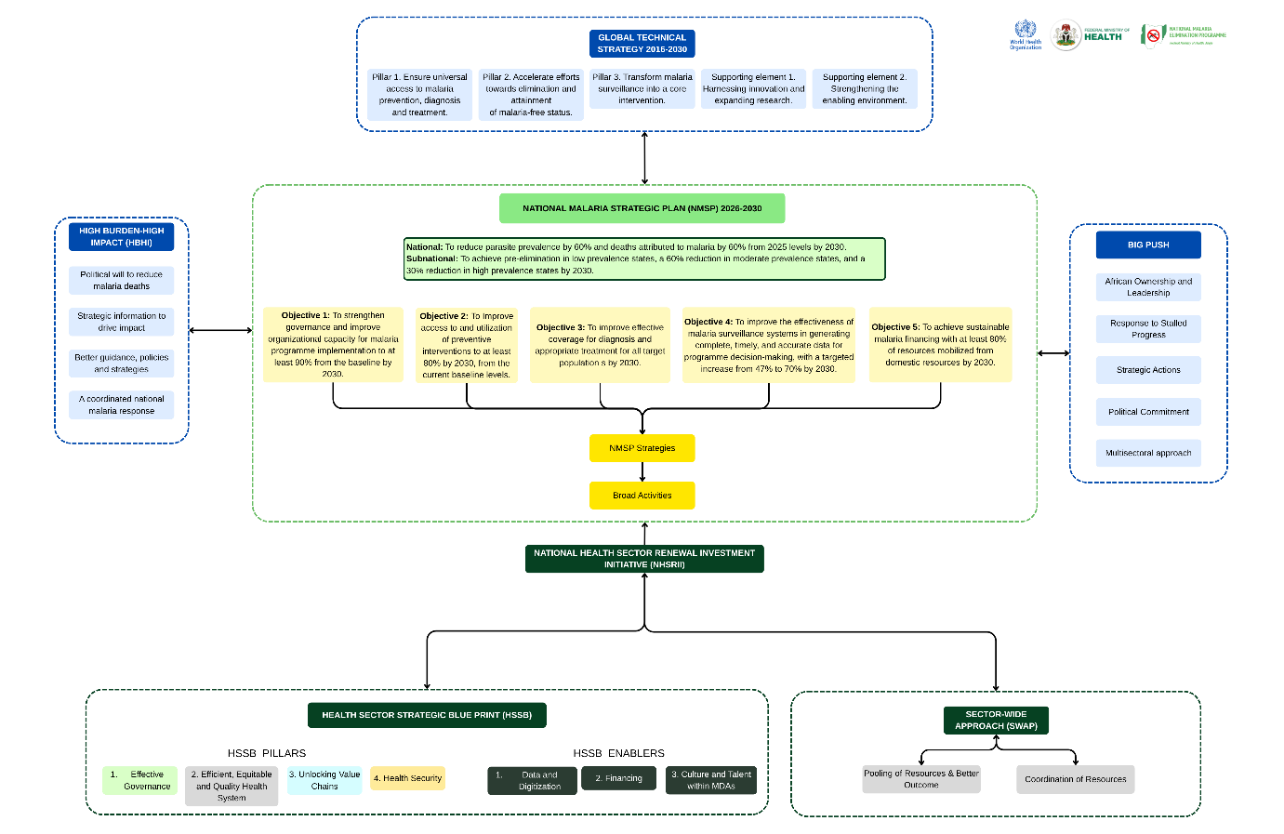
Fig 10. Conceptual framework for strategic direction and policy priorities

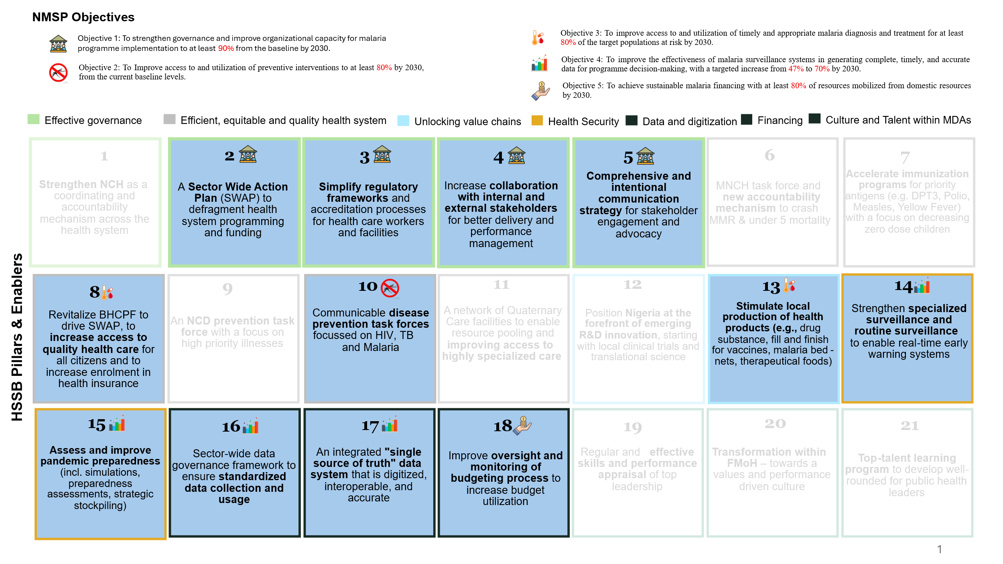
Fig 11. NMSP Objectives embedded in the HSSB Pillars and Enablers.

4.4. Goals and objectives
4.4.1. Goals
National: To reduce parasite prevalence by 60% and deaths attributed to malaria by 60% from 2025 levels by 2030.
Subnational: To achieve very low prevalence in low prevalence states, a 60% reduction in moderate prevalence states, and a 30% reduction in high prevalence states by 2030.
4.4.2. Objectives of NMSP, 2026-2030
- To strengthen governance and improve organizational capacity for malaria programme implementation to at least 90% from the baseline by 2030.
- To Improve access to and utilization of preventive interventions to at least 80% by 2030, from
the current baseline levels.
- To improve effective coverage for diagnosis and appropriate treatment for all target populations at risk by 2030.
- To improve the effectiveness of malaria surveillance systems in generating complete, timely, and accurate data for programme decision-making, with a targeted increase from 47% to 70% by 2030.
- To achieve sustainable malaria financing with at least 80% of resources mobilized from domestic resources by 2030.

4.4.3. Supportive Cross-cutting priority areas
Beyond the strategic objectives, there are cross-cutting priority areas that are fundamental to the achievement of the NMSP goal. These priority areas include;

Advocacy, Communication and Social Mobilization (ACSM)
ACSM is a fundamental strategy that cuts across all the objectives of the NMSP. It remains the component that consistently educates and promotes desired positive behavioural change for the prevention, diagnosis and treatment and all manners of malaria interventions at all levels.
Effective ACSM strategy is central to generating the political will needed for malaria elimination in Nigeria. In other words, ACSM is a strategic driver for ensuring adequate political will at all tiers as stipulated in Pillar 1 of the High Burden High Impact (HBHI) approach.
ACSM interventions make crucial contributions to the implementation of the outcome indicators of the NMSP strategic objectives such as governance, vector control, chemoprevention, diagnosis and treatment, financing and the M&E performance framework that involves behavioural change and enlightenment.
ACSM is not treated as a stand-alone component, but it is fully integrated, resourced, and aligned with all the strategic objectives. However, it is imperative to mainstream ACSM in all thematic planning and budgets, develop integrated communication strategies by thematic areas, and designate an ACSM focal point for the various objectives. The ACSM focus areas include:
- Provider-based initiative
- Utilization of multiple channels, with a focus on new media platforms
- Community mobilization (enhancing accountability, engagement, and ownership)
- Improving coverage of SBC activities
- Standardization of planning and implementation, along with the introduction of uniform tools for reporting
The ACSM strategies of this NMSP will focus on achieving objectives 1 to 5 by influencing behaviours of people at 4 different levels which are: Policy; Services or Systems; Community; Household and Individual. ACSM supports the programme in strengthening coordination, planning, networking, data management, resource mobilization and also drives effective delivery of SBC interventions at all levels. It will also support the development of advocacy tools to generate more funds at national and sub-national levels, as well as those to increase coordination between service delivery and SBC to align demand and supply factors and efforts.
Behaviour changes at each level include:
- Policy: Increased political commitment through budget allocation and improved release of funds for malaria as well as policy reviews/adoption based on evidence. Advocacy will drive these expected results through the provision of facts on malaria control interventions and funding, including scorecards. More collaboration and commitment of the private sector –through consistent and outcome/result-driven advocacy.
- Services or Systems: Improved providers’ knowledge, attitude and behaviours; service communication; relevant stakeholders’ engagement; buy-in and enabling environment (including accessibility, affordability and availability). Improved demand for testing and ANC for IPTp.
- Community: Increased commitment and ownership through community groups and associations, Community Health Workers. Promotion of SMC and positive norms for malaria control
- Household and Individuals: Increased knowledge, change in social norms or beliefs and increased demand and use for products and services, intensify the promotion of early ANC attendance among pregnant women, which includes uptake of 3 or more doses of IPTp.

Product and Supply Chain Management (PSM)
PSM is another fundamental area that cuts across the various objectives. For the NMSP 2026-2030, PSM priority strategies will be deployed to strengthen the connection between the National Malaria Programme NMEP and other health agencies by ensuring active participation in relevant working groups with the DFDS, NPSCMP, National Primary Health Care Development Agency (NPHCDA), and National Agency for Food and Drug Administration and Control (NAFDAC).
The success of this NMSP hinges on robust PSM strategies that ensure the right commodities are in the right place, at the right time, in the right quantity, and at the right quality. These strategies will also focus on minimizing stock-outs, wastages, and expiries, while encouraging local manufacturing and optimizing last mile delivery.
Key PSM functions include the following:
- Ensuring commodity availability and access
- Aligning forecasting and quantification with programme needs
- Driving efficiency in PSM
- Improving last mile delivery and Equity, Human Rights, Gender considerations
- Supporting surveillance and decision making
- Ensuring Quality Assurance and Regulatory Compliance
- Promoting sustainability and transition from donor dependency
- Strengthen national and sub-national supply chain systems to reduce reliance on parallel donor-funded systems.
- Incorporate initiatives to improve health facility logistics reporting efficiency by leveraging innovative relevant applications and digital tools like mSupply to automate the process.
- Enhance procurement and supply chain outcomes by aligning the malaria programme with new resources like the Rethinking Malaria and PVAC initiatives

Equity, Human Rights, and Gender Equality (EHRGE)

The previous NMSP focused its targeting to key vulnerable populations like women, children, the poor, IDPs and refugees. Through consultations during the NMSP development process and as part of MPR, it has been agreed that Nigeria will expand its targeting to additional priority population groups, while continuing to strengthen the groups identified in the previous NMSP. Key groups identified for the expanded targeting include populations displaced by natural and manmade disasters - (IDPs and refugees), People with Disabilities (PWDs), incarcerated populations, youth living in hostels, and miners.
As part of the MPR and NMSP development process, the stakeholders have agreed that the 2026–2030 malaria strategy will mainstream the Equity, Human Rights, and Gender Equality (EHRGE) as a cross-cutting theme. These perspectives have been woven into the strategic framework, financing considerations, and monitoring indicators, ensuring inclusivity in both design, data systems, and implementation.
EHRGE is at the core of Nigeria’s health sector strategic blueprint and the malaria response. Malaria continues to exact a disproportionate toll on Nigeria’s most vulnerable populations, with children under five and pregnant women accounting for nearly 75% of malaria out-patient consultations in the country. Therefore, EHRGE strategies intentionally cut across the strategic objectives of the NMSP.
Despite policy progress, out-of-pocket expenditures (OOPE) on malaria-related care remains unsustainably high, rising from 71% in 2018 to 84% in 2024, highlighting weak financial risk protection and insufficient uptake of mechanisms like the Basic Health Care Provision Fund (BHCPF) and the National Health Insurance Authority (NHIA). These are further complicated by other systemic and operational challenges that persist, including:
- Limited data disaggregation: Routine systems (e.g., DHIS2) lack variables for displacement, disability, income, and incarceration, making inequities poorly visible and difficult to manage.
- Some underserved populations (including IDPs, mine workers, migrants, prisoners, and people with disability) are often not fully recognized in planning, data systems, and budgeting.
- Gender barriers persist and require intentionality to address. Some of the barriers faced by women in some settings include spousal permission, financial dependence, and safety concerns, impacting timely care-seeking and uptake of malaria preventive tools.
- Financial burden remains high as OOPE has increased significantly over the years, with inadequate weak linkages between malaria services and social health protection schemes.
For the NMSP 2026-2030, key enablers and opportunities for EHRGE include: Strong legal and policy frameworks (such as NHIA Act, BHCPF), strong technical platforms (DHIS2, NDHS, MIS, Matchbox equity scan), pilot experiences with malaria delivery in humanitarian contexts, renewed national commitment under NHSRII.
Specifically, efforts will be made to embed explicit commitments to underserved populations, strengthen data systems, institutionalize gender-responsive budgeting, ensure financial protection, and prioritize institutional partnerships.

Malaria in Humanitarian Settings
While the EHRGE-focused malaria response seeks to ensure that no vulnerable population is left behind, worsening humanitarian crises on the other hand, continue to forcibly displace populations and further exacerbate vulnerability with increased risk of malaria and other diseases. Managing this requires intense collaborations and leveraging multi-sectoral programmes.

4.5. Strategies and Broad Activities.
To consolidate recent gains and accelerate progress towards malaria elimination, Nigeria will maximize the impact of WHO-recommended strategies through context-specific deployment, reflecting the country’s heterogeneous malaria epidemiology. These strategies, with the identified broad activities, will be implemented to strengthen the effectiveness of the country’s malaria response at both national and subnational levels. The NMSP objectives and strategies are described below:
4.5.1. Objective 1: To strengthen governance and improve organizational capacity for malaria programme implementation to at least 90% from the baseline by 2030.
Leveraging the Federal Ministry of Health’s Sector-Wide Approach (SWAp), NMEP will prioritize governance and organizational capacity as critical elements of the country’s malaria elimination efforts. This strategic objective aims to ensure that leadership structures, coordination platforms, partnerships, and accountability mechanisms are operating at optimal levels. Strengthening governance will foster improved leadership, policy environment, and effective coordination among stakeholders, while enhancing organizational capacity will empower NMEP to build and sustain strategic partnerships, effectively plan and implement interventions, and robustly monitor and evaluate progress. By aligning with the SWAp initiative, this approach promotes integration, efficiency, and sustainability across malaria elimination efforts and the wider health sector.
Priority areas for Governance and Organizational Capacity
- Sustained political commitment at national and subnational levels, supported by a coordinated sector-wide approach.
- Stronger multisectoral collaboration and partnerships.
- Enhanced private sector coordination and active participation in malaria programming.
- Capacity strengthening for effective programme management at national and subnational levels to sustain a robust malaria response
- Strengthen country ownership and leadership, alongside active community engagement and accountability

Table 2: This objective will be implemented through the following strategies:
Core Strategies | Broad Activities | HSSB Code
1.1 Strengthen the commitment, leadership, and sustained support from government at all levels. | 1.1.1 Integrate malaria elimination activities into national and subnational health and economic plans | HSSB 1.2.2.1
 | 1.1.2 Deploy African Leaders Malaria Alliance (ALMA) scorecard and accountability framework at the national and subnational levels | HSSB 1.2.2.1
1.2 Provide evidence-based policies and ongoing guidance for the deployment of malaria interventions, adapting global policies to local context and fostering innovation (across the various thematic areas) | 1.2.1 Develop/disseminate national policies and guidelines ensuring they are effectively communicated, adopted, implemented, and integrated at the state level. | HSSB 2.7.11.2
 | 1.2.2 Establish consultative meetings to review existing mechanisms and status of compliance to national policies, strategies, and regulatory framework. | HSSB 2.7.11.2
 | 1.2.3 Conduct EHRGE vulnerability assessment using Malaria Matchbox methodology covering at the least the following groups: populations affected by natural disasters, incarcerated populations, mine workers and mining communities, and youth living in educational hostels | HSSB 2.7.11.2
1.3 Strengthen evidence-based planning with subnational inputs that align with Country Fiscal Frameworks | 1.3.1 Scale-up mechanisms for periodic malaria programme progress and performance reviews at the federal and state levels. Establish coordination mechanisms (including data sharing) with BHCPF (Basic Healthcare Provision Fund) and NHEA for sharing data on priority EHRGE commitments. | HSSB 1.4.4.1
 | 1.3.2 Develop/support annual operational plan for malaria programme at the federal and in 36 states plus FCT. Develop or adopt Grievance Redressal Mechanisms covering all malaria related interventions at community and facility levels. | HSSB 1.4.4.2
 | 1.3.3 Mid-term and End-term reviews of the NMSP and development of the next NMSP | HSSB 1.4.4.1
 | 1.3.4 Development of a pragmatic costed plan | HSSB 1.4.4.1
1.4 Strengthen structures for the coordination of malaria strategy, and activities at all levels. | 1.4.1 Strengthen external coordination platforms at Federal level and 36 states plus FCT. | HSSB 1.4.5.2
 | 1.4.2 Strengthen internal coordination platforms at Federal level and 36 states plus FCT. Revise ToR and membership of all existing committees and working groups to ensure EHRGE inclusion as per the national coordination framework. | HSSB 1.4.5.2
 | 1.4.3 Establish multi-sectoral collaborative platforms at the national and subnational levels (MDAs / SWAp / PVAC / Environment). Ensure the inclusion of EHRGE dimensions in the OCA tool by 2030. | HSSB 1.4.5.2
1.5 Strengthen collaborative platforms and partnerships with private sector stakeholders at National and Subnational levels to increase coverage of targeted interventions | 1.5.1 Facilitate regular private sector coordination mechanisms to provide an enabling environment for private sector participation in decision making and co-creation of strategic interventions. | HSSB 2.7.11.5
 | 1.5.2 Engage regulatory bodies to strengthen partnerships with the private sector and ensure compliance with standard regulations. | HSSB 1.3.3.3
1.6 Facilitate a well-established and empowered NMEP that is strategically positioned to provide technical support and coordination of all malaria programme priorities at national and state levels | 1.6.1 Develop tools and establish mechanisms to regularly assess NMEP/SMEP capacity to implement the NMSP priority interventions. | HSSB 2.9.15.6
 | 1.6.2 Develop a capacity building plan to enhance individual skills and organizational resources for improving programme delivery. | HSSB 2.9.15.6
1.7.1 Strengthen strategic partnerships across service delivery, supply chain, and social and behaviour change (SBC) actors by fostering collaboration among relevant ministries, departments, agencies, and partner organizations | 1.7.1 Improve collaboration and integration between SBC and service delivery stakeholders to ensure synchronized malaria prevention, diagnosis, and treatment efforts. | HSSB 2.5.6.9
 | 1.7.2 Foster collaboration with national supply chain bodies, procurement agencies, and development partners to ensure efficient forecasting, procurement, and distribution of malaria commodities (including NPSCMP, NAFDAC, NPHCDA, PVAC etc). | HSSB 1.4.5.2

4.5.2 Objective 2: To improve access to and utilization of malaria preventive interventions to at least 80% by 2030, from current baseline levels.
This objective commits Nigeria to raise both access to, and correct use of, proven preventive measures. These include vector control tools such as insecticide-treated nets (ITNs), indoor residual spraying (IRS) where appropriate, larval source management (LSM) in appropriate settings, evidence-based chemoprevention interventions, and malaria vaccine. Additionally, this strategic objective will prioritize insecticide resistance monitoring and vector surveillance with tailored approaches for urban and complex environments. The focus includes getting the right tool to the right place, guided by current evidence and lessons, including insecticide-resistance as well as entomological data. Equity is central to optimizing this objective, therefore micro-plans will prioritize underserved wards, humanitarian and mobile populations, emergencies and private-sector outlets. There will be priority strategies for efficient product supply chain management and innovative social and behaviour change interventions.
Priority areas for Malaria Prevention
- Deploy WHO-recommended, quality-assured malaria prevention strategies, aligned with the transmission intensity stratification and sub-stratification, to ensure tailored and impactful implementation.
- Strengthen the tailoring of prevention interventions to local epidemiological and entomological contexts to ensure optimal impact and efficient use of resources, in alignment with the country’s transmission stratification and sub-stratification.
- Maintain a robust entomological surveillance and monitoring to guide evidence-based vector control decisions.
- Strengthen the process of monitoring and management of insecticide resistance to preserve the effectiveness of vector control tools.
- Expand preventive treatment for vulnerable populations through appropriate chemoprevention strategies in eligible settings.
- Scale up the deployment of malaria vaccines among eligible populations in line with WHO recommendations.

Table 3: This objective will be implemented through the following strategies:
Core Strategies | Broad Activities | HSSB Code
2.1 Deploy safe and effective integrated vector control interventions based on malaria transmission intensity, epidemiological stratification, and contextual factors. | 2.1.1 High transmission settings (malaria prevalence ≥ 35%). Deploy the following:  - ITN mass distribution  - ITN continuous distribution  - Targeted IRS in eligible hotspots  - LSM where feasible, in urban and semi-urban areas | HSSB 2.6.10.5
 | 2.1.2 Moderate transmission settings; category A (malaria prevalence 15 to <35%). Deploy the following:  - ITN mass distribution  - ITN continuous distribution  - Targeted IRS in eligible hotspots  - LSM where feasible, in urban and semi-urban areas | HSSB 2.6.10.5
 | 2.1.3 Moderate transmission settings; category B (malaria prevalence 10 to <15%). Deploy the following:  - ITN mass distribution  - ITN continuous distribution  - Targeted IRS in eligible hotspots  - LSM where feasible, in urban and semi-urban areas | HSSB 2.6.10.5
 | 2.1.4 Low transmission settings; category A (malaria prevalence 5 to <10%). Deploy the following:  - Targeted ITN mass distribution  - ITN continuous distribution  - Targeted IRS in eligible hotspots  - LSM where feasible, in urban and semi-urban areas | HSSB 2.6.10.5
 | 2.1.5 Low transmission settings; category B (malaria prevalence 1 to <5%). Deploy the following:  - ITN continuous distribution focusing on population groups at risk  - Targeted IRS in eligible hotspots  - LSM where feasible, in urban and semi-urban areas | HSSB 2.6.10.5
 | 2.1.6 Very low transmission settings (malaria prevalence 0 to <1%). Deploy the following:  - ITN continuous distribution focusing on population groups at risk  - Targeted IRS in active foci, and during outbreak response  - LSM where feasible | HSSB 2.6.10.5
2.2 Establish a sustainable decision-making mechanism for deployment of IVM interventions using entomological surveillance evidence (insecticide resistance monitoring and vector surveillance). | 2.2.1 Sustain vector sentinel surveillance to generate evidence for informed vector control decision-making. | HSSB 2.6.10.5
 | 2.2.2 Sustain insecticide resistance monitoring to generate evidence for informed vector control decision-making. | HSSB 2.6.10.5
 | 2.2.3 Strengthen capacity of NMEP and key stakeholders for planning, implementation, monitoring, and evaluation of vector control interventions. | HSSB 2.6.10.5
2.3 Deploy innovative vector control tools in targeted areas to complement mainstream vector control interventions. | 2.3.1 Implement innovative vector control tools such as house screening, insecticide-treated paints and clothes, spatial repellents, attractive sugar baits (ATSB) etc. | HSSB 2.6.10.5
2.4 Deploy malaria preventive measures in humanitarian settings and complex operating environments. | 2.4.1 Develop an emergency preparedness plan and revise existing implementation strategies and protocols to ensure they reflect EHRGE priority groups. | HSSB 2.6.10.5
 | 2.4.2 Provide ITNs and other appropriate preventive interventions for populations in humanitarian settings and other complex operating environments, including people in prisons, students in hostels, miners, unregistered migrants, and internally displaced persons/returnees. | HSSB 2.6.10.5
2.5 Deploy Chemo-preventive interventions to eligible populations (IPTp, SMC, PMC, IPTsc). | 2.5.1 Provide Seasonal Malaria Chemoprevention (SMC) services to eligible populations in LGAs where more than 60% of rainfall occurs within four to five consecutive months. | HSSB 2.6.10.7
 | 2.5.2 Scale up Perennial Malaria Chemoprevention (PMC) services to eligible populations in the eligible LGAs. | HSSB 2.6.10.7
 | 2.5.3 Provide Intermittent Preventive Treatment in pregnancy (IPTp) to all pregnant women across the country at ANC facilities and at community levels. | HSSB 2.6.10.7
 | 2.5.4 Deploy IPTsc services to eligible populations in the eligible LGAs. | HSSB 2.6.10.7
 | 2.5.5 Pilot Post Discharge Malaria Chemoprevention (PDMC) amongst patients recently discharged from hospitals. | HSSB 2.6.10.7
 | 2.5.6 Provide Chemoprophylaxis for Special groups, especially in individuals with Sickle Cell Anaemia and non-immune travellers. | HSSB 2.6.10.7
2.6 Support the deployment of Malaria Vaccine to eligible populations. | 2.6.1 Scale up the delivery of malaria vaccine to eligible populations, ensuring equitable access and high coverage. | HSSB 2.6.10.7
 | 2.6.2 Strengthen the coordination between NMEP and NPHCDA for effective scale-up of malaria vaccine. | HSSB 2.6.10.7
 | 2.6.3 Integrate malaria vaccine uptake with other malaria prevention campaigns (ITN, SMC) for a more comprehensive protection. | HSSB 2.6.10.7
2.7 Deploy targeted Vector Control interventions in pre-elimination settings | 2.7.1 Prioritize focal IRS in identified hotspots and high-risk institutions such as boarding schools, prisons, and urban slums. | HSSB 2.6.10.5
 | 2.7.2 Continuous entomological surveillance to inform deployment of interventions. | HSSB 2.6.10.5
 | 2.7.3 Sustain coverage of ITNs through routine and targeted distribution in vulnerable communities | HSSB 2.6.10.5
 | 2.7.4 Implement LSM, particularly in urban and peri-urban areas with identifiable breeding sites | HSSB 2.6.10.5
 | 2.7.5 Strengthen collaboration with sectors such as Environment, Urban Planning, and Waste Management to support integrated vector control efforts. | HSSB 1.4.5.2
2.8 Deploy environmentally safe and effective management of medical and chemical wastes. | 2.8.1 Strengthen waste management systems and create awareness on effective waste management. | HSSB 2.6.10.5
 | 2.8.2 Build capacity of health workers on safe handling of materials, waste segregation and appropriate waste disposal. | HSSB 2.6.10.5

Table 4: Supportive PSM Strategies
Strategies | Broad Activities | HSSB Code
2.9 Strengthen systems for continuous availability of, and access to health products for the prevention of malaria through vector control, chemoprevention, and malaria vaccine. | 2.9.1 Strengthen systems and processes to reliably quantify malaria commodities used in prevention interventions, including vector control, chemoprevention, and malaria vaccination. | HSSB 3.13.19.2
 | 2.9.2 Strengthen and harmonize procurement processes to ensure timely and cost-effective acquisition of malaria prevention commodities. | HSSB 3.13.19.2
 | 2.9.3 Promote the integrated procurement framework and its benefits to stakeholders, including policymakers, and communities. | HSSB 3.13.19.2
 | 2.9.4 Leverage technology to strengthen inventory management, monitor stockouts, and improve demand forecasting for malaria commodities at all levels of the health system. | HSSB 3.13.19.3
 | 2.9.5 Carry out effective last-mile delivery of malaria preventive commodities by implementing equitable and practical costing and resource allocation methods that prioritize access for vulnerable and underserved populations. | HSSB 3.13.19.4

Table 5: Supportive ACSM Strategies
ACSM Strategies | Broad Activities | HSSB Code
2.10 Sustain and increase public awareness and understanding of malaria prevention to enhance demand, access, and proper use of malaria preventive measures, especially among vulnerable and hard-to-reach populations. | 2.10.1 Conduct studies on awareness, ownership and use of malaria control interventions. | HSSB 1.16.22.5
 | 2.10.2 Develop/adapt and deploy tools for provider and client behaviour change to enhance client-provider engagement. | HSSB 2.5.6.8
 | 2.10.3 Promote access to, and utilization of malaria prevention interventions through electronic/mass/new media. | HSSB 2.5.6.8
2.11 Leverage the influence of trusted community figures and public personalities to promote malaria prevention behaviours and drive access, uptake, and proper use of malaria interventions. | 2.11.1 Design, implement, and sustain a malaria champion and brand ambassador programme, especially in hard-to-reach areas and other high-risk populations, to improve ownership and utilization of malaria prevention interventions. | HSSB 2.5.6.8

Objective 3: To improve effective coverage for diagnosis and appropriate treatment for all target populations at risk by 2030.
This objective for the strategic plan adopts a dual-pronged approach. First, to prioritize the deployment and routine use of reliable parasitological diagnostics, ensuring that every suspected malaria case is tested before treatment. Second, it aims to ensure that all confirmed cases are managed with effective antimalarial medicines in line with national guidelines and WHO standards. Achieving this objective will require scaling up diagnostic coverage at community, facility, and private sector levels; strengthening supply chain systems to ensure uninterrupted availability of rapid diagnostic tests (RDTs) and antimalarials; training and mentoring health workers for quality service delivery; and reinforcing community awareness to drive timely care-seeking. These efforts will be embedded within national and sub-national systems, monitored through robust surveillance and reporting mechanisms, and supported by sustained partnerships to secure progress towards the 2030 goal. The target defined under this objective will be achieved through the implementation of the following strategies:
Priority areas for Diagnosis and Treatment
- Ensure parasitological confirmation of malaria in both public and private health facilities before treatment.
- Provide quality-assured treatment to all confirmed malaria cases in accordance with the national guidelines.
- Ensure availability of quality-assured antimalarial medicines and diagnostics.
- Scale up community-based testing and treatment, to expand access, particularly in underserved and hard-to-reach areas.
- Monitor the safety and efficacy of antimalarial medicines, and strengthen surveillance systems to detect and manage emerging antimalarial drug resistance.
- In states within the Low Transmission Band, particularly sub-category B, focus will shift from burden reduction to active case detection. Therefore, every suspected case will be tested, and strong surveillance will be implemented as a core intervention.

Table 6: This objective will be implemented through the following strategies:
Strategies | Broad Activities | HSSB Code
- Deployment of effective parasitological diagnostics for testing care-seeking persons with suspected malaria | - Build capacity of personnel in public health facilities on basic malaria microscopy. | HSSB 2.7.11.3
 | 3.1.2 Support the expansion of malaria microscopy certification programmes to build a larger pool of certified malaria microscopists across all states. | HSSB 2.7.11.3
 | 3.1.3 Build capacity of personnel in private health facilities at all levels and among private medical retailers (Community Pharmacists and PPMVs) for parasitological confirmation of malaria. | HSSB 2.7.11.3
 | 3.1.4 Provide rapid diagnostic testing and microscopy for parasitological confirmation of malaria in public and private health facilities and at the community level. | HSSB 2.6.10.7
 | 3.1.5 Scale up of quality assurance and quality control systems for malaria diagnosis. | HSSB 2.6.10.7
 | 3.1.6 Conduct operational research on the deployment and acceptability of existing and emerging parasitological confirmation tests, including the Urine Malaria Test and AI-assisted and automated diagnosis. | HSSB 3.10.16.3
 | 3.1.7 Strengthen prompt malaria diagnosis in humanitarian emergencies (including internally displaced populations - IDPs, prisoners, miners etc). | HSSB 2.6.10.7
3.2 Ensure appropriate treatment for individuals with confirmed malaria using effective antimalarial medicines. | - Provision of treatment services for uncomplicated malaria at health facilities and the community levels. | HSSB 2.6.10.7
 | 3.2.2 Strengthen the management of severe malaria in public and private health facilities (including capacity building, increasing access to pre-referral treatment using Rectal Artesunate at primary healthcare facilities, and Injection Artesunate at secondary and tertiary healthcare facilities). | HSSB 2.6.10.7
 | 3.2.3 Scale-up community case management of malaria as a component of integrated community case management (iCCM) through the Community-Based Health Workforce programme, especially in hard-to-reach areas | HSSB 2.8.12.36
 | 3.2.4 Ensure compliance to National Malaria Treatment Guidelines and the National Quality of Care Guideline on malaria case management. | HSSB 2.6.10.7
 | 3.2.5 Strengthen prompt malaria diagnosis in humanitarian emergencies (including internally displaced populations – IDPs, prisoners, miners etc). | HSSB 2.6.10.7
 | 3.2.6 Strengthen malaria surveillance activities (Antimalarial drug therapeutic efficacy test - DTET) | HSSB 2.6.10.7
 | 3.2.7 Strengthen Pharmacovigilance activities in collaboration with NAFDAC. | HSSB 2.6.10.7
 | 3.2.8 Pilot the implementation of Multiple First Line Therapy (MFT) to generate evidence for scale-up, to delay the emergence of resistance. | HSSB 2.6.10.7
 | 3.2.9 Potential scale up of MFT following a successful pilot. | HSSB 2.6.10.7
3.3 Deploy active malaria case detection strategies to identify and respond to residual transmission foci in pre-elimination settings | 3.3.1 Implement proactive and reactive case detection approaches, conducting community-based screening in high-risk areas and investigating all confirmed cases to identify secondary infections | HSSB 2.6.10.7

Supportive PSM Strategies
Strategies | Broad Activities | HSSB Code
3.4 Strengthen systems for continuous availability of, and access to health products for the diagnosis and treatment of malaria. | 3.4.1 Strengthen systems and processes to reliably quantify malaria commodities used for diagnosis and treatment. | HSSB 3.13.19.2
 | 3.4.2 Strengthen and harmonize procurement processes to ensure timely and cost-effective acquisition of malaria commodities for diagnosis and treatment. | HSSB 3.13.19.2
 | 3.4.3 Carry out effective last-mile delivery of malaria diagnosis and treatment commodities by implementing equitable and practical costing and resource allocation methods that prioritize access for vulnerable and underserved populations. | HSSB 3.13.19.4

Supportive ACSM Strategies
Strategies | Broad activities | HSSB Code
3.5 Deploy an integrated ACSM campaign that combines mass media, digital platforms, and interpersonal communication through trusted structures to increase awareness, demand, and correct use of diagnostic and treatment services. | 3.5.1 Promote access to, and utilization of malaria diagnosis and treatment interventions through electronic/mass/new media. | HSSB 2.5.6.8
3.6 Establishment of accountability (social) mechanism to improve quality of community level malaria /ACSM activities. | 3.6.1 Design, implement, and sustain a malaria champion and brand ambassador programme, especially in hard-to-reach areas and other high-risk populations, to improve ownership and utilization of malaria diagnosis and treatment interventions. | HSSB 2.5.6.8

4.5.4 Objective 4: To improve the effectiveness of malaria surveillance systems in generating complete, timely, and accurate data for programme decision-making, with a targeted increase from 47% to 70% by 2030.
The surveillance objective seeks to improve the comprehensiveness of the malaria surveillance system from a baseline of 47% in 2022 to 70% by 2030 through improving data quality approaches, mapping and digitalizing integrated malaria data reporting, improving the capacity of human resources for SMEOR at all levels, strengthening entomological surveillance system, strengthening data governance and coordination, expanding operational research for malaria surveillance, adaptive surveillance to the trends of disease burden, and strengthening drugs and diagnostics surveillance for evidence-based decision-making.
Improving the performance and comprehensiveness of malaria surveillance is central to Nigeria’s 2026-2030 goal, as part of the broader malaria elimination agenda, which emphasizes data-driven decision-making, accountability, and the tailoring of interventions at the sub-national level. This aligns with global commitments under the WHO Global Technical Strategy for Malaria 2016-2030, which underscores surveillance as a core intervention for elimination. By leveraging digital health platforms such as DHIS2 and the Nigeria Malaria Data Repository (NMDR), investments will ensure integrated, real-time, and interoperable data systems that consolidate routine, entomological, and drug surveillance data for rapid use.
Furthermore, capacity development at all levels will foster sustainability and ownership, while stratification of states based on transmission intensity will enable precision-targeting of interventions, ensuring resources are deployed where they are most needed. Ultimately, this objective will contribute to accelerating the trajectory towards malaria elimination, improving accountability, and innovation.
Priority areas for the surveillance system
- Improve the quality of data generation, analysis, use, and feedback mechanisms
- Mapping and digitalizing integrated malaria data reporting
- Improving the capacity of human resources for SMEOR at all levels
- Strengthen entomological surveillance
- Strengthen drugs and diagnostics surveillance through the conduct of TES for evidence-based decision-making
- Expand research for malaria surveillance
- Strengthen data governance and coordination
- Adaptive surveillance to the trends of disease burden
Table 5: This objective will be implemented through the following strategies:
Strategies | Broad activities | HSSB Code
4.1 Mapping and digitalizing integrated malaria data reporting | 4.1.1 Expand digital reporting and support the standardization of malaria data elements for Electronic Medical Record (EMR). | HSSB 1.16.23.2
 | 4.1.2 Strengthen the integration of all data sources with NMDR. Revise SMEOR strategy and document data collection mechanisms to ensure availability of disaggregated data for all NMSP priority groups for all interventions. | HSSB 1.16.22.6
 | 4.1.3 Strengthen data sharing and dissemination of health information for evidence-based decision making | HSSB 1.16.22.8
 | 4.1.4 Support the interoperability between NHMIS and NHLMIS data systems. Regularly share disaggregated data analysis with decision makers and technical forums for course correction at national and state levels. | HSSB 1.16.22.6
 | 4.1.5 Improve private sector data reporting. | HSSB 2.8.13.27
4.2 Improving capacity of Human Resources for SMEOR at all levels. | 4.2.1 Strengthen the capacity of healthcare providers on HMIS to optimize data collection and reporting. | HSSB 1.16.23.5
4.3 Improve data quality, analysis and feedback loops | - Develop/maintain dashboards and automated alerts to track  anomalies or missing reports. | HSSB 2.6.10.6
4.3 Improve data quality, analysis and feedback loops | 4.3.2 Improve the generation of evidence for decision-making and impact through reporting of quality malaria data and information from the health facilities. | HSSB 2.6.10.6
4.4 Strengthen  Entomological surveillance | 4.4.1 Expanding entomological sites across the country for data generation. | HSSB 2.6.10.5
4.4 Strengthen  Entomological surveillance | 4.4.2 Support expansion of Molecular analysis laboratories. | HSSB 2.6.10.5
4.4 Strengthen  Entomological surveillance | 4.4.3 Monitor emerging vectors such as Anopheles Stephensi | HSSB 4.15.21.4
4.5 Strengthen drugs and diagnostics surveillance through the conduct of TES and evidence-based decision  making | 4.5.1 Conduct regular TES across the study sites in the country | HSSB 3.13.19.6
 | 4.5.2 Monitor molecular markers of antimalarial resistance. | HSSB 3.13.19.6
 | 4.5.3 Conduct implementation research on HRP2/3 antigen deletions to generate evidence that will guide informed decision-making on the deployment of appropriate mRDTs in the country. | HSSB 3.13.19.6
4.6 Expand research for Malaria Surveillance. | 4.6.1 Strengthen Operations Research (OR) through enhanced collaboration with tertiary institutions, engagement with the academia, and consistent generation of evidence for programme decision making. | HSSB 3.10.16.3
4.6 Expand research for Malaria Surveillance. | 4.6.2 Support the coordination, design, and implementation of malaria-related surveys. | HSSB 1.16.22.5
4.7 Strengthen surveillance systems to support case notification, follow-up, and timely response in pre-elimination settings | 4.7.1 Integrate community health workers and private providers into active surveillance networks to expand reach and ensure prompt case identification. | HSSB 1.16.22.8
 | 4.7.2 Utilize digital tools for real-time data reporting, geo-mapping of cases, and monitoring of intervention impact. | HSSB 1.16.23.2

Supportive PSM Strategies
Strategies | Broad Activity | HSSB Code
4.8 Significantly improve Health Facility logistics reporting efficiency for optimal utilization of commodities, wider coverage and  evidence-based supply chain decisions | 4.8.1 Enhance the generation of quality logistics data by leveraging innovative relevant applications and digital tools | HSSB 3.13.19.3
 | 4.8.2 Build capacity for analysis and use of logistics data | HSSB 2.8.13.27
 | 4.8.3 Conduct Regular data quality assessments and feedback | HSSB 2.8.13.27
4.9 Periodic review and feedback on outcome measurements | 4.9.1 Establish performance metrics and monitoring systems to assess (PSM) performance; including the use of stakeholder feedback mechanism to identify areas for improvement | HSSB 2.8.13.27

Objective 5: To achieve sustainable malaria financing with at least 80% of resources mobilized from domestic resources by 2030.
This Financial Resource Management builds on the National Malaria Strategic Plan 2026–2030 and the implementation matrix developed under the eight strategic financing pillars. It reflects lessons from the 2021–2025 plan, where funding was highly dependent on external donors and government allocations were vulnerable to oil price fluctuations. This also considers the potential advocacy of making the National programme an agency. The FRMP aims to diversify revenue streams, institutionalize accountability, and ensure sustainability through the National Malaria Financing Facility (NMFF), domestic revenue measures, private sector engagement, and equity-focused protection mechanisms.
Priority areas for Sustainable Financing
- Increase domestic financing to sustain recent progress and consolidate gains.
- Mobilize additional international financing to complement domestic resources and address funding gaps.
- Strengthen and sustain high-level political commitment to support predictable and long-term financing for malaria.
- Explore innovative financing mechanisms, including blended finance, earmarked funds, and performance-based funding models.
- Explore innovative financing mechanisms, including opportunities under the Sector-Wide Approach (SWAp).
- Improve alignment with national priorities
- Leverage private sector engagement and resources through strategic partnerships, corporate social responsibility initiatives, and other opportunities.

Table 6: Core Strategies
Strategies | Broad activities | HSSB Code
5.1 Enhance capacity to generate, manage and utilize financial resources equitably and efficiently for malaria | 5.1.1 Strengthen financial resource mapping, evidence generation, and expenditure tracking processes. | HSSB 2.17.24.4
 | 5.1.2 Develop tools/facilitate allocative efficiency in the disbursement of funds for malaria sub-nationally tailored interventions. | HSSB 2.17.24.7
 | 5.1.3 Organize high-level annual malaria financing roundtable events to galvanize political commitment and mobilize resources. | HSSB 2.17.24.6
5.2 Attract and optimize external funding through development partners and global health initiatives | 5.2.1 Initiate/Support joint regional initiatives for domestic resource mobilization. | HSSB 2.17.24.6
5.3 Deploy innovative financing mechanisms | 5.3.1 Promote innovative resource mobilization initiatives targeting individuals, corporate organizations, and philanthropic organizations including End Malaria Council (EMC). | HSSB 2.17.24.6
5.3 Deploy innovative financing mechanisms | 5.3.2 Facilitate public, private, philanthropic, and donor dialogue platforms to align priorities. | HSSB 2.17.24.6
5.4 Secure greater health allocations from national and subnational governments | 5.4.1 Develop a legislative engagement plan to ensure ring-fenced funds for malaria from statutory budget allocations. | HSSB 2.17.24.3
 | 5.4.2 Position the malaria programme as part of constituency empowerment and address malaria issues as a constituency development issue. Allocate Financial Resources for NMEP Capacities to ensure adequate Targeting, ability to work in Complex Operating Environments, and respond to Emergencies | HSSB 2.17.24.3

Supportive PSM Strategies
Strategies | Broad Activities | HSSB Code
5.5 Leverage private capital and contributions for domestic resourcing of malaria commodities | 5.5.1 Establish a co-payment mechanism for malaria commodities and an enabling environment for local manufacturing of malaria commodities in Nigeria. | HSSB 2.17.24.6

Supportive ACSM Strategies
Strategies | Broad activities | HSSB Code
5.6 Engage policy makers to generate increased political will for malaria funding | 5.6.1 Deploy advocacy intervention tools and packages targeted at public policy makers at the national and state levels. | HSSB 2.8.13.6
5.7 Mobilize Civil Society Organizations for improved transparency and accountability | 5.7.1 Strengthen the role of Civil Society Organizations in tracking malaria programme implementation, financing, and results at the national and subnational level. | HSSB 2.5.6.6

4.6. Banding and Stratification
Given Nigeria’s complexity and epidemiological diversity, the various states are currently progressing towards malaria elimination at different rates. Therefore, each state is required to intensify efforts through combinations of interventions tailored to its specific local context, aligned with the country’s transmission stratification and sub-stratification (transmission bands).
In view of this, a country-tailored stratification approach is essential to optimize the delivery and impact of malaria interventions. Overall, Nigeria’s journey towards a malaria-free status is continuous and dynamic, with the states positioned at different points along the elimination pathway.
Recognizing this heterogeneity, intervention mixes are recommended for each transmission band (fig 12 below), and state malaria programmes will align with the specific band that is appropriate for their context. This targeted approach will further strengthen and optimize the malaria control response across the country.
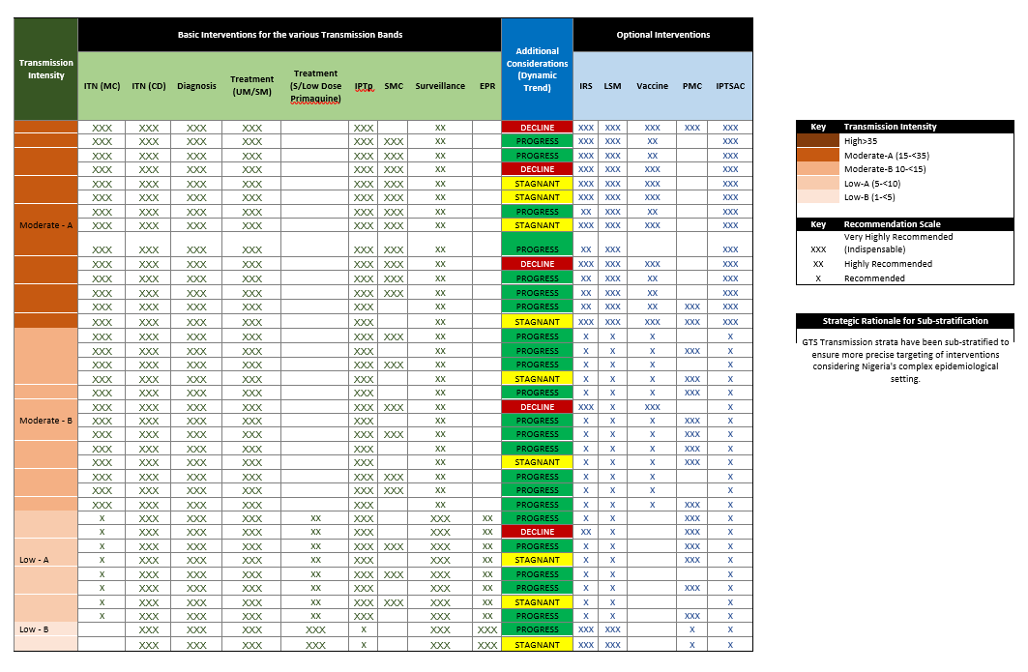

Fig 12: Banding and Stratification

Chapter 5

Implementation Framework
5.1. MSP Work Plan
To achieve the goal and objectives of the NMSP, the work plan below articulates the relevant strategies, broad activities, implementation timelines and responsible entities.
Table 7: Objectives, Strategies, Broad Activities, Implementation timelines and Key Responsible
Objective 1: To strengthen governance and improve organizational capacity for malaria programme implementation to at least 90% from the baseline by 2030.
Strategy | Broad Activity | Implementation Timeline |  |  |  |  | Key Responsible
Strategy | Broad Activity | 2026 | 2027 | 2028 | 2029 | 2030 | Key Responsible
1.1 Strengthen the commitment, leadership, and sustained support from government at all levels. | 1.1.1 Integrate malaria elimination activities into national and subnational health and economic plans | X | X | X | X | X | NMEP  PM/Partners
 | 1.1.2 Deploy African Leaders Malaria Alliance (ALMA) scorecard at the national and subnational levels | X | X | X | X | X | NMEP  PM/Partners
1.2 Provide evidence-based policies and ongoing guidance for the deployment of malaria interventions, adapting global policies to local context and fostering innovation (across the various thematic areas) | 1.2.1 Develop/disseminate national policies and guidelines ensuring they are effectively communicated, adopted, implemented, and integrated at the state level. | X | X | X | X | X | NMEP  PM/Partners
 | 1.2.2 Establish consultative meetings to review existing mechanisms and status of compliance to national policies, strategies, and regulatory framework. | X | X | X | X | X | NMEP  PM/Partners
 | 1.2.3 Conduct periodic EHRGE vulnerability assessments (including use of Malaria Matchbox methodology) to inform governance decisions, subnational planning, and prioritization of underserved populations. | X |  |  |  |  | NMEP  PM/Partners
1.3 Strengthen evidence-based planning with subnational inputs that align with Country Fiscal Frameworks | 1.3.1 Scale-up mechanisms for periodic malaria programme progress and performance reviews at the federal and state levels. | X | X | X | X | X | NMEP  PM/Partners
 | 1.3.2 Develop/support annual operational plan for malaria programme at the federal and in 36 states plus FCT. | X | X | X | X | X | NMEP  PM/Partners
 | 1.3.3 Mid-term and End-term reviews of the NMSP and development of the next NMSP | X | X | X | X | X | NMEP  PM/Partners
1.4 Strengthen structures for the coordination of malaria strategy, and activities at all levels. | 1.4.1 Strengthen external coordination platforms at Federal level and 36 states plus FCT. | X | X | X | X | X | NMEP  PM/Partners
 | 1.4.2 Strengthen internal coordination platforms at Federal level and 36 states plus FCT. | X | X | X | X | X | NMEP  PM/Partners
 | 1.4.3 Establish multi-sectoral collaborative platforms at the national and subnational levels (MDAs / SWAp / PVAC / Environment) | X | X | X | X | X | NMEP  PM/Partners
1.5 Strengthen collaborative platforms and partnerships with private sector stakeholders at National and Subnational levels to increase coverage of targeted interventions | 1.5.1 Facilitate regular private sector coordination mechanisms to provide an enabling environment for private sector participation in decision making and co-creation of strategic interventions. | X | X | X | X | X | NMEP  PM/Partners
 | 1.5.2 Engage regulatory bodies to strengthen partnerships with the private sector and ensure compliance with standard regulations. Operationalize grievance redress mechanisms for malaria interventions. | X | X | X | X | X | NMEP  PM/Partners
1.6 Facilitate a well-established and empowered NMEP that is strategically positioned to provide technical support and coordination of all malaria programme priorities at national and state levels | 1.6.1 Develop tools and establish mechanisms to regularly assess NMEP/SMEP capacity to implement the NMSP priority interventions. | X | X | X | X | X | NMEP  PM/Partners
 | 1.6.2 Develop a capacity building plan to enhance individual skills and organizational resources for improving programme delivery. | X | X | X | X | X | NMEP  PM/Partners
1.7.1 Strengthen strategic partnerships across service delivery, supply chain, and social and behaviour change (SBC) actors by fostering collaboration among relevant ministries, departments, agencies, and partner organizations | 1.7.1 Improve collaboration and integration between SBC and service delivery stakeholders to ensure synchronized malaria prevention, diagnosis, and treatment efforts. | X | X | X | X | X | NMEP  PM/Partners
 | 1.7.2 Foster collaboration with national supply chain bodies, procurement agencies, and development partners to ensure efficient forecasting, procurement, and distribution of malaria commodities (including NPSCMP, NAFDAC, NPHCDA, PVAC etc). | X | X | X | X | X | NMEP  PM/Partners

Table 8: Objective 2: To Improve access and utilization of vector control and chemoprevention interventions to 80% from baseline by 2030.
Strategy | Broad Activity | Implementation Timeline |  |  |  | Key Responsible
Strategy | Broad Activity | 2026 | 2027 | 2028 | 2029 | 2030
2.1 Deploy safe and effective integrated vector control interventions based on malaria transmission intensity, epidemiological stratification, and contextual factors. | 2.1.1 High transmission settings (API >= 450/1000), deploy the following:  1. ITN mass distribution | X | X | X | X | X | NMEP/IVM/SM EP
 | - ITN continuous distribution | X | X | X | X | X | NMEP/IVM/SM EP
 | - Targeted IRS in eligible hotspots | X | X | X | X | X | NMEP/IVM/SM EP
 | - LSM where feasible, in urban and semi-urban areas | X | X | X | X | X | NMEP/IVM/SM EP
 | 2.1.2 Moderate transmission settings (API = 250-449/1000), deploy the following:  1. ITN mass distribution | X | X | X | X | X | NMEP/IVM/SM EP
 | 2. ITN continuous distribution | X | X | X | X | X | NMEP/IVM/SM EP
 | - Targeted IRS in eligible hotspots | X | X | X | X | X | NMEP/IVM/SM EP
 | - LSM where feasible, in urban and semi-urban areas | X | X | X | X | X | NMEP/IVM/SM EP
 | 2.1.3 Low transmission settings (API = 100-249/1000) deploy  1. ITN mass distribution | X | X | X | X | X | NMEP/IVM/SM EP
 | - ITN continuous distribution | X | X | X | X | X | NMEP/IVM/SM EP
 | - Targeted IRS in eligible hotspots | X | X | X | X | X | NMEP/IVM/SM EP
 | - LSM where feasible, in urban and semi-urban areas | X | X | X | X | X | NMEP/IVM/SM EP
 | 2.1.4 Very low transmission settings (API < 100/1000) deploy  1. ITN continuous distribution focusing on population groups at risk | X | X | X | X | X | NMEP/IVM/SM EP
 | - Targeted IRS in active foci, and during outbreak response | X | X | X | X | X | NMEP/IVM/SM EP
 | - LSM where feasible | X | X | X | X | X | NMEP/IVM/SM EP
2.2 Establish a sustainable decision-making mechanism for deployment of IVM interventions using entomological surveillance evidence (insecticide resistance monitoring and vector surveillance). | 2.2.1 Sustain vector sentinel surveillance to generate evidence for informed vector control decision-making. | X | X | X | X | X | NMEP/IVM/SM EP
 | 2.2.2 Sustain insecticide resistance monitoring to generate evidence for informed vector control decision-making. | X | X | X | X | X | NMEP/IVM/SM EP
 | 2.2.3 Strengthen capacity of NMEP and key stakeholders for planning, implementation, monitoring, and evaluation of vector control interventions. | X | X | X | X | X | NMEP/IVM/SM EP
2.3 Deploy innovative vector control tools in targeted areas to complement mainstream vector control interventions. | 2.3.1 Implement innovative vector control tools such as house screening, insecticide-treated paints and clothes, spatial repellents, attractive sugar baits (ATSB) etc. | X | X | X | X | X | NMEP/IVM/SM EP
2.4 Deploy malaria preventive measures in humanitarian settings and complex operating environments. | 2.4.1 Develop an emergency preparedness plan. | X | X | X | X | X | NMEP/IVM/SM EP
 | 2.4.2 Provide ITNs and other appropriate preventive interventions for populations in humanitarian settings and other complex operating environments, including people in prisons, students in hostels, miners, unregistered migrants, and internally displaced persons/returnees. | X | X | X | X | X | NMEP/IVM/SM EP
2.5 Deploy Chemo-preventive interventions to eligible populations (IPTp, SMC, PMC, IPTsc). | 2.5.1 Provide Seasonal Malaria Chemoprevention (SMC) services to eligible populations in LGAs where more than 60% of rainfall occurs within four to five consecutive months. | X | X | X | X | X | NMEP/IVM/SM EP
 | 2.5.2 Scale up Perennial Malaria Chemoprevention (PMC) services to eligible populations in the eligible LGAs. | X | X | X | X | X | NMEP/IVM/SM EP
 | 2.5.3 Provide Intermittent Preventive Treatment in pregnancy (IPTp) to all pregnant women across the country at ANC facilities and at community levels. | X | X | X | X | X | NMEP/IVM/SM EP
 | 2.5.4 Deploy IPTsc services to eligible populations in the eligible LGAs. | X | X | X | X | X | NMEP/IVM/SM EP
 | 2.5.5 Pilot Post Discharge Malaria Chemoprevention (PDMC) amongst patients recently discharged from hospitals. | X | X | X | X | X | NMEP/IVM/SM EP
 | 2.5.6 Provide Chemoprophylaxis for Special groups, especially in individuals with Sickle Cell Anaemia and non-immune travellers. | X | X | X | X | X | NMEP/IVM/SM EP
2.6 Support the deployment of Malaria Vaccine to eligible populations. | 2.6.1 Scale up the delivery of malaria vaccine to eligible populations, ensuring equitable access and high coverage. | X | X | X | X | X | NMEP/IVM/SM EP
 | 2.6.2 Strengthen the coordination between NMEP and NPHCDA for effective scale-up of malaria vaccine. | X | X | X | X | X | NMEP/IVM/SM EP
 | 2.6.3 Integrate malaria vaccine uptake with other malaria prevention campaigns (ITN, SMC) for a more comprehensive protection. | X | X | X | X | X | NMEP/IVM/SM EP
2.7 Deploy targeted Vector Control interventions in pre-elimination settings | 2.7.1 Prioritize focal IRS in identified hotspots and high-risk institutions such as boarding schools, prisons, and urban slums. | X | X | X | X | X | NMEP/IVM/SM EP
 | 2.7.2 Continuous entomological surveillance to inform deployment of interventions. | X | X | X | X | X | NMEP/IVM/SM EP
 | 2.7.3 Sustain coverage of ITNs through routine and targeted distribution in vulnerable communities | X | X | X | X | X | NMEP/IVM/SM EP
 | 2.7.4 Implement LSM, particularly in urban and peri-urban areas with identifiable breeding sites | X | X | X | X | X | NMEP/IVM/SM EP
 | 2.7.5 Strengthen collaboration with sectors such as Environment, Urban Planning, and Waste Management to support integrated vector control efforts. | X | X | X | X | X | NMEP/IVM/SM EP
2.8 Deploy environmentally safe and effective management of medical and chemical wastes | 2.8.1 Strengthen waste management systems and create awareness on effective waste management. | X | X | X | X | X | NMEP/IVM/SM EP
 | 2.8.2 Build capacity of health workers on safe handling of materials, waste segregation and appropriate waste disposal. | X | X | X | X | X | NMEP/IVM/SM EP
2.9 Strengthen systems for continuous availability of, and access to health products for the prevention of malaria through vector control, chemoprevention, and malaria vaccine. | 2.9.1 Strengthen systems and processes to reliably quantify malaria commodities used in prevention interventions, including vector control, chemoprevention, and malaria vaccination. | X | X | X | X | X | NMEP/PSM/SMEP/Partners
 | 2.9.2 Strengthen and harmonize procurement processes to ensure timely and cost-effective acquisition of malaria prevention commodities. | X | X | X | X | X | NMEP/PSM/SMEP/Partners
 | 2.9.3 Promote the integrated procurement framework and its benefits to stakeholders, including policymakers, and communities. | X | X | X | X | X | NMEP/PSM/SMEP/Partners
 | 2.9.4 Leverage technology to strengthen inventory management, monitor stockouts, and improve demand forecasting for malaria commodities at all levels of the health system. | X | X | X | X | X | NMEP/PSM/SMEP/Partners
 | 2.9.5 Carry out effective last-mile delivery of malaria preventive commodities by implementing equitable and practical costing and resource allocation methods that prioritize access for vulnerable and underserved populations. | X | X | X | X | X | NMEP/PSM/SMEP/Partners
2.10 Sustain and increase public awareness and understanding of malaria prevention to enhance demand, access, and proper use of malaria preventive measures, especially among vulnerable and hard-to-reach populations. | 2.10.1 Conduct studies on awareness, ownership and use of malaria control interventions. | X | X | X | X | X | NMEP/ACSM/SMEP/Partners
 | 2.10.2 Develop/adapt and deploy tools for provider and client behaviour change to enhance client-provider engagement. | X | X | X | X | X | NMEP/ACSM/SMEP/Partners
 | 2.10.3 Promote access to, and utilization of malaria prevention interventions through electronic/mass/new media. | X | X | X | X | X | NMEP/ACSM/SMEP/Partners
2.11 Leverage the influence of trusted community figures and public personalities to promote malaria prevention behaviours and drive access, uptake, and proper use of malaria interventions. | 2.11.1 Design, implement, and sustain a malaria champion and brand ambassador programme, especially in hard-to-reach areas and other high-risk populations, to improve ownership and utilization of malaria prevention interventions. | X | X | X | X | X | NMEP/ACSM/SMEP/Partners

Table 9: Objective 3: To improve effective coverage for diagnosis and appropriate treatment for all target populations at risk by 2030.
Strategy | Broad Activity | Implementation Timeline |  |  |  |  | Key Responsible
Strategy | Broad Activity | 2026 | 2027 | 2028 | 2029 | 2030 | Key Responsible
3.1 Deployment of effective parasitological diagnostics for testing care-seeking persons with suspected malaria | 3.1.1 Build capacity of personnel in public health facilities on basic malaria microscopy. | X | X | X | X | X | NMEP/CM/SMEP/Partners
 | 3.1.2 Support the expansion of malaria microscopy certification programmes to build a larger pool of certified malaria microscopists across all states. | X | X | X | X | X | NMEP/CM/SMEP/Partners
 | 3.1.3 Build capacity of personnel in private health facilities at all levels and among private medical retailers (Community Pharmacists and PPMVs) for parasitological confirmation of malaria. | X | X | X | X | X | NMEP/CM/SMEP/Partners
 | 3.1.4 Provide rapid diagnostic testing and microscopy for parasitological confirmation of malaria in public and private health facilities and at the community level. | X | X | X | X | X | NMEP/CM/SMEP/Partners
 | 3.1.5 Scale up of quality assurance and quality control systems for malaria diagnosis. | X | X | X | X | X | NMEP/CM/SMEP/Partners
 | 3.1.6 Conduct operational research on the deployment and acceptability of existing and emerging parasitological confirmation tests, including the Urine Malaria Test and AI-assisted and automated diagnosis. | X | X | X | X | X | NMEP/CM/SMEP/Partners
 | 3.1.7 Strengthen prompt malaria diagnosis in humanitarian emergencies (including internally displaced populations - IDPs, prisoners, miners etc). | X | X | X | X | X | NMEP/CM/SMEP/Partners
3.2 Ensure appropriate treatment for individuals with confirmed malaria using effective antimalarial medicines. | 3.2.1 Provision of treatment services for uncomplicated malaria at health facilities and the community levels. | X | X | X | X | X | NMEP/CM/SMEP/Partners
 | 3.2.2 Strengthen the management of severe malaria in public and private health facilities (including capacity building, increasing access to pre-referral treatment using Rectal Artesunate at primary healthcare facilities, and Injection Artesunate at secondary and tertiary healthcare facilities). | X | X | X | X | X | NMEP/CM/SMEP/Partners
 | 3.2.3 Scale-up community case management of malaria as a component of integrated community case management (iCCM) through the Community-Based Health Workforce programme, especially in hard-to-reach areas | X | X | X | X | X | NMEP/CM/SMEP/Partners
 | 3.2.4 Ensure compliance to National Malaria Treatment Guidelines and the National Quality of Care Guideline on malaria case management. | X | X | X | X | X | NMEP/CM/SMEP/Partners
 | 3.2.5 Strengthen prompt malaria diagnosis in humanitarian emergencies (including internally displaced populations – IDPs, prisoners, miners etc). | X | X | X | X | X | NMEP/CM/SMEP/Partners
 | 3.2.6 Strengthen malaria surveillance activities (Antimalarial drug therapeutic efficacy test - DTET) | X | X | X | X | X | NMEP/CM/SMEP/Partners
 | 3.2.7 Strengthen Pharmacovigilance activities in collaboration with NAFDAC. | X | X | X | X | X | NMEP/CM/SMEP/Partners
 | 3.2.8 Pilot the implementation of Multiple First Line Therapy (MFT) to generate evidence for scale-up, to delay the emergence of resistance. | X | X | X | X | X | NMEP/CM/SMEP/Partners
 | 3.2.9 Potential scale up of MFT following a successful pilot. | X | X | X | X | X | NMEP/CM/SMEP/Partners
3.3 Deploy active malaria case detection strategies to identify and respond to residual transmission foci in pre-elimination settings | 3.3.1 Implement proactive and reactive case detection approaches, conducting community-based screening in high-risk areas and investigating all confirmed cases to identify secondary infections | X | X | X | X | X | NMEP/CM/SMEP/Partners
3.4 Strengthen systems for continuous availability of, and access to health products for the diagnosis and treatment of malaria. | 3.4.1 Strengthen systems and processes to reliably quantify malaria commodities used for diagnosis and treatment. | X | X | X | X | X | NMEP/PSM/SMEP/Partners
 | 3.4.2 Strengthen and harmonize procurement processes to ensure timely and cost-effective acquisition of malaria commodities for diagnosis and treatment. | X | X | X | X | X | NMEP/PSM/SMEP/Partners
 | 3.4.3 Carry out effective last-mile delivery of malaria diagnosis and treatment commodities by implementing equitable and practical costing and resource allocation methods that prioritize access for vulnerable and underserved populations. | X | X | X | X | X | NMEP/PSM/SMEP/Partners
3.5 Deploy an integrated ACSM campaign that combines mass media, digital platforms, and interpersonal communication through trusted structures to increase awareness, demand, and correct use of diagnostic and treatment services. | 3.5.1 Promote access to, and utilization of malaria diagnosis and treatment interventions through electronic/mass/new media. | X | X | X | X | X | NMEP/ACSM/SMEP/Partners
3.6 Establishment of accountability (social) mechanism to improve quality of community level malaria /ACSM activities. | 3.6.1 Design, implement, and sustain a malaria champion and brand ambassador programme, especially in hard-to-reach areas and other high-risk populations, to improve ownership and utilization of malaria diagnosis and treatment interventions. | X | X | X | X | X | NMEP/ACSM/SMEP/Partners

Table 10: Objective 4: To improve the effectiveness of malaria surveillance systems in generating complete, timely, and accurate data for programme decision-making, with a targeted increase from 47% to 70% by 2030.

Strategy | Broad Activity | Implementation Timeline |  |  |  |  | Key Responsible
Strategy | Broad Activity | 2026 | 2027 | 2028 | 2029 | 2030 | Key Responsible
4.1 Mapping and digitalizing integrated malaria data reporting | 4.1.1 Expand digital reporting and support the standardization of malaria data elements for Electronic Medical Record (EMR). | X | X | X | X | X | NMEP/SMEOR/SMEP/Partners
 | 4.1.2 Strengthen the integration of all data sources with NMDR. | X | X | X | X | X | NMEP/SMEOR/SMEP/Partners
 | 4.1.3 Strengthen data sharing and dissemination of health information for evidence-based decision making | X | X | X | X | X | NMEP/SMEOR/SMEP/Partners
 | 4.1.4 Support the interoperability between NHMIS and NHLMIS data systems. | X | X | X | X | X | NMEP/SMEOR/SMEP/Partners
 | 4.1.5 Improve private sector data reporting ensuring routine disaggregation of malaria data.. | X | X | X | X | X | NMEP/SMEOR/SMEP/Partners
4.2 Improving capacity of Human Resources for SMEOR at all levels. | 4.2.1 Strengthen the capacity of healthcare providers on HMIS to optimize data collection and reporting. | X | X | X | X | X | NMEP/SMEOR/SMEP/Partners
4.3 Improve data quality, analysis and feedback loops | 4.3.1 Develop/maintain dashboards and automated alerts to track  anomalies or missing reports. | X | X | X | X | X | NMEP/SMEOR/SMEP/Partners
4.3 Improve data quality, analysis and feedback loops | 4.3.2 Improve the generation of evidence for decision-making and impact through reporting of quality malaria data and information from the health facilities. | X | X | X | X | X | NMEP/SMEOR/SMEP/Partners
4.4 Strengthen  Entomological surveillance | 4.4.1 Expanding entomological sites across the country for data generation. | X | X | X | X | X | NMEP/SMEOR/SMEP/Partners
4.4 Strengthen  Entomological surveillance | 4.4.2 Support expansion of Molecular analysis laboratories. | X | X | X | X | X | NMEP/SMEOR/SMEP/Partners
4.4 Strengthen  Entomological surveillance | 4.4.3 Monitor emerging vectors such as Anopheles Stephensi | X | X | X | X | X | NMEP/SMEOR/SMEP/Partners
4.5 Strengthen drugs and diagnostics surveillance through the conduct of TES and evidence-based decision  making | 4.5.1 Conduct regular TES across the study sites in the country | X | X | X | X | X | NMEP/SMEOR/SMEP/Partners
 | 4.5.2 Monitor molecular markers of antimalarial resistance. | X | X | X | X | X | NMEP/SMEOR/SMEP/Partners
 | 4.5.3 Conduct implementation research on HRP2/3 antigen deletions to generate evidence that will guide informed decision-making on the deployment of appropriate mRDTs in the country. | X | X | X | X | X | NMEP/SMEOR/SMEP/Partners
4.6 Expand research for Malaria Surveillance. | 4.6.1 Strengthen Operations Research (OR) through enhanced collaboration with tertiary institutions, engagement with the academia, and consistent generation of evidence for programme decision making. | X | X | X | X | X | NMEP/SMEOR/SMEP/Partners
4.6 Expand research for Malaria Surveillance. | 4.6.2 Support the coordination, design, and implementation of malaria-related surveys. | X | X | X | X | X | NMEP/SMEOR/SMEP/Partners
4.7 Strengthen surveillance systems to support case notification, follow-up, and timely response in pre-elimination settings | 4.7.1 Integrate community health workers and private providers into active surveillance networks to expand reach and ensure prompt case identification. | X | X | X | X | X | NMEP/SMEOR/SMEP/Partners
 | 4.7.2 Utilize digital tools for real-time data reporting, geo-mapping of cases, and monitoring of intervention impact. | X | X | X | X | X | NMEP/SMEOR/SMEP/Partners
4.8 Significantly improve Health Facility logistics reporting efficiency for optimal utilization of commodities, wider coverage and  evidence-based supply chain decisions | 4.8.1 Enhance the generation of quality logistics data by leveraging innovative relevant applications and digital tools | X | X | X | X | X | NMEP/PSM/SMEP/Partners
 | 4.8.2 Build capacity for analysis and use of logistics data | X | X | X | X | X | NMEP/PSM/SMEP/Partners
 | 4.8.3 Conduct Regular data quality assessments and feedback | X | X | X | X | X | NMEP/PSM/SMEP/Partners
4.9 Periodic review and feedback on outcome measurements | 4.9.1 Establish performance metrics and monitoring systems to assess (PSM) performance; including the use of stakeholder feedback mechanism to identify areas for improvement | X | X | X | X | X | NMEP/PSM/SMEP/Partners

Table 11: Objective 5: To achieve sustainable malaria financing with at least 80% of resources mobilized from domestic resources by 2030
Strategy | Broad Activity | Implementation Timeline |  |  |  |  | Key Responsible
Strategy | Broad Activity | 2026 | 2027 | 2028 | 2029 | 2030 | Key Responsible
5.1 Enhance capacity to generate, manage and utilize financial resources equitably and efficiently for malaria | 5.1.1 Strengthen financial resource mapping, evidence generation, and expenditure tracking processes. | X | X | X | X | X | NMEP/PM/SMEP/  Partners
 | 5.1.2 Develop tools/facilitate allocative efficiency in the disbursement of funds for malaria sub-nationally tailored interventions. | X | X | X | X | X | NMEP/PM/SMEP/  Partners
 | 5.1.3 Organize high-level annual malaria financing roundtable events to galvanize political commitment and mobilize resources. | X | X | X | X | X | NMEP/PM/SMEP/  Partners
5.2 Attract and optimize external funding through development partners and global health initiatives | 5.2.1 Initiate/Support joint regional initiatives for domestic resource mobilization. | X | X | X | X | X | NMEP/PM/SMEP/  Partners
5.3 Deploy innovative financing mechanisms | 5.3.1 Promote innovative resource mobilization initiatives targeting individuals, corporate organizations, and philanthropic organizations including End Malaria Council (EMC). | X | X | X | X | X | NMEP/PM/SMEP/  Partners
5.3 Deploy innovative financing mechanisms | 5.3.2 Facilitate public, private, philanthropic, and donor dialogue platforms to align priorities. | X | X | X | X | X | NMEP/PM/SMEP/  Partners
5.4 Secure greater health allocations from national and subnational governments | 5.4.1 Develop a legislative engagement plan to ensure ring-fenced funds for malaria from statutory budget allocations. | X | X | X | X | X | NMEP/PM/SMEP/  Partners
 | 5.4.2 Position the malaria programme as part of constituency empowerment and address malaria issues as a constituency development issue. | X | X | X | X | X | NMEP/PM/SMEP/  Partners
5.5 Leverage private capital and contributions for domestic resourcing of malaria commodities | 5.5.1 Establish a co-payment mechanism for malaria commodities and an enabling environment for local manufacturing of malaria commodities in Nigeria. | X | X | X | X | X | NMEP/PSM/SMEP/  Partners
5.6 Engage policy makers to generate increased political will for malaria funding | 5.6.1 Deploy advocacy intervention tools and packages targeted at public policy makers at the national and state levels. | X | X | X | X | X | NMEP/ACSM/SMEP/  Partners
5.7 Mobilize Civil Society Organizations for improved transparency and accountability | 5.7.1 Strengthen the role of Civil Society Organizations in tracking malaria programme implementation, financing, and results at the national and subnational level. | X | X | X | X | X | NMEP/ACSM/SMEP/  Partners

5.2. Implementation arrangements
In alignment with Sustainable Development Goal 3 and the WHO Global Technical Strategy for Malaria 2016-2030, NMEP will implement the NMSP 2026-2030 through the existing health facilities and community-level structures. Implementation will build on the successes, while addressing the challenges, and also incorporating the recommendations from the review of the NMSP 2021-2025. It will leverage the High Burden, High Impact (HBHI) approach and apply lessons learned from the implementation of subnational tailoring (SNT) intervention mixes, while taking into account the technical and operational needs of decentralized malaria programmes across states.
Achieving this will require a concerted effort from multiple stakeholders, strengthened multisectoral coordination, and sustained collaboration at the federal, state, LGA, community, and household levels to effectively deliver on the strategies, priorities, and timelines of the plan. A synergy of bilateral and multilateral agencies, implementing partners, Civil Society groups, Research Institutions, Academia and the private sector will be a catalyst to the achievement of the goal and objectives of the NMSP.
While NMEP and Federal MDAs provide policy and guidelines for key malaria control/elimination strategies, implementation will be integrated and decentralized to the States and the LGAs, managed by the State Malaria Elimination Programmes (SMEPs) through their Annual Operation Plan (AOP) development and periodic reviews to check implementation progress. Critical state-level stakeholders include the State Primary Health Care Development Agencies (SPHCDAs), Hospital Management Boards (HMBs), State Logistics Management Coordination Units (LMCUs), Department of Planning Research & Statistics/Health Management Information System (DPRS/HMIS), State Health Insurance Agencies, LGA malaria focal persons, PHC facilities, private health facilities, community health workers and the new CBHWP initiative.
Guiding Principles for the NMSP 2026-2030
The implementation of this NMSP will be guided by the following:
- Subnational Tailoring (SNT): The implementation of the NMSP 2026-2030 will be guided by subnational tailoring of interventions as one of its core principles. This strategic approach acknowledges Nigeria’s heterogeneous malaria epidemiology, diverse transmission patterns, evolving entomology, and varied contextual realities across different settings. By aligning appropriate interventions with local needs, subnational tailoring ensures that resources are used more efficiently, interventions are more effective, and local ownership is strengthened. States will be supported to develop and regularly update their malaria operational plans based on their specific transmission dynamics and disease burden. This approach is expected to enhance responsiveness, improve impact, and accelerate progress towards malaria elimination in Nigeria

- Evidence-based malaria programming: Annual Parasite Incidence (API) will be regularly updated to guide subnational stratification, allowing for the deployment of context-specific intervention mixes aligned with transmission intensity. This evidence-based programming will enhance effective planning and prioritization of interventions. Other data systems will be strengthened and operations research will be promoted, to foster a culture of data-driven decision-making at all levels

- Leveraging SWAp to improve the effectiveness of donor support: Malaria partners will align their support with national priorities under the Sector Wide Approach (SWAp) framework to enhance coordination, efficiency, and impact. Partners activities should be harmonized and overseen by NMEP for results, ensuring that resources are deployed in line with the country’s strategic direction

- Multi-stakeholder and Multisectoral Approach: Successful implementation of the NMSP strategies and broad activities will most times require the involvement of staff from different branches of NMEP, departments of FMOH and other line Ministries and Agencies e.g., Family Health, NPHCDA, SPHCDA, NHIA, SHIA, NPSCMP, NCDC, NEMA, SEMA, Private Sector, partners etc

- Equity, Human Rights, and Gender Equality (EHRGE): EHRGE will be a central pillar of the NMSP 2026-2030, ensuring that malaria interventions are inclusive, and responsive to the needs of all populations especially the most vulnerable. High priority must be given to groups disproportionately affected by malaria, including the rural poor, women, children under five, mobile and migrant populations, internally displaced persons, and refugees. These groups often face systemic barriers to accessing healthcare services. Integrating EHRGE into malaria programming means deliberately identifying and addressing these barriers, and a strong focus on EHRGE will enhance the reach and inclusiveness of malaria interventions across the country

- Efficiency: Implementation of the NMSP 2026-2030 will be guided by the principle of efficiency, ensuring that all available and prospective resources are optimally allocated and utilized to deliver maximum value for money. The NMSP will emphasize evidence-based resource allocation, programme efficiency, integration and synergy of interventions, and robust monitoring and accountability mechanisms

- Multi-sectoral Coordination and Partnerships: Strengthen collaboration with relevant sectors such as education, environment, and water resources, and with key stakeholders, including the private sector, civil society, and development partners. Coordination platforms will be operationalized at national and sub-national levels to foster effective integration and collaboration. Business processes will be clearly defined, with responsibilities assigned according to institutional mandates to enhance coordinated implementation

- Mechanisms for Performance Tracking: NMEP and partners will institutionalize robust systems for monitoring implementation progress, financial performance, and commodity management. These mechanisms will support real-time data analysis, accountability, and adaptive programme management to enhance effectiveness and ensure results are achieved

- Leveraging Community Health Services: At the subnational level, implementation of malaria-related activities will build on existing community and social structures rather than creating new tiers of workstreams. The plan will leverage existing systems such as the Civil Society network, the Community Health Workers Programme, and other community-based platforms to enhance reach, ownership, and sustainability of interventions

- Risk Management: Potential risks and assumptions associated with malaria programme implementation will be proactively identified, assessed, and mitigated. A structured risk management framework will address issues related to programme standards, internal controls, and quality assurance to safeguard efficiency, accountability, and sustainability of interventions

5.2.1. Programme Planning:
NMEP, SMEP and Partners will develop Annual Operational Plans (AOPs) that will highlight implementation activities and budget breakdown for malaria programmes, as well as articulate the investments of malaria partners within the fiscal year that are consistent with the priorities set in the NMSP. This is in line with the. Partnership coordination system, guided by the practice directive from the Federal Ministry of Finance, Budget and National Planning, where the FMoH and MDAs develop AOP in alignment with the HSSB tool. The planning cycle aligns with the fiscal policy and budget cycle of January to December each year.
5.2.2. Partnership coordination framework
The Malaria Technical Working Group (mTWG) coordinates NMEP and the framework for NMEP and Partners, which serves as a guide for internal and external coordination of RBM Partners to End Malaria in Nigeria at all levels. Apart from providing broad support to FMoH and NMEP, mTWG has six thematic area sub-committees that provides in-depth support to the technical areas of the Malaria Elimination Strategies. At the states level, the Partners forum, the Malaria Control Advisory Committees, or Malaria Control Advisory Committees coordinates the state malaria framework. It is expected that the Malaria-TWG and the sub-committees provide needed technical and financial support to NMEP and the SMEPs towards the MSP implementation.
5.2.3. Procurement and supply management (PSM) system
The National Supply Chain system for the malaria programme in Nigeria is a complex and multi-tiered system, coordinated by the Procurement and Supply Chain Management (PSM) branch of the National Malaria Elimination Programme (NMEP). The PSM branch is responsible for forecasting and quantifying the country's malaria health product needs, which serves as the basis for procurement by the government and donors/implementing partners.
The procurement process is informed by the national quantification outcome, and donor commitment to specific states is taken into account. Where there are gaps between the forecast and donor commitment for each state, the Government of Nigeria (GoN) takes responsibility to bridge the gaps. This largely ensures that the country usually has a steady supply of malaria health products to meet the needs of the citizens.
The malaria supply chain in Nigeria has three storage levels: national warehouses, axial or zonal warehouses, and state warehouses. The national warehouses, located in Lagos and Abuja, serve as the primary entry points for all malaria health products imported into the country. From these national warehouses, products are transported to the zonal warehouses, which are strategically located in six zones across the country, namely: Lagos (South-West), Gombe (North-East), Sokoto (North-West), Abuja (North Central), Cross River (South-South), and Anambra (South-East).
The zonal warehouses then serve as the hubs for distributing malaria health products to the states within their respective zones. At the state level, the Logistics Management Coordination Unit (LMCU) plays a critical role in aggregating the health product needs of each health facility, based on the Bimonthly Facility Stock Report (BFSR) generated at the facility level. The aggregated needs are used to generate the Last Mile Delivery (LMD) Plan for each health facility, which outlines the specific quantities of malaria health products required by each facility.
The LMD plan is reviewed by the national programme and sent back to the LMCU for approval by the relevant authority. Once approved, the LMD plan is sent to the axial warehouse for Last Mile delivery to the health facilities. At the health facility level, the health products are received, and the Proof of Delivery (POD) is signed off, confirming receipt of the quantities issued from the axial warehouses.
Each health facility has Logistics Management Information System (LMIS) tools for reporting and recording transactions. The BFSR is used to generate logistics reports at the health facility level every two months, which are collected by the Local Government Area (LGA) LMCU and transmitted to the state LMCU. The state LMCU then enters the data into the National Health Logistics Management Information System (NHLMIS), which generates the malaria logistics dashboard and informs the LMD plan. The LMD plan drives the bimonthly re-supply of malaria health products to the facilities, ensuring that necessary products are available.
The system's effectiveness relies on the collaboration and coordination among various stakeholders, including the government, donors, implementing partners, and healthcare providers. The system leverages LMIS tools and the NHLMIS to track inventory levels, generate accurate forecasts, and ensure that malaria health products are delivered to where they are needed most.
However, MPR observes the occasional challenge with reconciliation of product quantities at the last mile of distribution attributable to previously noted varying degrees of controversial practices including dumping and proxy delivery. Again weak linkages noted between the National Malaria Programme (NMP) and relevant MDAs resulted in the little evidence of Post Marketing Surveillance (PMS); also there was insufficient clarity of information flow across relevant MDAs involved in Supply Chain Management with non-definition of baseline data and periodic (annual) targets for PSM; furthermore, the clarity on Domestic Market Shaping strategies for malaria commodities and indicators to monitor domestic supply side activities, production or delivery performance.
The strategic plan (2026-2030) is an opportunity to
- Strengthen the connection between the National Malaria Programme (NMP) by ensuring active participation in relevant working groups with the DFDS, NPSCMP, National Primary Health Care Development Agency (NPHCDA), and National Agency for Food and Drug Administration and Control (NAFDAC)
- Incorporate initiatives to improve health facility logistics reporting efficiency by leveraging innovative relevant applications and digital tools like mSupply to automate the process.
- Enhance procurement and supply chain outcomes by aligning the malaria programme with new resources like the Rethinking Malaria and PVAC initiatives
- Strengthen and ensure comprehensiveness of the QA/QC sampling protocol for malaria commodities as well as specifically define baseline values and annual targets for all PSM indicators
5.2.4. Financial Resource Management
Sustainable financing is a critical component of the NMSP 2026-2030, particularly in the context of evolving donor landscape and shifting funding dynamics. To demonstrate financial resilience in the next five years, the country will prioritize long-term domestic sustainability strategies focusing on efficiency, equity, accountability, and equally explore more private sector partnerships, subnational financing, and diverse innovative opportunities. This approach aims to diversify revenue streams, institutionalize accountability, and ensure sustainability through domestic revenue measures, private sector engagement, and equity-focused protection mechanisms. It incorporates key lessons learned from the malaria programme review to ensure more effective resource allocation and improved outcomes in the new planning cycle.
The End Malaria Council (EMC) is positioned to play a crucial role in leading high-level advocacy and intensified resource mobilization efforts, working closely with NMEP and SMEPs. It is imperative to mobilize political commitment at the highest levels to ensure that malaria remains a national priority, through effective collaboration and partnerships between governments and the private sector. These collaborative efforts will leverage innovations, technology, and equally strengthen operational capacity for resource mobilization and sustainable financing.
The major financing sources for NMSP 2026–2030 will include:
- Federal & State Budgetary Allocations (via the proposed Malaria Financing Act, BHCPF, State Health Insurance, HOPE-PHC Programme etc.)
- National Malaria Financing Facility (NMFF): Pooled contributions from government, private sector, End Malaria Council and philanthropy
- Private Sector and Community Contributions: CSR, fintech-driven micro-donations, malaria diaspora and corporate bonds, cooperative savings, other innovative domestic revenue sources
- Donor Resources: Global Fund, Gates Foundation, World Bank, Islamic Development Bank, Philanthropic donors, etc.
Some of the financial mechanisms for increasing indirect resource allocation to malaria elimination efforts include:
National Health Insurance Agency (NHIA): This is Nigeria's health financing strategy to attain Universal Health Coverage, though the scheme currently covers less than 10% of the population, which is more of the formal working class. Nonetheless, NHIA offers a strategic opportunity to increase access, sustainability, and financial protection for malaria services. Integration of malaria services into NHIA benefit packages provides an opportunity to ensure that essential malaria services are covered, reducing out-of-pocket costs, especially for vulnerable populations such as pregnant women and children under 5.
Basic Healthcare Provision Fund (BHCPF): States have commenced to draw down the 1% Consolidated Revenue Fund allocated to the BHCPF each year in accordance with the provisions of the National Health Act 2014. This will aid the implementation of the Basic Minimum Package of Health Services which includes Malaria.
Drug Revolving Fund (DRF) Schemes: The State and LGA DRF initiatives are opportunities for financing Malaria medicines and other commodities at the sub-national levels. This also holds the key for the sustainability strategy of the NMEP.
RMNCHAH Week: Malaria interventions remain a major component of the week-long bi-annual implementation of integrated reproductive, maternal, neonatal, child and adolescent health. The intervention provides opportunity for scaling up priority health services particularly in hard-to-reach areas with support from the State Governments via the Hospital Management Boards, UNICEF, UNDP, WHO, etc.
Public Private Partnership (PPP): Leveraging the corporate social responsibility (CSR) of private companies and organisations to fund malaria related interventions and galvanising private sector support for malaria through CAMA. Private sector engagement will be guided by the direction provided in the HSSB.
5.2.5. Risk Management and Mitigation.
The risks likely to be associated with the implementation of the NMSP 2026-2030 and the mitigating actions are shown in the table below:
Table 12: Risk categories and mitigation actions
Risk Category | Key Risk | Risk Rating | Mitigation Actions
Financing | Reduced external funding and inadequate domestic financing may create coverage gaps in malaria interventions and surveillance activities | 4 | Strengthen and diversify malaria financing mechanisms to ensure sustainable and resilient funding:  - Leverage domestic funding (including the BHCPF, federal, state, and LGA budget lines, and co-financing arrangements)  - Engage the private sector through partnerships and corporate social responsibility initiatives to ensure sustainable and predictable funding.
Security and Humanitarian Access | Worsening insecurity and population displacement continues to limit access to affected areas, hinder the movement of commodities, and threaten staff safety, resulting in gaps and  disruptions of malaria service delivery. | 4 | - Integrate security analysis and flexible planning into the malaria programme  - Use community-based platforms and personnel to sustain service delivery in hard-to-reach areas  - Strengthen remote monitoring using digital tools  - Maintain strong coordination with NEMA and partners working in security-challenged areas, and ensure security protocols are updated regularly
Supply Chain and Logistics | Foreign exchange volatility, supplier delays, port congestion, road insecurity, and limited warehousing capacity may disrupt the supply chain, leading to delayed distribution and stockouts of malaria commodities. | 3 | - Strengthen supply chain resilience through early procurement planning, diversification of suppliers, and improved warehousing  - Enhance coordination with partners, donor agencies, and authorities  - Monitor stock levels using digital tools such as mSupply  - Prioritize local procurement where feasible
Climate change | Increasing climate variability and severe flooding may displace populations, damage health infrastructure, disrupt malaria service delivery, and alter transmission patterns. Additionally, concurrent outbreak of climate-related diseases may put strain on available resources and response capacity. | 4 | - Coordinate with disaster management, humanitarian partners, and relevant agencies such as the Nigeria Meteorological Agency (NiMet) and the Nigeria Hydrological Services Agency (NIHSA) for forecasting and management of water-related hazards  - Enhance early warning and surveillance to anticipate any shifts  - Engage communities on malaria prevention and safe access to services during climate-related disruptions
Private Sector Engagement | Limited private sector engagement may result in inadequate buy-in, fragmented service delivery, and insufficient data reporting, potentially undermining the effectiveness of the national malaria response. | 3 | - Engage private sector stakeholders through regular consultations, capacity building, and inclusion in the malaria programme planning activities  - Use professional associations to maintain active and coordinated private sector involvement in the national malaria response
Coordination and Collaboration | Weak coordination and collaboration among the MDAs, partners, and other stakeholders may lead to duplication of efforts, inefficient resource use, and coverage gaps. | 2 | - Establish and sustain regular multi-stakeholder coordination platforms  - Align malaria activities with national health strategies and humanitarian response mechanisms  - Monitor collaboration outcomes to identify gaps and improve efforts

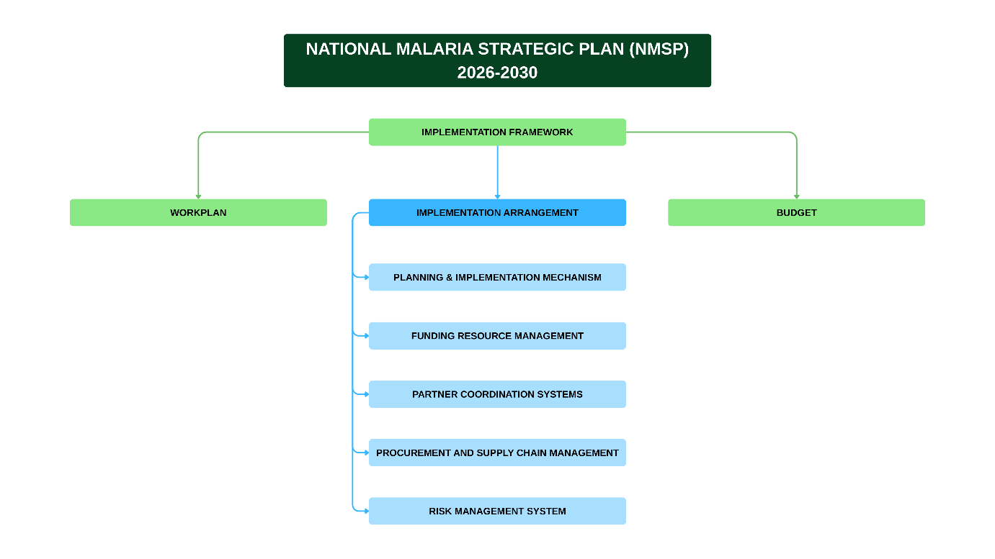
Fig 13: Structure of the NMSP Implementation Framework

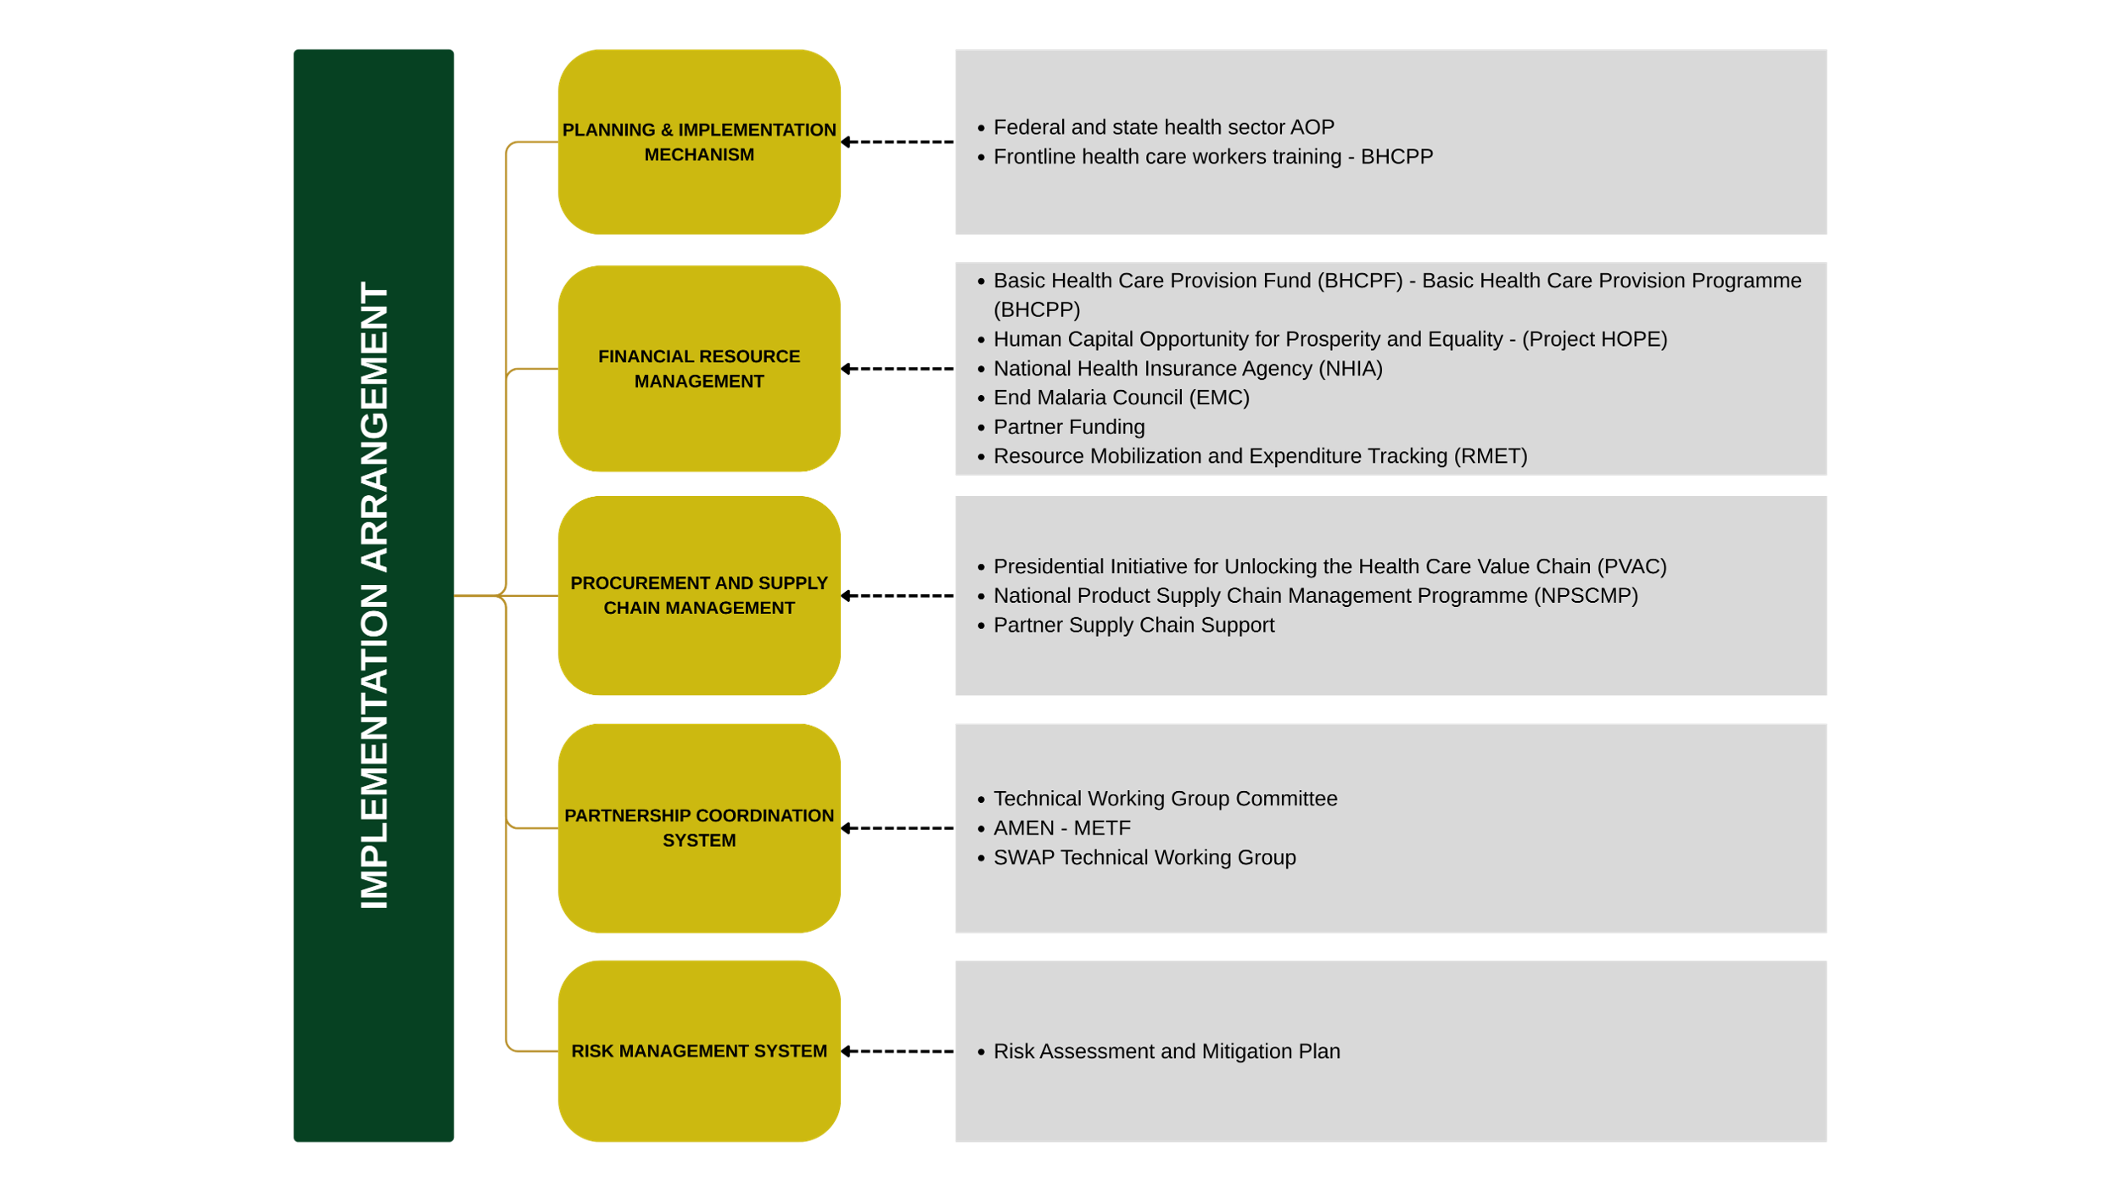

Fig 14: Overview of the Implementation Arrangements
5.3. NMSP Budget
Total estimated budget (2026 - 2030)
The Total Budget for the NMSP 2026-2030 is twenty trillion, eight hundred and fifty billion, eight hundred and thirty-nine million, nine hundred and forty-seven thousand and twenty-seven Naira (₦20,850,839,947,077) equivalent of thirteen billion, nine hundred million, five hundred and fifty-nine thousand, nine hundred and sixty-five Dollars ($13,900,559,965) using exchange rate of 1,500 NGN per USD.

Table 13: Budget Summary
NMSP Objectives | 2026 | 2027 | 2028 | 2029 | 2030 | 2026-2030  (Total Budget)
Objective 1 | 8,885,103,620 | 6,709,918,380 | 7,018,956,900 | 6,835,387,580 | 7,144,426,100 | 36,593,792,580
Objective 2 | 3,744,438,154,633 | 4,175,454,882,594 | 3,879,089,613,192 | 3,575,759,146,952 | 4,048,095,221,121 | 19,422,837,018,492
Objective 3 | 193,605,005,218 | 196,182,708,204 | 199,288,241,917 | 202,188,834,009 | 205,329,329,567 | 996,594,118,916
Objective 4 | 25,488,607,957 | 25,429,341,637 | 25,816,997,847 | 25,471,939,937 | 27,019,591,637 | 129,226,479,015
Objective 5 | 7,650,524,895 | 121,375,228,355 | 7,601,337,215 | 121,375,228,355 | 7,586,219,255 | 265,588,538,075
Annual Budget (NGN) | 3,980,067,396,323 | 4,525,152,079,170 | 4,118,815,147,071 | 3,931,630,536,833 | 4,295,174,787,680 | 20,850,839,947,077
Annual Budget (USD) | 2,653,378,264 | 3,016,768,053 | 2,745,876,765 | 2,621,087,025 | 2,863,449,858 | 13,900,559,965
1USD = 1,500NGN

Table 14: Malaria Funding Landscape and NMSP Budget Gap Analysis
Resources Mapping | 2026 | 2027 | 2028 | 2029 | 2030 | 2026-2030  (Total Budget) | Funding Gap
Total NMSP Budget | 3,980,067,396,323 | 4,525,152,079,170 | 4,118,815,147,071 | 3,931,630,536,833 | 4,295,174,787,680 | 20,850,839,947,077
Current and Expected Domestic Resources
Current and Expected External Resources
Total Current and Expected Resources (B + C)
Financial Gap (A - D)

Annual Budget (NGN) | 3,980,067,396,323 | 4,525,152,079,170 | 4,118,815,147,071 | 3,931,630,536,833 | 4,295,174,787,680 | 20,850,839,947,077
Annual Budget (USD)  *exchange rate | 2,653,378,264 | 3,016,768,053 | 2,745,876,765 | 2,621,087,025 | 2,863,449,858 | 13,900,559,965

Table 15: Malaria Commodity Needs for 2026 - 2030
Commodity | Annual Needs |  |  |  |  | 2026 – 2030 Needs
Commodity | 2026 | 2027 | 2028 | 2029 | 2030 | 2026 – 2030 Needs
ACT doses (Public sector) | 69,147,382 | 69,851,866 | 70,575,018 | 71,317,518 | 72,080,081 | 283,119,999
ACT doses (Private sector) | 93,056,667 | 93,975,990 | 94,904,395 | 95,841,972 | 96,788,812 | 474,567,836
RDT quantity (Public sector) | 61,812,317 | 63,804,581 | 65,864,226 | 67,993,802 | 70,195,977 | 329,670,903
RDT quantity (Private sector) | 83,301,891 | 86,083,006 | 88,956,971 | 91,926,887 | 94,995,956 | 445,264,711
Microscopy needs (Public sector) | 16,613,315 | 17,167,967 | 17,741,137 | 18,333,442 | 18,945,522 | 88,801,383
Microscopy needs (Private sector) | 26,901,251 | 27,799,376 | 28,727,486 | 29,686,581 | 30,677,697 | 143,792,391
ITN quantity (Mass Campaign) | 18,700,002 | 88,862,475 | 36,269,768 | 20,734,862 | 97,400,751 | 261,967,858
ITN quantity (Routine) | 18,114,590 | 19,141,217 | 20,244,005 | 21,430,024 | 22,707,103 | 101,636,939
Artesunate Injection doses (Public) | 6,698,653 | 6,766,898 | 6,836,951 | 6,908,879 | 6,982,750 | 20,518,354
Rectal Artesunate Suppositories (Public) | 535,893 | 541,347 | 546,946 | 552,694 | 558,598 | 2,735,478
SPAQ need | 113,367,119 | 117,397,678 | 121,596,187 | 125,971,639 | 130,533,688 | 608,866,311
SP need (Public sector) | 136,351,121 | 141,289,343 | 146,451,240 | 151,851,850 | 157,507,651 | 733,451,205
SP need (Private sector) | 12,549,629 | 13,195,464 | 13,882,784 | 14,615,010 | 15,395,916 | 69,638,803
Malaria Vaccine need | 6,616,028 | 6,837,276 | 7,066,696 | 7,304,660 | 7,551,556 | 35,376,216

Table 16: Summary of NMSP Budget by Intervention Areas
Intervention Area | Annual Budget |  |  |  |  | 2026-2030 Budget | % of Total
Intervention Areas | 2026 | 2027 | 2028 | 2029 | 2030 | 2026 – 2030 (Total) | % of Total
Vector Control: ITN | 208,664,720,362 | 630,480,963,038 | 324,391,651,674 | 238,618,106,896 | 700,370,348,265 | 2,102,525,790,235 | 10.084
Vector Control: IRS | 3,043,765,051,215 | 3,043,765,051,215 | 3,043,765,051,215 | 3,043,765,051,215 | 3,043,765,051,215 | 15,218,825,256,075 | 72.989
Vector Control: LSM | 227,709,261,114 | 227,698,430,454 | 227,698,430,454 | 0 | 0 | 683,106,122,022 | 3.276
Vector Control: Entomological surveillance | 640,121,460 | 640,121,460 | 640,121,460 | 640,121,460 | 640,121,460 | 3,200,607,300 | 0.015
Vector Control: Other Interventions | 100,303,410 | 79,185,450 | 79,185,450 | 79,185,450 | 79,185,450 | 417,045,210 | 0.002
Specific Prevention Interventions (SPI): SP for IPTp | 20,147,733,855 | 21,294,738,135 | 22,530,275,495 | 23,863,229,841 | 25,303,537,726 | 113,139,515,052 | 0.543
Specific Prevention Interventions (SPI): SP for PMC | 35,697,977,178 | 36,818,278,360 | 37,974,123,443 | 39,166,673,719 | 40,397,115,967 | 190,054,168,667 | 0.911
Specific Prevention Interventions (SPI): SP for IPTsc
Specific Prevention Interventions (SPI): Malaria Vaccine | 49,655,472,298 | 51,299,714,092 | 53,020,378,888 | 54,805,108,594 | 56,656,824,526 | 265,437,498,398 | 1.273
Specific Prevention Interventions (SPI): Seasonal Malaria Intervention (SMC) | 157,971,782,071 | 163,374,620,899 | 168,986,615,623 | 174,817,890,288 | 180,879,257,022 | 846,030,165,903 | 4.058
Case Management: Diagnosis | 43,808,024,091 | 45,030,329,591 | 46,451,484,867 | 47,920,892,137 | 49,440,392,594 | 232,651,123,280 | 1.116
Case Management: Treatment | 149,794,481,127 | 151,152,378,613 | 152,689,595,850 | 154,267,941,872 | 155,888,936,973 | 763,793,334,436 | 3.663
RSSH: PSM | 12,598,928,349 | 12,555,133,449 | 13,028,370,259 | 12,579,133,449 | 12,567,133,449 | 63,328,698,955 | 0.304
RSSH: SMEOR | 13,004,838,173 | 12,951,571,853 | 13,013,152,453 | 12,970,170,153 | 14,529,821,853 | 66,469,554,485 | 0.319
RSSH: ACSM | 5,952,994,050 | 119,675,188,590 | 5,901,297,450 | 119,675,188,590 | 5,886,179,490 | 257,090,848,170 | 1.233
Programme Management | 10,555,707,570 | 8,336,373,970 | 8,645,412,490 | 8,461,843,170 | 8,770,881,690 | 44,770,218,890 | 0.215
Annual Intervention Budget (NGN) | 3,980,067,396,323 | 4,525,152,079,170 | 4,118,815,147,071 | 3,931,630,536,833 | 4,295,174,787,680 | 20,850,839,947,077
Annual Intervention Bu | 2,653,378,264 | 3,016,768,053 | 2,745,876,765 | 2,621,087,025 | 2,863,449,858 | 13,900,559,965

Chapter Six

Monitoring and Evaluation Framework
This Monitoring and Evaluation (M&E) Framework serves as a critical roadmap for ensuring the effective implementation, tracking, and assessment of the NMSP 2026–2030. It provides a structured approach for measuring progress, identifying implementation gaps, and promoting accountability across all programmatic areas. The framework is composed of three core components: the Performance Framework (PF), which outlines key indicators, targets, and milestones for monitoring results; the Data Management System which details data flow, sources, and quality assurance mechanisms across all levels of the health system; M&E Feedback Mechanisms which represent structured data reviews and communication channels for continuous learning and data improvements; and the M&E Coordination Mechanisms which define roles, responsibilities, and collaboration structures among stakeholders at federal, state, and LGA levels.
The Surveillance, Monitoring, Evaluation, and Operations Research (SMEOR) Branch of NMEP provides leadership for the design, implementation, and continuous improvement of malaria data systems. The branch ensures that high-quality, timely, and reliable data inform decision-making, policy development, and resource allocation. Under the NMSP 2026-2030, data systems will be further strengthened through integration, digital innovations, and enhanced capacity-building initiatives to improve data use at all levels.
The monitoring of the NMSP 2026–2030 will apply an equity, vulnerability, and gender lens to ensure that programme performance reflects the needs of populations disproportionately affected by malaria. Routine data systems will progressively integrate relevant disaggregation (e.g., sex, age, geographic vulnerability, displacement or mobility status) where feasible, and states will be supported to analyse coverage gaps affecting groups such as the rural poor, women, children under five, mobile and migrant populations, IDPs and refugees.
Performance reviews, DHIS2/NMDR dashboards, and quarterly/state review meetings will be used to track equity-related gaps in access and utilisation, and to guide corrective actions through existing decision-making forums. This approach ensures that EHRGE considerations remain embedded within programme monitoring and accountability processes without creating parallel reporting systems.

6.1 Performance Framework
The performance framework (PF) provides a structured approach for systematically tracking the implementation, outcomes, and impact of the NMSP 2026-2030. It serves as a key management tool for measuring progress, assessing the effectiveness of interventions, and identifying areas that require course correction. Through defined performance indicators, the framework enables programme managers and stakeholders to determine when implementation is on track and when adjustments are needed to achieve desired results.
The indicators outlined in the Performance Framework (Table 13) have data sources, targets, frequency of measurement, and designated responsible entities across the malaria programme. This ensures consistency in data collection, facilitates comparability, and also supports evidence-based decision-making throughout the implementation period.

Table 13: Performance Framework for the NMSP 2026-2030
Goals and Objectives | Indicators | Baseline |  | Annual Target |  |  |  |  | Data Source
Goals and Objectives | Indicators | Value | Year | 2026 | 2027 | 2028 | 2029 | 2030 | Data Source
Goals | Impact Indicators
National  To reduce malaria parasite prevalence by 60% and deaths attributed to malaria by 60% from 2025 levels by 2030.  Subnational  To achieve pre-elimination in low prevalence states, a 60% reduction in moderate, prevalence states, and a 30% reduction in high prevalence states by 2030. | Parasite prevalence in U5 (slide) | 22% | 2021 | 18% | 15% | 12% | 9% | 7% | NMIS
 | Parasite prevalence among pregnant women (RDT) | 18% | 2024 | 15% | 12% | 10% | 8% | 6% | HMIS
 | Entomological inoculation rate (indoor/outdoor) | 9.0 | 2024 | 7.2 | 5.9 | 4.5 | 3.6 | 2.7 | Ento-surveillance report
 | Annual parasite incidence per 1,000 population | 298 | 2023 | 260 | 220 | 180 | 150 | 120 | WMR
 | Malaria mortality per 100,000 population | 81 | 2023 | 60 | 40 | 42 | 35 | 30 | WMR
 | All-cause U5 mortality per 1,000 population | 88 | 2024 | 80 | 72 | 65 | 58 | 50 | NDHS
Objective 1 | Outcome Indicators
1. To strengthen governance and improve organizational capacity to at least 90% from baseline by 2030 | - Proportion of the planned activities fully implemented at >=80% (federal & state) | 62% | 2025 | 68% | 74% | 80% | 86% | 90% | MPR
 | - Organizational Capacity Assessment (OCA) score at all levels (federal, state, LGA) | 60% | 2024 | 70% | 75% | 80% | 86% | 90% | OCA report
Objective 2 | Outcome Indicators
2. To improve access to and utilization of preventive interventions to at least 80% of the target population by 2025 | - % of households with at least 1 ITN | 59% | 2024 | 65% | 70% | 75% | 78% | 80% | NDHS
 | - % of households with at least 1 ITN for every 2 persons | 32% | 2024 | 40% | 50% | 60% | 70% | 80% | NDHS
 | - % of population with access to an ITN in the household | 48% | 2024 | 55% | 60% | 65% | 70% | 75% | NDHS
 | - % of household residents who slept under ITN the previous night | 65% | 2024 | 68% | 72% | 75% | 78% | 80% | NDHS
 | - % of under-5 children who slept under ITN previous night | 43% | 2024 | 55% | 60% | 65% | 70% | 75% | NDHS
 | - % of pregnant women who slept under ITN previous night | 46% | 2024 | 55% | 60% | 65% | 70% | 75% | NDHS
 | - % of population protected by IRS in the last 12 months | 3% | 2024 | 5% | 7% | 10% | 12% | 15% (focal) | Activity report
 | - Proportion of larval habitats with no larvae post-implementation in targeted areas | 0% | 2024 | 40% | 55% | 65% | 75% | 85%  (focal) | Activity report
 | - % of women who received ≥3 doses of IPTp | 26% | 2024 | 35% | 45% | 55% | 65% | 75% | NDHS
 | - % of targeted children receiving all SMC cycles | 97% | 2024 | 97% | 98% | 98% | 99% | 99% | Activity report
 | - % of eligible under-2 children receiving all 4 doses of SP for PMC | 10% | 2025 | 25% | 40% | 55% | 70% | 80% | Activity report
 | - % of eligible (targeted) under-2 children receiving all 4 doses of malaria vaccine | 34% | 2025 | 45% | 55% | 65% | 75% | 85% | Routine report
Objective 3 | Outcome Indicators
3. To improve effective coverage for diagnosis and appropriate treatment for all target populations at risk by 2030 | 3.1 % of persons with suspected malaria receiving a diagnostic test (RDT and/or microscopy) according to national guideline | 94% | 2024 | 95% | 96% | 97% | 98% | 99% | NMDR (DHIS2)
 | 3.2 % of confirmed malaria cases who received first line antimalarial treatment according to national guideline | 98% | 2024 | 98% | 99% | 99% | 99% | 100% | NMDR (DHIS2)
 | 3.3 % of U5 children with fever for whom advice was sought within 24h | 60% | 2024 | 65% | 70% | 75% | 80% | 85% | NDHS
 | 3.4 % receiving ACT, among U5 children with fever in the last two weeks who received any antimalarial drug | 57% | 2024 | 65% | 70% | 75% | 80% | 85% | NDHS
 | 3.5 % of health facilities without stock out of ACTs for 7 consecutive days in a month | 60% | 2024 | 70% | 75% | 80% | 85% | 90% | e-NHLMIS
 | 3.6 Malaria Test Positivity Rate | 70% | 2024 | 65% | 60% | 55% | 50% | 45% | NMDR  (DHIS2)
 | 3.7 % of healthcare providers who ensure confirmation of malaria with a test before treatment | 80% | 2024 | 85% | 90% | 93% | 95% | 97% | TBD
 | 3.8 Order Fill Rate / OTIF: % of malaria product orders fulfilled in full and on time | 75% | 2024 | 80% | 85% | 88% | 92% | 95% | Programme  Reports
 | 3.9 % of malaria medicines/products that met quality specifications during post-marketing surveillance | 95% | 2024 | 96% | 97% | 98% | 98% | 99% | Programme  Reports
Objective 4 | Outcome Indicators
4. To improve the effectiveness of malaria surveillance systems in generating complete, timely, and accurate data, with a targeted increase from 47% to 70% by 2030 | 4.1 % of expected HF reports received & complete | 93% | 2024 | 94% | 95% | 96% | 97% | 98% | NMDR  (DHIS2)
 | 4.2 % of HF assessed that met the national data-quality threshold (≥ 80%) | 83% | 2024 | 85% | 87% | 90% | 93% | 95% | NMDR  (Power BI)
 | 4.3 % of HFs with ≤5% variance between NHMIS & NHLMIS | 50% | 2024 | 60% | 70% | 75% | 80% | 85% | e-NHLMIS
 | 4.4 % of operational decisions guided by routine/surveillance data | 40% | 2024 | 55% | 60% | 65% | 70% | 80% | Programme  Reports
 | 4.5 % of designated TES sites completing full therapeutic assessment | 100% | 2024 | 100% | 100% | 100% | 100% | 100% | Programme  Reports
 | 4.6 % of OR findings translated into policy | 25% | 2024 | 35% | 45% | 55% | 65% | 75% | Programme  Reports
 | 4.7 % of malaria cases detected by surveillance system | 60% | 2024 | 65% | 70% | 75% | 78% | 80% | Programme  Reports
Objective 5 | Outcome Indicators
5. To achieve sustainable malaria financing with at least 80% of resources mobilized from domestic resources | 5.1 % of states funding ≥40% of MOP from domestic sources | 10% | 2024 | 20% | 30% | 45% | 60% | 80% | Annual Prog  Report
 | 5.3 % of malaria expenditure that is out-of-pocket | 25.4% | 2024 | 50% | 46% | 42% | 38% | 35% | NHA
 | 5.4 % of total malaria expenditure contributed by Government (federal, states + FCT) | 20% | 2024 | 25% | 30% | 35% | 40% | 45% | Annual Prog  Report

6.2 Data Management System
The Surveillance, Monitoring, Evaluation, and Operational Research (SMEOR) policy and system constitute a core component of the country’s malaria response, providing the framework for evidence-based planning, implementation, and performance monitoring across all levels of the malaria programme. The SMEOR system is guided by several strategic documents and operational tools, including the National Malaria Operations Research Agenda (NMORA), the M&E Plan, SOPs for Data Management, and guidelines for Data Quality Assurance (DQA) as well as integrated Monitoring and Supportive Supervision (iMSV) protocols. Other key components include the Model Health Facility (MHF) initiative designed to promote best practices in malaria data management and service delivery, and comprehensive M&E Training Manuals aimed at strengthening capacity among programme officers at all levels. It is important to note that PHCs in Nigeria are using the 2019 version of the National Health Management Information System (NHMIS) tool for data collection. However, the 2024 version is being finalized and is anticipated to be rolled out during the lifespan of the current NMSP.
At the national level, the NMEP/SMEOR branch conducts monthly malaria data analyses using data in the National Malaria Data Repository (NMDR), including routine service data added from the DHIS2 platform. These analyses help identify trends, data gaps (including outliers), and performance bottlenecks. NMEP and its partners disseminate feedback reports through the SMEOR Subcommittee, biannual M&E Review Meetings and other platforms, highlighting facilities or states with data quality concerns and providing recommendations for corrective action. Additionally, the National Health Logistics Management Information System (NHLMIS) serves as a complementary platform for managing and monitoring malaria commodity logistics data. It is imperative for NMEP and partners to ensure that service data and logistics data are effectively linked and triangulated, to support decisions on forecasting, procurement, and distribution of malaria health products such as RDTs, ACTs, ITNs, SPAQ, and SP.
At the State level, dedicated malaria M&E officers oversee the implementation of SMEOR activities. They work closely with the State HMIS officers within the Department of Health Planning, Research, and Statistics (DHPRS) to ensure data accuracy, consistency, and timely submission of service data to the DHIS2 platform. Similarly, the State Coordinators for the Logistics Management Coordination Unit (LMCU) are responsible for the management of the malaria logistics data.
At the LGA level, the LGA malaria focal persons, along with the LGA M&E officers, are responsible for data validation, quality assurance, and timely reporting of malaria service data using the standard indicators. While the LGA M&E officer is responsible for uploading the service delivery data into the DHIS2 platform, the LGA LMCU Coordinator is responsible for reporting the logistics data to the NHLMIS platform. The SMEPs use data from the DHIS2 and NMDR to produce a quarterly malaria bulletin.
The flow of data follows a hierarchical structure from the health facility level through the LGA and State levels, culminating at the national level, as illustrated in figure 10 below. Although the community data flow is depicted on the data flow chart, it’s relatively weak. Continued efforts towards achieving interoperability between the DHIS2 and NHLMIS platforms will further enhance data integration, accountability, and availability of high-quality data, for programme decision-making.

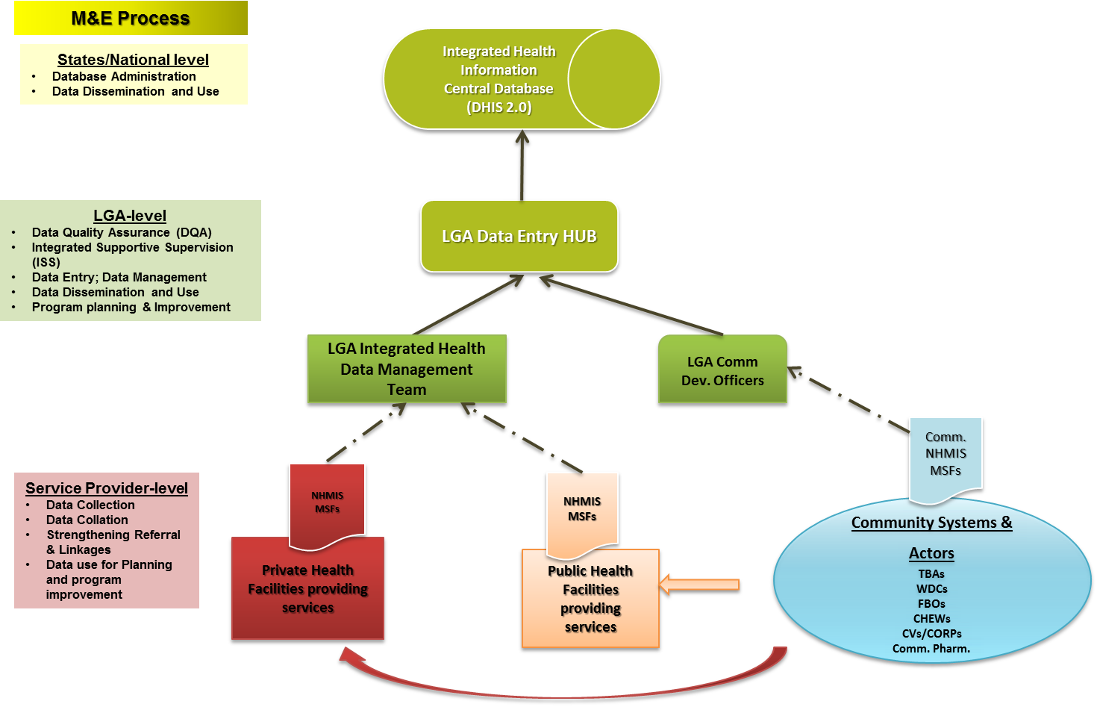
Fig 15: National Malaria data flow

6.3 M&E Feedback, Complaint, and Response Mechanism (FCRM)
To ensure that data within the DHIS2/NMDR remains accurate, reliable, and responsive to programmatic needs, a structured Feedback, Complaint, and Response Mechanism (FCRM) has been established. This mechanism enables Monitoring and Evaluation (M&E) personnel and other data users at national, state, and local government levels to provide timely feedback on data quality, system functionality, and overall usability.
The FCRM establishes structured channels for collecting, reviewing, and addressing feedback on the data platform/repository, enhancing accountability and promoting continuous improvement in data quality and decision-making. Feedback is provided by stakeholders at all levels, including National, State, and LGA M&E Officers, among other users who identify data issues whilst interacting with the DHIS2/NMDR platform. Current feedback channels include meetings, review sessions, WhatsApp groups, phone calls, and field visits, enabling real-time reporting and communication between data users and system managers.
Once feedback is received, DHIS2/NMDR system managers and the M&E leadership at national and state levels review and categorize submissions, determine corrective actions (e.g., data validation, troubleshooting, or escalation), and provide timely responses to submitters through appropriate channels. This process maintains a closed feedback loop, promoting transparency and collaboration between data users and managers.
Currently, feedback is not formally logged in the DHIS2/NMDR, but the long-term goal is to adopt a structured digital tracking system (e.g., an integrated ticketing or issue-tracking platform). Insights from this mechanism further support data quality assurance, staff capacity building, and system improvement, ultimately fostering a culture of data ownership, responsiveness, and continuous learning within the health information system.
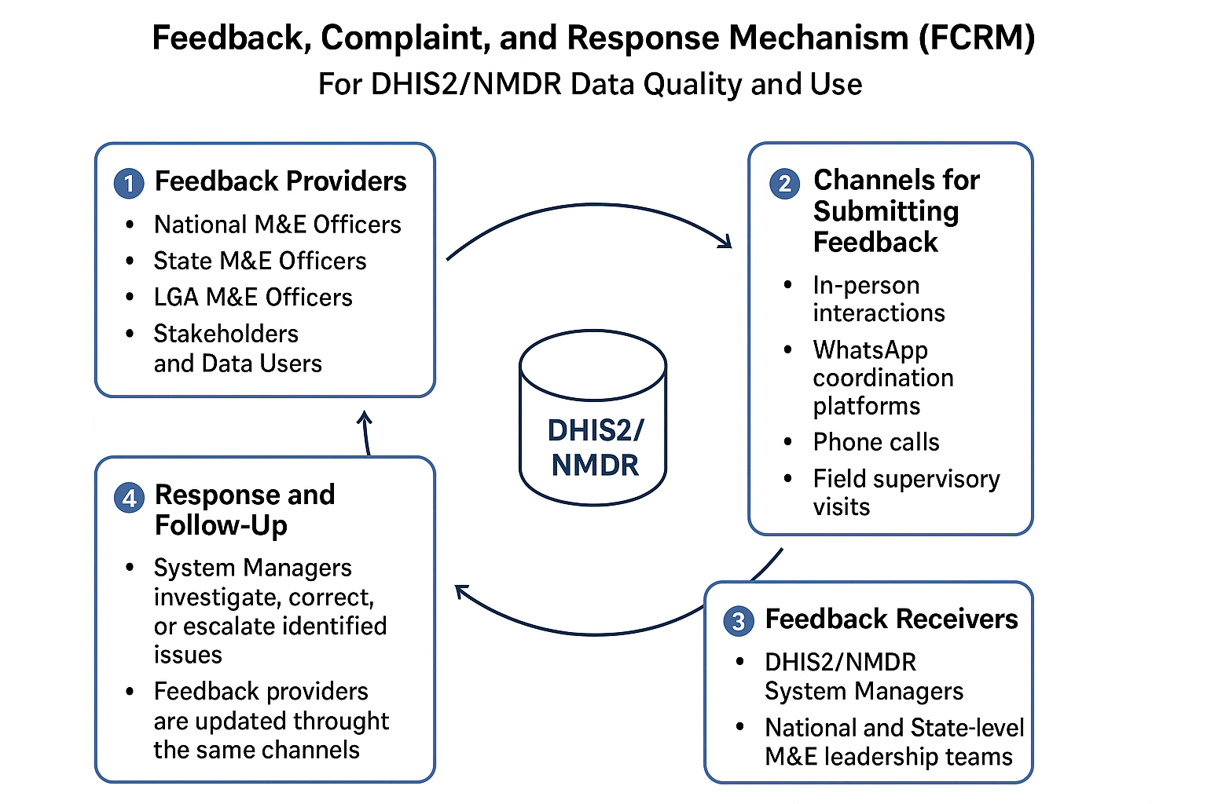
Fig. 16: Feedback, Complaint, and Response Mechanism

6.4 M&E Coordination Mechanisms
The coordination of SMEOR activities will be guided by well-defined mechanisms at both national and sub-national levels. These mechanisms aim to strengthen collaboration, ensure data quality, and enhance evidence-based decision-making across all programmatic areas.
Different layers of DQAs will be implemented by NMEP and partners (national, state, and LGA) to promote continuous performance improvement while iMSVs will be conducted in close collaboration with the various thematic areas, to improve the completeness, accuracy, and timeliness of malaria data reporting. Furthermore, the SMEOR branch will leverage existing partnerships and coordination platforms with key stakeholders, including MDAs and implementing partners, to optimize resource mobilization, strengthen data sharing, and promote the effective use of information for programme planning and policy formulation. Such existing partnerships and coordination platforms include Data Management Expert Group (DMEG), Malaria Operations Research Expert Group (MOREG), SMEOR sub-committee and other task teams.
At the sub-national level, M&E coordination mechanisms comprise regular data review meetings and data control rooms, which serve as platforms for monitoring data quality, addressing reporting challenges, facilitating timely decision-making and tracking feedback between state, LGA, and facility-level teams.

